UNITED STATES
SECURITIES AND EXCHANGE COMMISSION
WASHINGTON, D.C. 20549
__________________________________________________
FORM 8-K
__________________________________________________

CURRENT REPORT PURSUANT TO
SECTION 13 OR 15(d) OF THE
SECURITIES EXCHANGE ACT OF 1934
Date of report (Date of earliest event reported): April 29, 2026
__________________________________________________
VICI Properties Inc.
VICI Properties L.P.
(Exact Name of Registrant as Specified in its Charter)
__________________________________________________
Maryland (VICI Properties Inc.) |  |  |  |  |  | 001-38372 |  |  |  |  |  | 81-4177147
Delaware (VICI Properties L.P.) |  |  |  |  |  | 333-264352-01 |  |  |  |  |  | 35-2576503
(State or Other Jurisdiction  of Incorporation) |  |  |  |  |  | (Commission  File Number) |  |  |  |  |  | (IRS Employer  Identification No.)
535 Madison Avenue
New York, New York 10022
(Address of Principal Executive Offices) (Zip Code)
Registrant’s telephone number, including area code: (646) 949-4631
Not Applicable
(Former Name or Former Address, if Changed Since Last Report)
__________________________________________________
Check the appropriate box below if the Form 8-K filing is intended to simultaneously satisfy the filing obligation of the registrant under any of the following provisions:
☐ |  |  | Written communications pursuant to Rule 425 under the Securities Act (17 CFR 230.425)
☐ |  |  | Soliciting material pursuant to Rule 14a-12 under the Exchange Act (17 CFR 240.14a-12)
☐ |  |  | Pre-commencement communications pursuant to Rule 14d-2(b) under the Exchange Act (17 CFR 240.14d-2(b))
☐ |  |  | Pre-commencement communications pursuant to Rule 13e-4(c) under the Exchange Act (17 CFR 240.13e-4(c))
Securities registered pursuant to Section 12(b) of the Act:
Title of each class |  |  |  |  |  | Trading Symbol |  |  |  |  |  | Name of each exchange on which registered
Common stock, $0.01 par value |  |  |  |  |  | VICI |  |  |  |  |  | New York Stock Exchange
Indicate by check mark whether the registrant is an emerging growth company as defined in Rule 405 of the Securities Act of 1933 (§230.405 of this chapter) or Rule 12b-2 of the Securities Exchange Act of 1934 (§240.12b-2 of this chapter).
VICI Properties Inc. |  |  | ☐ |  |  | Emerging growth company
VICI Properties L.P. |  |  | ☐ |  |  | Emerging growth company
If an emerging growth company, indicate by check mark if the registrant has elected not to use the extended transition period for complying with any new or revised financial accounting standards provided pursuant to Section 13(a) of the Exchange Act.
VICI Properties Inc. |  |  | ☐
VICI Properties L.P. |  |  | ☐

Item 2.02. |  |  | Results of Operations and Financial Condition.
On April 29, 2026, VICI Properties Inc. (the “Company”) issued a press release announcing its consolidated financial results for the three months ended March 31, 2026, and made available supplemental financial and operating information concerning the Company as of March 31, 2026. A copy of the press release and a copy of this supplemental information are furnished herewith as Exhibit 99.1 and Exhibit 99.2, respectively, to this Current Report on Form 8-K and are incorporated herein by reference.
Item 7.01. |  |  | Regulation FD Disclosure.
The disclosure contained in Item 2.02 is incorporated herein by reference.
The information included in Item 2.02 and Item 7.01 of this Current Report on Form 8-K, including Exhibit 99.1 and Exhibit 99.2, is being furnished and shall not be deemed “filed” for purposes of Section 18 of the Securities Exchange Act of 1934, as amended (the “Exchange Act”), or otherwise subject to the liabilities of that Section, nor shall it be deemed incorporated by reference into any of the Company’s filings under the Securities Act of 1933, as amended, or the Exchange Act, whether made before or after the date hereof and regardless of any general incorporation language in such filings, except to the extent expressly set forth by specific reference in such a filing. The furnishing of the information included in Item 7.01 of this Current Report on Form 8-K shall not be deemed an admission as to the materiality of any information herein that is required to be disclosed solely by reason of Regulation FD.
Item 9.01. |  |  | Financial Statements and Exhibits.
(d) Exhibits
Exhibit  No. |  |  |  |  |  | Description
99.1 |  |  |  |  |  | Press Release, dated April 29, 2026
99.2 |  |  |  |  |  | Supplemental Financial & Operating Data, First Quarter Ended March 31, 2026
104 |  |  |  |  |  | Cover Page Interactive Data File (embedded within the Inline XBRL document)

SIGNATURES
Pursuant to the requirements of the Securities Exchange Act of 1934, each registrant has duly caused this report to be signed on its behalf by the undersigned hereunto duly authorized.
 |  |  | VICI PROPERTIES INC.
Date: April 29, 2026 |  |  | By: |  |  | /s/ SAMANTHA S. GALLAGHER
 |  |  |  |  |  | Samantha S. Gallagher
 |  |  |  |  |  | Executive Vice President, General Counsel and Secretary
 |  |  | VICI PROPERTIES L.P.
Date: April 29, 2026 |  |  | By: |  |  | /s/ SAMANTHA S. GALLAGHER
 |  |  |  |  |  | Samantha S. Gallagher
 |  |  |  |  |  | Secretary

Exhibit 99.1

VICI PROPERTIES INC. ANNOUNCES FIRST QUARTER 2026 RESULTS
- Announced Expanded $1.5 Billion Investment with Cain and Eldridge Industries -
- Announced Sale-Leaseback of Canadian Casino Portfolio with PURE -
- Raises Guidance for Full Year 2026 -

NEW YORK, NY – April 29, 2026 – VICI Properties Inc. (NYSE: VICI) (“VICI Properties”, "VICI" or the “Company”), an experiential real estate investment trust, today reported results for the quarter ended March 31, 2026. All per share amounts included herein are on a per diluted common share basis unless otherwise stated.
First Quarter 2026 Financial and Operating Highlights
•Total revenues increased 3.5% year-over-year to $1.0 billion
•Net income attributable to common stockholders increased 60.5% year-over-year to $872.4 million and, on a per share basis, increased 58.7% year-over-year to $0.82 due to the impact of the change in the CECL allowance for the quarter ended March 31, 2026
•AFFO attributable to common stockholders increased 5.7% year-over-year to $650.9 million and, on a per share basis, increased 4.5% year-over-year to $0.61
•Announced expansion of strategic relationship with Cain and Eldridge Industries by providing a $1.5 billion mezzanine loan as part of the construction financing for the One Beverly Hills development
•Announced the pending acquisition of two casino assets and two adjacent limited-service hotels, all located in Alberta, Canada, for CAD$200.6 million / USD$144.4 million in connection with Pure Casino Entertainment's pending take-private acquisition of Gamehost Inc. (GH.TO)
•Ended the quarter with $480.2 million in cash and cash equivalents and $241.6 million of estimated forward sale equity proceeds
•Raised AFFO guidance for full year 2026 to between $2,665 million and $2,695 million, or between $2.44 and $2.47 per diluted share
•Subsequent to quarter-end:
◦Entered into a lease agreement with an affiliate of funds managed by Clairvest in connection with its acquisition of the operations of MGM Northfield Park in Northfield, Ohio, adding VICI's 14th tenant on April 21, 2026
◦Announced that all gaming regulatory and shareholder approvals had been met for the previously announced $1.16 billion acquisition of 100% of the land, real property and improvements of seven casino properties from Golden Entertainment, with closing expected on or around April 30, 2026, subject to the satisfaction of remaining customary closing conditions
CEO Comments
Edward Pitoniak, Chief Executive Officer of VICI Properties, said, "In the first quarter of 2026, we grew our quarterly revenue by 3.5% and our AFFO per share by approximately 4.5% year-over-year, reflecting the continued compounding of our business model. This quarter demonstrated what we believe to be one of VICI's most durable competitive advantages: the ability to grow through deepening relationships with our existing partners. Our expansion of the One Beverly Hills mezzanine loan to $1.5 billion alongside Cain and Eldridge and our pending acquisition of casino real estate in Alberta in connection with PURE's acquisition of Gamehost each represent second and third chapters in partnerships that began with a single investment. As we look ahead to the

expected closings of our Golden Entertainment and Gamehost transactions, we remain confident that VICI's partner-driven model will continue to generate attractive, sustained growth for our shareholders."
First Quarter 2026 Financial Results
Total Revenues
Total revenues were $1.0 billion for the quarter, an increase of 3.5% compared to $984.2 million for the quarter ended March 31, 2025. Total revenues for the quarter included $130.0 million of non-cash leasing and financing adjustments and $18.9 million of other income.
Net Income Attributable to Common Stockholders
Net income attributable to common stockholders was $872.4 million for the quarter, or $0.82 per share, compared to $543.6 million, or $0.51 per share, for the quarter ended March 31, 2025. The year-over-year increase in net income was driven, on an absolute basis, by the $305.7 million aggregate change in the CECL allowance for the quarter ended March 31, 2026 compared to the quarter ended March 31, 2025.
Funds from Operations (“FFO”)
FFO attributable to common stockholders was $872.4 million for the quarter, or $0.82 per share, compared to $543.6 million, or $0.51 per share, for the quarter ended March 31, 2025. The year-over-year increase in FFO was driven, on an absolute basis, by the $305.7 million aggregate change in the CECL allowance for the quarter ended March 31, 2026 compared to the quarter ended March 31, 2025.
Adjusted Funds from Operations (“AFFO”)
AFFO attributable to common stockholders was $650.9 million for the quarter, an increase of 5.7% compared to $616.0 million for the quarter ended March 31, 2025. AFFO per share was $0.61 for the quarter, an increase of 4.5% compared to $0.58 for the quarter ended March 31, 2025.
First Quarter 2026 and Subsequent Investment Activity
Investment Activity
On March 23, 2026, VICI announced that it expanded its long-term strategic relationship with Cain and Eldridge Industries by providing a $1.5 billion mezzanine loan (the “OBH Mezzanine Loan”) behind a $2.8 billion senior loan commitment led by J.P. Morgan as part of the construction financing for One Beverly Hills. The OBH Mezzanine Loan represents a $1.05 billion incremental commitment beyond VICI’s existing $450.0 million investment in the project and is the culmination of the first expression of VICI’s previously announced long-term strategic relationship with Cain and Eldridge Industries. Construction on the One Beverly Hills development commenced in 2024, with vertical works beginning in the fall of 2025 and phased delivery scheduled to commence in 2028. The OBH Mezzanine Loan has an initial term of 4 years with one 12-month extension option, subject to certain conditions, and will be deployed over the course of the initial term. Upon the closing of the transaction, VICI deployed an initial funding of $650.0 million. VICI has funded and intends to continue to fund the investment with cash on hand.
In connection with this increase in VICI’s participation in the financing of the One Beverly Hills development, Cain, Eldridge Industries, and VICI have agreed in principle pursuant to a non-binding letter of intent to further their strategic relationship that
2
was first announced in February 2025. The letter of intent expresses Cain, Eldridge Industries, and VICI’s shared intention to expand their strategic relationship into an Experiential Cross-Capital Venture whereby the three companies will, when suitable, work together to identify, pursue, and potentially participate in the funding of each other’s experiential investment activities in various structures. Accordingly, it is the intention of Cain, Eldridge Industries, and VICI that, upon maturity of the OBH Mezzanine Loan, the companies will seek opportunities to deploy VICI’s returned capital into new experiential investments that meet each company’s investment criteria. Additionally, VICI may from time to time and at its sole election present to Cain and Eldridge Industries experiential investment opportunities in which Cain and/or Eldridge Industries may participate.
On March 30, 2026, VICI announced the CAD$200.6 million / USD$144.4 million (based on the exchange rate at the time of announcement) pending acquisition (the “Gamehost Real Estate Transaction”) of the real estate assets of Deerfoot Inn & Casino, Great Northern Casino and two limited-service hotels that are adjacent to Great Northern Casino (collectively, the “Gamehost Portfolio”) located in Alberta, Canada, in connection with Pure Casino Entertainment Limited Partnership’s (“PURE”) pending take-private acquisition of Gamehost Inc. (GH.TO) (“Gamehost”). Simultaneous with the closing of the Gamehost Real Estate Transaction, the Gamehost Portfolio will be added to the existing triple-net master lease agreement between VICI Properties and PURE (the “PURE Master Lease”) and annual rent will increase by CAD$16.1 million / USD$11.6 million (based on the exchange rate at the time of announcement) representing an acquisition capitalization rate of 8.0%. The Gamehost Portfolio rent will escalate at 1.0% on February 1 following the first full 12 months post-closing (in line with the timing of the PURE Master Lease escalation), and escalation will conform to the PURE Master Lease thereafter at the greater of 1.5% or the change in Canadian CPI (capped at 2.5%). Additionally, the term of the PURE Master Lease will be extended such that, upon closing of the Gamehost Real Estate Transaction, the PURE Master Lease will have a full 25-years remaining in the initial lease term, with four 5-year tenant renewal options. The tenants’ obligations under the PURE Master Lease will continue to be guaranteed by Indigenous Gaming Partners, Inc.
Subsequent to quarter-end, on April 21, 2026, VICI announced that, in connection with the closing of MGM Resorts International's (NYSE: MGM) ("MGM Resorts") sale of the operations of MGM Northfield Park ("Northfield Park") located in Northfield, OH, to an affiliate of funds managed by Clairvest Group Inc. (TSX: CVG) ("Clairvest"), VICI has entered into a new separate triple-net lease with an affiliate of Clairvest with respect to the real property of Northfield Park and also entered into an amendment to the master lease between VICI Properties and MGM Resorts to reflect such sale.
Subsequent to quarter-end, on April 23, 2026, VICI announced that all gaming regulatory and shareholder approvals had been met for the previously announced $1.16 billion acquisition of 100% of the land, real property and improvements of seven casino properties from Golden Entertainment, Inc. (NASDAQ: GDEN) ("Golden Entertainment"), and the parties expect to close the transaction on or around April 30, 2026, subject to the satisfaction of remaining customary closing conditions. Upon closing, VICI will enter into a triple-net master lease (the "Golden Entertainment Master Lease") with a newly formed entity that is owned and controlled by Blake L. Sartini, chairman and chief executive officer of Golden Entertainment, which entity will have acquired the operating business of Golden Entertainment ("Golden OpCo"). The Golden Entertainment Master Lease will have an initial total annual rent of $87.0 million, representing an acquisition cap rate of 7.5%, and an initial term of 30 years, with four 5-year tenant renewal options. Rent under the Golden Entertainment Master Lease will escalate annually at 2.0% beginning in Lease Year 3. The obligations of Golden OpCo under the Golden Entertainment Master Lease will be guaranteed by a holding company that is owned and controlled by Mr. Sartini and owns all of the gaming and operating assets of Golden Entertainment, with additional credit support provided by financial covenants within the lease.
3
Pursuant to the Golden Entertainment master transaction agreement, upon closing, Golden Entertainment shareholders will receive approximately 24.3 million shares of newly issued VICI stock in exchange for the outstanding shares of Golden Entertainment stock, which represents an agreed-upon exchange ratio of 0.902 per share of Golden Entertainment’s common stock based on VICI’s 10-day volume weighted average price as of November 5, 2025, as well as cash consideration that is payable by an affiliate of the Golden OpCo. In connection with the closing of the transaction, VICI will assume and immediately retire Golden Entertainment’s outstanding $426 million of debt using a combination of cash on hand and net proceeds from the settlement of outstanding forward sale agreements.
First Quarter 2026 and Subsequent Capital Markets Activity
During the three months ended March 31, 2026, the Company entered into forward-starting interest rate swap agreements with an aggregate notional amount of $450.0 million, and subsequent to quarter-end, the Company entered into forward-starting interest rate swap agreements with an aggregate notional amount of $50.0 million, intended to reduce the variability in future cash flows for a forecasted issuance of long-term debt.
Subsequent to quarter end, on April 29, 2026, the Company physically settled the remaining 7,750,000 shares under its outstanding forward sale agreement in exchange for total net settlement proceeds of approximately $242.1 million.
The following table details the issuance of outstanding shares of common stock, including restricted common stock:
 |  |  |  |  |  | Three Months Ended March 31,
Common Stock Outstanding |  |  |  |  |  | 2026 |  |  |  |  |  | 2025
Beginning Balance January 1, |  |  |  |  |  | 1,068,811,371 |  |  |  |  |  | 1,056,366,685
Issuance of common stock upon physical settlement of forward sale agreements |  |  |  |  |  | — |  |  |  |  |  | —
Issuance of restricted and unrestricted common stock under the stock incentive program, net of forfeitures |  |  |  |  |  | 177,628 |  |  |  |  |  | 301,369
Ending Balance March 31, |  |  |  |  |  | 1,068,988,999 |  |  |  |  |  | 1,056,668,054
The following table reconciles the weighted-average shares of common stock outstanding used in the calculation of basic earnings per share to the weighted-average shares of common stock outstanding used in the calculation of diluted earnings per share:
 |  |  | Three Months Ended March 31,
(In thousands) |  |  | 2026 |  |  |  |  |  | 2025
Determination of shares:
Weighted-average shares of common stock outstanding |  |  | 1,068,399 |  |  |  |  |  | 1,056,012
Assumed conversion of restricted stock |  |  | 128 |  |  |  |  |  | 392
Assumed settlement of forward sale agreements |  |  | — |  |  |  |  |  | 28
Diluted weighted-average shares of common stock outstanding |  |  | 1,068,528 |  |  |  |  |  | 1,056,433
Balance Sheet and Liquidity
As of March 31, 2026, the Company had approximately $17.1 billion in total debt and approximately $3.1 billion in liquidity, comprised of $480.2 million in cash and cash equivalents, $241.6 million of estimated net proceeds available upon physical settlement of 7,750,000 shares outstanding under its forward sale agreement, and approximately $2.4 billion of availability under its revolving credit facility. The Company's revolving credit facility includes the option to (i) increase the revolving loan commitments by up to $1.0 billion, and (ii) add one or more tranches of term loans of up to $2.0 billion in the aggregate, in each
4
case, to the extent that any one or more lenders (from the syndicate or otherwise) agree to provide such additional credit extensions.
As noted above, subsequent to quarter-end, on April 29, 2026, the Company physically settled the remaining 7,750,000 shares under its outstanding forward sale agreements in exchange for aggregate net proceeds of approximately $242.1 million.
The Company’s outstanding indebtedness as of March 31, 2026 was as follows:
($ in millions USD) |  |  | March 31, 2026
Revolving Credit Facility
USD Borrowings |  |  | $ | —
CAD Borrowings (1) |  |  | 118.6
GBP Borrowings (1) |  |  | 21.8
4.500% Notes Due 2026 |  |  | 500.0
4.250% Notes Due 2026 |  |  | 1,250.0
5.750% Notes Due 2027 |  |  | 750.0
3.750% Notes Due 2027 |  |  | 750.0
4.500% Notes Due 2028 |  |  | 350.0
4.750% Notes Due 2028 |  |  | 1,250.0
4.750% Notes Due 2028 |  |  | 400.0
3.875% Notes Due 2029 |  |  | 750.0
4.625% Notes Due 2029 |  |  | 1,000.0
4.950% Notes Due 2030 |  |  | 1,000.0
4.125% Notes Due 2030 |  |  | 1,000.0
5.125% Notes Due 2031 |  |  | 750.0
5.125% Notes Due 2032 |  |  | 1,500.0
5.750% Notes Due 2034 |  |  | 550.0
5.625% Notes Due 2035 |  |  | 900.0
5.625% Notes Due 2052 |  |  | 750.0
6.125% Notes Due 2054 |  |  | 500.0
Total Unsecured Debt Outstanding |  |  | $ | 14,090.4
CMBS Debt Due 2032 |  |  | $ | 3,000.0
Total Debt Outstanding |  |  | $ | 17,090.4
Cash and Cash Equivalents |  |  | $ | 480.2
Net Debt |  |  | $ | 16,610.2
___________________
(1) Based on applicable exchange rates as of March 31, 2026.
Dividends
On March 5, 2026, the Company declared a regular quarterly cash dividend of $0.45 per share. The Q1 2026 dividend was paid on April 9, 2026 to stockholders of record as of the close of business on March 19, 2026 and totaled in aggregate approximately $480.8 million.
2026 Guidance
The Company is raising its AFFO guidance for the full year 2026. In determining AFFO, the Company adjusts for certain items that are otherwise included in determining net income attributable to common stockholders, the most comparable generally accepted accounting principles in the United States (“GAAP”) financial measure. In reliance on the exception provided by
5
applicable rules, the Company does not provide guidance for GAAP net income, the most comparable GAAP financial measure, or a reconciliation of 2026 AFFO to GAAP net income because we are unable to predict with reasonable certainty the amount of the change in non-cash allowance for credit losses under ASU No. 2016-13 - Financial Instruments—Credit Losses (Topic 326) (“ASC 326”) for a future period. The non-cash change in allowance for credit losses under ASC 326 with respect to a future period is dependent upon future events that are entirely outside of the Company’s control and may not be reliably predicted, including its tenants’ respective financial performance, fluctuations in the trading price of their common stock, credit ratings and outlook (each to the extent applicable), as well as broader macroeconomic performance. Based on past results and, as disclosed in our historical financial results, the impact of these adjustments could be material, individually or in the aggregate, to the Company’s reported GAAP results. For more information, see “Non-GAAP Financial Measures.”
The Company estimates AFFO for the year ending December 31, 2026 will be between $2,665 million and $2,695 million, or between $2.44 and $2.47 per diluted common share. Guidance does not include the impact on operating results from any pending acquisitions without announced expected closing dates, possible future acquisitions or dispositions, capital markets activity, or other non-recurring transactions.
The following is a summary of the Company’s updated full-year 2026 guidance:
 |  |  |  |  |  | Updated Guidance |  |  |  |  |  |  |  |  |  |  |  | Prior Guidance
For the Year Ending December 31, 2026: |  |  |  |  |  | Low |  |  |  |  |  | High |  |  |  |  |  | Low |  |  |  |  |  | High
Estimated Adjusted Funds From Operations (AFFO) (in millions) |  |  |  |  |  | $2,665 |  |  |  |  |  | $2,695 |  |  |  |  |  | $2,590 |  |  |  |  |  | $2,625
Estimated Adjusted Funds From Operations (AFFO) per diluted share |  |  |  |  |  | $2.44 |  |  |  |  |  | $2.47 |  |  |  |  |  | $2.42 |  |  |  |  |  | $2.45
Estimated Weighted Average Share Count for the Year (in millions) |  |  |  |  |  | 1,090.7 |  |  |  |  |  | 1,090.7 |  |  |  |  |  | 1069.9 |  |  |  |  |  | 1069.9
VICI partnership units held by third parties are reflected as non-controlling interests and the income allocable to them is deducted from net income to arrive at net income attributable to common stockholders and AFFO; accordingly, guidance represents AFFO per share attributable to common stockholders based solely on outstanding shares of VICI common stock.
The estimates set forth above reflect management’s view of current and future market conditions, including assumptions with respect to the earnings impact of the events referenced in this release. The estimates set forth above may be subject to fluctuations as a result of several factors and there can be no assurance that the Company’s actual results will not differ materially from the estimates set forth above.
Supplemental Information
In addition to this release, the Company has furnished Supplemental Financial Information, which is available on our website in the “Investors” section, under the menu heading “Financials”. This additional information is being provided as a supplement to the information in this release and our other filings with the SEC. The Company has no obligation to update any of the information provided to conform to actual results or changes in the Company’s portfolio, capital structure or future expectations, except as may be required by applicable law.
Conference Call and Webcast
The Company will host a conference call and audio webcast on Thursday, April 30, 2026 at 10:00 a.m. Eastern Time (ET). Please visit the VICI Properties website (https://investors.viciproperties.com/news-events/events) to listen to the earnings call via a live webcast. Listeners who wish to participate in the question and answer session may do so via telephone by pre-registering on the
6
Company’s earnings call registration webpage (https://register-conf.media-server.com/register/BIaf99f602b8f1435c9467b1ceff3225b7). All registrants will receive dial-in information and a PIN allowing them to access the live call. An on-demand replay of the earnings call will be available on the Company’s website (https://investors.viciproperties.com/news-events/events) immediately following the conclusion of the live call for a period of one year.
About VICI Properties
VICI Properties Inc. is an S&P 500® experiential real estate investment trust that owns one of the largest portfolios of market-leading gaming, hospitality, wellness, entertainment and leisure destinations, including Caesars Palace Las Vegas, MGM Grand and the Venetian Resort Las Vegas, three of the most iconic entertainment facilities on the Las Vegas Strip. VICI Properties owns 93 experiential assets across a geographically diverse portfolio consisting of 54 gaming properties and 39 other experiential properties across the United States and Canada. The portfolio is comprised of approximately 127 million square feet and features approximately 60,300 hotel rooms and over 500 restaurants, bars, nightclubs and sportsbooks. Its properties are occupied by industry-leading gaming, leisure and hospitality operators under long-term, triple-net lease agreements. VICI Properties has a growing array of real estate and financing partnerships with leading developers and operators in other experiential sectors, including Cabot, Cain, Canyon Ranch, Chelsea Piers, Great Wolf Resorts, Homefield, Kalahari Resorts and Lucky Strike Entertainment. VICI Properties also owns four championship golf courses and approximately 33 acres of undeveloped and underdeveloped land adjacent to the Las Vegas Strip. VICI Properties’ goal is to create the highest quality and most productive experiential real estate portfolio through a strategy of partnering with the highest quality experiential place makers and operators. For additional information, please visit www.viciproperties.com.
Forward-Looking Statements
This press release contains forward-looking statements within the meaning of the federal securities laws. You can identify these statements by our use of the words “anticipates,” “assumes,” “believes,” “estimates,” “expects,” “guidance,” “intends,” “plans,” “projects,” and similar expressions that do not relate to historical matters. All statements other than statements of historical fact are forward-looking statements. You should exercise caution in interpreting and relying on forward-looking statements because they involve known and unknown risks, uncertainties, and other factors which are, in some cases, beyond the Company’s control and could materially affect actual results, performance, or achievements, which could differ materially from those set forth in the forward-looking statements and may be affected by a variety of risks. Among those risks, uncertainties and other factors are: the impact of changes in general economic conditions and market developments, including inflation, interest rate changes and volatility, tariffs and trade barriers, supply chain disruptions, changes in consumer spending, consumer confidence levels, unemployment levels, governmental action (including significant layoffs or reductions in force among federal government employees or a prolonged U.S. federal government shutdown), and depressed real estate prices resulting from the severity and duration of any downturn or recession in the U.S. or global economy; our ability to successfully pursue and consummate transactions, including investments in, and acquisitions of, real estate and to obtain debt financing for such investments at attractive interest rates, or at all; risks associated with our pending and completed transactions, including our ability or failure to realize the anticipated benefits thereof; our dependence on our tenants at our properties and their affiliates that serve as guarantors of the lease payments, and the negative consequences any material adverse effect on their respective businesses could have on us; the possibility that any pending or future transactions may not be consummated on the terms or timeframes contemplated, or at all, including our ability to obtain the financing necessary to complete any acquisitions on the terms we expect in a timely manner, or at all, the ability of the parties to satisfy the conditions set forth in the definitive transaction documents, including the receipt of, or delays in obtaining, governmental and regulatory approvals and consents required to consummate such transactions, or other
7
delays or impediments to completing the transactions; the anticipated benefits of certain arrangements with certain tenants in connection with our funding of “same store” capital improvements in exchange for increased rent pursuant to the terms of our agreements with such tenants, which we refer to as the Partner Property Growth Fund strategy; our decision and ability to exercise our purchase rights under our put-call agreements, call agreements, right of first refusal agreements and right of first offer agreements; the credit risk of our tenants and borrowers in connection with the rental and other obligations owed to us under applicable leases, related guarantees, or loan agreements, including risks distinct to our lending activities with respect to development and construction loans for non-stabilized properties; our dependence on the gaming industry, which is characterized by, among other things, a high degree of competition, extensive regulation, and sensitivity to changes in consumer behavior and discretionary spending; our ability to pursue our business and growth strategies may be limited by the requirement that we distribute 90% of our REIT taxable income in order to qualify for taxation as a REIT and that we distribute 100% of our REIT taxable income in order to avoid current entity-level U.S. federal income taxes; the impact of extensive regulation from gaming and other regulatory authorities, including developments relating to the regulation of emerging alternative platforms; the ability of our tenants to obtain and maintain regulatory approvals in connection with the operation of our properties, or the imposition of conditions to such regulatory approvals; the possibility that our tenants may choose not to renew their respective lease agreements following the initial or subsequent terms of the leases; restrictions on our ability to sell our properties subject to the lease agreements; our tenants and any guarantors’ historical results may not be a reliable indicator of their future results; our substantial amount of indebtedness and ability to service, refinance (at attractive interest rates, or at all), and otherwise fulfill our obligations under such indebtedness; our historical financial information may not be reliable indicators of our future results of operations, financial condition and cash flows; the possibility that we identify significant environmental, tax, legal or other issues, including additional costs or liabilities, that materially and adversely impact the value of assets acquired or secured as collateral (or other benefits we expect to receive) in any of our pending and completed transactions; the impact of changes to tax laws and regulations, including U.S. federal income tax laws, state tax laws or global tax laws; the impact of changes in governmental or regulatory actions and initiatives; the possibility of adverse tax consequences as a result of our pending and completed transactions, including pursuant to tax protection agreements to which we are a party; increased volatility in our stock price, including as a result of our pending and completed transactions; our inability to maintain our qualification for taxation as a REIT; the impact of climate change, natural disasters or other severe weather events, war or conflict, geopolitical uncertainty, tariffs and trade barriers, public health conditions, uncertainty or civil unrest, violence or terrorist activities or threats on our properties, or in areas where our properties are located, or globally, and changes in economic conditions or heightened travel security, and any measures instituted in response to these events; the impact of reduced travel demand or increased costs of travel affecting visitation and operating performance at the properties operated by our tenants, particularly in destination markets such as Las Vegas; the loss of the services of key personnel; the inability to attract, retain and motivate employees; the costs and liabilities associated with environmental compliance; failure to establish and maintain an effective system of integrated internal controls; the risks related to us or our tenants not having adequate insurance to cover potential losses; the potential impact on the amount of our cash distributions if we determine to sell or divest any of our properties in the future or are unable to redeploy capital returned from investments at attractive rates, or at all; our ability to continue to make distributions to holders of our common stock or maintain anticipated levels of distributions over time, including our reliance on distributions received from our subsidiaries, including VICI OP, to make such distributions to our stockholders; and competition for transaction opportunities, including from other REITs, investment companies, private equity firms and hedge funds, sovereign funds, lenders, gaming companies and other investors that may have greater resources and access to capital and a lower cost of capital or different investment parameters than us.
8
Although the Company believes that in making such forward-looking statements its expectations are based upon reasonable assumptions, such statements may be influenced by factors that could cause actual outcomes and results to be materially different from those projected. The Company cannot assure you that the assumptions upon which these statements are based will prove to have been correct. Additional important factors that may affect the Company’s business, results of operations and financial position are described from time to time in the Company’s Annual Report on Form 10-K for the year ended December 31, 2025, Quarterly Reports on Form 10-Q and the Company’s other filings with the Securities and Exchange Commission. The Company does not undertake any obligation to update or revise any forward-looking statement, whether as a result of new information, future events, or otherwise, except as may be required by applicable law.
Non-GAAP Financial Measures
This press release presents Funds From Operations (“FFO”), FFO per share, Adjusted Funds From Operations (“AFFO”), AFFO per share and Adjusted EBITDA, which are not required by, or presented in accordance with, generally accepted accounting principles in the United States (“GAAP”). These are non-GAAP financial measures and should not be construed as alternatives to net income or as an indicator of operating performance (as determined in accordance with GAAP). We believe FFO, FFO per share, AFFO, AFFO per share and Adjusted EBITDA provide a meaningful perspective of the underlying operating performance of our business.
FFO is a non-GAAP financial measure that is considered a supplemental measure for the real estate industry and a supplement to GAAP measures. Consistent with the definition used by the National Association of Real Estate Investment Trusts (Nareit), we define FFO as our net income (or loss) attributable to common stockholders (computed in accordance with GAAP) excluding (i) gains (or losses) from sales of certain real estate assets, (ii) depreciation and amortization related to real estate, (iii) gains and losses from change in control and (iv) impairment write-downs of certain real estate assets and investments in entities when the impairment is directly attributable to decreases in the value of depreciable real estate held by the entity.
AFFO is a non-GAAP financial measure that we use as a supplemental operating measure to evaluate our performance. We calculate AFFO by adding or subtracting from FFO non-cash leasing and financing adjustments, non-cash change in allowance for credit losses, non-cash stock-based compensation expense, transaction costs incurred in connection with the acquisition of real estate investments, amortization of debt issuance costs and original issue discount, other non-cash interest expense, non-real estate depreciation (which is comprised of the depreciation related to our golf course operations), capital expenditures (which are comprised of additions to property, plant and equipment related to our golf course operations), impairment charges related to non-depreciable real estate, gains (or losses) on debt extinguishment and interest rate swap settlements, other gains (or losses), deferred income tax expenses and benefits, other non-recurring non-cash transactions and non-cash adjustments attributable to non-controlling interest with respect to certain of the foregoing.
We calculate Adjusted EBITDA by adding or subtracting from AFFO contractual interest expense (including the impact of the forward-starting interest rate swaps and treasury locks) and interest income (collectively, interest expense, net), current income tax expense and adjustments attributable to non-controlling interests.
These non-GAAP financial measures: (i) do not represent cash flow from operations as defined by GAAP; (ii) should not be considered as an alternative to net income as a measure of operating performance or to cash flows from operating, investing and financing activities; and (iii) are not alternatives to cash flow as a measure of liquidity. In addition, these measures should not be viewed as measures of liquidity, nor do they measure our ability to fund all of our cash needs, including our ability to make cash
9
distributions to our stockholders, to fund capital improvements, or to make interest payments on our indebtedness. Investors are also cautioned that FFO, FFO per share, AFFO, AFFO per share and Adjusted EBITDA, as presented, may not be comparable to similarly titled measures reported by other real estate companies, including REITs, due to the fact that not all real estate companies use the same definitions. Our presentation of these measures does not replace the presentation of our financial results in accordance with GAAP.
Reconciliations of net income to FFO, FFO per share, AFFO, AFFO per share and Adjusted EBITDA are included in this release.

10
VICI Properties Inc.
Consolidated Balance Sheets
(In thousands)

 |  |  | March 31, 2026 |  |  |  |  |  | December 31, 2025
Assets
Real estate portfolio:
Investments in leases - sales-type, net |  |  | $ | 23,897,827 |  |  |  |  | $ | 23,706,563
Investments in leases - financing receivables, net |  |  | 18,806,242 |  |  |  |  |  | 18,697,133
Investments in loans and securities, net |  |  | 2,710,021 |  |  |  |  |  | 2,525,457
Land |  |  | 148,002 |  |  |  |  |  | 148,002
Cash and cash equivalents |  |  | 480,206 |  |  |  |  |  | 563,479
Short-term investments |  |  | — |  |  |  |  |  | 44,484
Other assets |  |  | 1,047,376 |  |  |  |  |  | 1,039,050
Total assets |  |  | $ | 47,089,674 |  |  |  |  | $ | 46,724,168
Liabilities
Debt, net |  |  | $ | 16,787,100 |  |  |  |  | $ | 16,773,241
Accrued expenses and deferred revenue |  |  | 173,509 |  |  |  |  |  | 238,715
Dividends and distributions payable |  |  | 486,316 |  |  |  |  |  | 486,259
Other liabilities |  |  | 1,023,887 |  |  |  |  |  | 1,003,366
Total liabilities |  |  | 18,470,812 |  |  |  |  |  | 18,501,581
Stockholders’ equity
Common stock |  |  | 10,690 |  |  |  |  |  | 10,688
Preferred stock |  |  | — |  |  |  |  |  | —
Additional paid-in capital |  |  | 24,900,713 |  |  |  |  |  | 24,898,868
Accumulated other comprehensive income |  |  | 118,852 |  |  |  |  |  | 121,031
Retained earnings |  |  | 3,158,398 |  |  |  |  |  | 2,767,053
Total VICI stockholders’ equity |  |  | 28,188,653 |  |  |  |  |  | 27,797,640
Non-controlling interests |  |  | 430,209 |  |  |  |  |  | 424,947
Total stockholders’ equity |  |  | 28,618,862 |  |  |  |  |  | 28,222,587
Total liabilities and stockholders’ equity |  |  | $ | 47,089,674 |  |  |  |  | $ | 46,724,168
_______________________________________________________
Note: As of March 31, 2026 and December 31, 2025, our Investments in leases - sales-type, Investments in leases - financing receivables, Investments in loans and securities and Other assets (sales-type sub-leases) are net of allowance for credit losses of $787.1 million, $726.8 million, $93.3 million and $20.4 million, respectively, and $919.2 million, $769.9 million, $56.4 million and $23.9 million, respectively.

11
VICI Properties Inc.
Consolidated Statement of Operations
(In thousands, except share and per share data)

 |  |  | Three Months Ended March 31,
 |  |  | 2026 |  |  |  |  |  | 2025
Revenues
Income from sales-type leases |  |  | $ | 536,717 |  |  |  |  | $ | 528,604
Income from lease financing receivables, loans and securities |  |  | 451,953 |  |  |  |  |  | 426,480
Other income |  |  | 18,899 |  |  |  |  |  | 19,513
Golf revenues |  |  | 10,952 |  |  |  |  |  | 9,607
Total revenues |  |  | 1,018,521 |  |  |  |  |  | 984,204
Expenses
General and administrative |  |  | 15,976 |  |  |  |  |  | 14,860
Depreciation |  |  | 967 |  |  |  |  |  | 996
Other expenses |  |  | 18,899 |  |  |  |  |  | 19,513
Golf expenses |  |  | 6,469 |  |  |  |  |  | 6,352
Change in allowance for credit losses |  |  | (118,775) |  |  |  |  |  | 186,957
Transaction and acquisition expenses |  |  | 167 |  |  |  |  |  | 45
Total expenses |  |  | (76,297) |  |  |  |  |  | 228,723
Interest expense |  |  | (209,362) |  |  |  |  |  | (209,251)
Interest income |  |  | 4,493 |  |  |  |  |  | 3,697
Other losses |  |  | (21) |  |  |  |  |  | (118)
Income before income taxes |  |  | 889,928 |  |  |  |  |  | 549,809
(Provision for) benefit from income taxes |  |  | (3,974) |  |  |  |  |  | 2,456
Net income |  |  | 885,954 |  |  |  |  |  | 552,265
Less: Net income attributable to non-controlling interests |  |  | (13,564) |  |  |  |  |  | (8,658)
Net income attributable to common stockholders |  |  | $ | 872,390 |  |  |  |  | $ | 543,607
Net income per common share
Basic |  |  | $ | 0.82 |  |  |  |  | $ | 0.51
Diluted |  |  | $ | 0.82 |  |  |  |  | $ | 0.51
Weighted average number of shares of common stock outstanding
Basic |  |  | 1,068,399,427 |  |  |  |  |  | 1,056,012,414
Diluted |  |  | 1,068,527,584 |  |  |  |  |  | 1,056,432,790

12
VICI Properties Inc.
Reconciliation of Net Income to FFO, FFO per Share, AFFO, AFFO per Share and Adjusted EBITDA
(In thousands, except share and per share data)

 |  |  | Three Months Ended March 31,
 |  |  | 2026 |  |  |  |  |  | 2025
Net income attributable to common stockholders |  |  | $ | 872,390 |  |  |  |  | $ | 543,607
Real estate depreciation |  |  | — |  |  |  |  |  | —
FFO attributable to common stockholders |  |  | 872,390 |  |  |  |  |  | 543,607
Non-cash leasing and financing adjustments |  |  | (130,032) |  |  |  |  |  | (132,047)
Non-cash change in allowance for credit losses |  |  | (118,775) |  |  |  |  |  | 186,957
Non-cash stock-based compensation |  |  | 4,125 |  |  |  |  |  | 2,904
Transaction and acquisition expenses |  |  | 167 |  |  |  |  |  | 45
Amortization of debt issuance costs and original issue discount |  |  | 17,283 |  |  |  |  |  | 18,771
Other depreciation |  |  | 836 |  |  |  |  |  | 867
Capital expenditures |  |  | (629) |  |  |  |  |  | (132)
Other losses (1) |  |  | 21 |  |  |  |  |  | 118
Deferred income tax provision (benefit) |  |  | 2,106 |  |  |  |  |  | (3,976)
Non-cash adjustments attributable to non-controlling interests |  |  | 3,415 |  |  |  |  |  | (1,132)
AFFO attributable to common stockholders |  |  | 650,907 |  |  |  |  |  | 615,982
Interest expense, net |  |  | 187,586 |  |  |  |  |  | 186,783
Current income tax expense |  |  | 1,868 |  |  |  |  |  | 1,520
Adjustments attributable to non-controlling interests |  |  | (2,135) |  |  |  |  |  | (2,149)
Adjusted EBITDA attributable to common stockholders |  |  | $ | 838,226 |  |  |  |  | $ | 802,136
Net income per common share
Basic |  |  | $ | 0.82 |  |  |  |  | $ | 0.51
Diluted |  |  | $ | 0.82 |  |  |  |  | $ | 0.51
FFO per common share
Basic |  |  | $ | 0.82 |  |  |  |  | $ | 0.51
Diluted |  |  | $ | 0.82 |  |  |  |  | $ | 0.51
AFFO per common share
Basic |  |  | $ | 0.61 |  |  |  |  | $ | 0.58
Diluted |  |  | $ | 0.61 |  |  |  |  | $ | 0.58
Weighted average number of shares of common stock outstanding
Basic |  |  | 1,068,399,427 |  |  |  |  |  | 1,056,012,414
Diluted |  |  | 1,068,527,584 |  |  |  |  |  | 1,056,432,790
____________________
(1) Represents non-cash foreign currency remeasurement adjustments..

13
VICI Properties Inc.
Revenue Breakdown
(In thousands)

 |  |  | Three Months Ended March 31,
 |  |  | 2026 |  |  |  |  |  | 2025
Contractual income from sales-type leases
Caesars Regional Master Lease (excluding Harrah's NOLA, AC, and Laughlin) & Joliet Lease |  |  | $ | 140,534 |  |  |  |  | $ | 137,689
Caesars Las Vegas Master Lease |  |  | 126,419 |  |  |  |  |  | 123,855
MGM Grand/Mandalay Bay Lease |  |  | 81,135 |  |  |  |  |  | 79,544
The Venetian Resort Las Vegas Lease |  |  | 76,089 |  |  |  |  |  | 74,219
PENN Master Lease (1) |  |  | 20,177 |  |  |  |  |  | 19,913
Century Master Lease (excluding Century Canadian Portfolio) |  |  | 12,677 |  |  |  |  |  | 12,321
Hard Rock Cincinnati Lease |  |  | 12,192 |  |  |  |  |  | 11,864
EBCI Southern Indiana Lease |  |  | 8,624 |  |  |  |  |  | 8,496
Income from sales-type leases non-cash adjustment (2) |  |  | 58,870 |  |  |  |  |  | 60,703
Income from sales-type leases |  |  | 536,717 |  |  |  |  |  | 528,604
Contractual income from lease financing receivables
MGM Master Lease |  |  | 193,670 |  |  |  |  |  | 189,873
Harrah's NOLA, AC, and Laughlin (3) |  |  | 44,603 |  |  |  |  |  | 43,683
Hard Rock Mirage Lease |  |  | 23,877 |  |  |  |  |  | 23,409
JACK Entertainment Master Lease |  |  | 18,340 |  |  |  |  |  | 17,950
CNE Gold Strike Lease |  |  | 10,612 |  |  |  |  |  | 10,404
Lucky Strike Master Lease |  |  | 8,300 |  |  |  |  |  | 8,098
Foundation Master Lease |  |  | 6,354 |  |  |  |  |  | 6,184
Chelsea Piers Lease |  |  | 6,075 |  |  |  |  |  | 6,000
PURE Master Lease |  |  | 4,126 |  |  |  |  |  | 3,870
Century Canadian Portfolio (4) |  |  | 3,282 |  |  |  |  |  | 3,069
Income from lease financing receivables non-cash adjustment (2) |  |  | 71,201 |  |  |  |  |  | 71,398
Income from lease financing receivables |  |  | 390,440 |  |  |  |  |  | 383,938
Contractual interest income
Senior secured notes |  |  | 2,371 |  |  |  |  |  | 2,409
Senior secured loans |  |  | 23,742 |  |  |  |  |  | 14,857
Mezzanine loans & preferred equity |  |  | 35,590 |  |  |  |  |  | 25,330
Income from loans non-cash adjustment (2) |  |  | (190) |  |  |  |  |  | (54)
Income from loans and securities |  |  | 61,513 |  |  |  |  |  | 42,542
Income from lease financing receivables, loans and securities |  |  | 451,953 |  |  |  |  |  | 426,480
Other income |  |  | 18,899 |  |  |  |  |  | 19,513
Golf revenues |  |  | 10,952 |  |  |  |  |  | 9,607
Total revenues |  |  | $ | 1,018,521 |  |  |  |  | $ | 984,204
____________________
(1) On December 4, 2025, VICI combined the individual leases with PENN Entertainment (the PENN Greektown Lease and the PENN Margaritaville Lease) into one master lease for both properties (the “PENN Master Lease”). There was no change to the aggregate amount of rent collected by VICI. (2) Amounts represent non-cash adjustments to recognize revenue on an effective interest basis in accordance with GAAP. (3) Assets are part of the Caesars Regional Master Lease. (4) Assets are part of the Century Master Lease.

14
Investor Contacts:
Investors@viciproperties.com
(646) 949-4631

Or

David Kieske
EVP, Chief Financial Officer
DKieske@viciproperties.com

Moira McCloskey
SVP, Capital Markets
MMcCloskey@viciproperties.com

LinkedIn:
www.linkedin.com/company/vici-properties-inc

Press Release Category: Financial Results

15
Supplemental Financial & Operating Data First Quarter Ended March 31, 2026 Exhibit 99.2

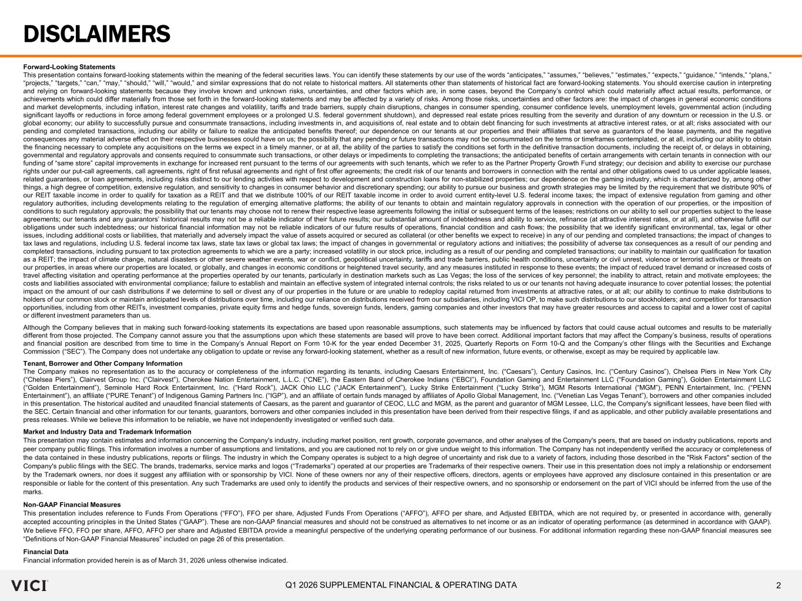
2Q1 2026 SUPPLEMENTAL FINANCIAL & OPERATING DATA Forward-Looking Statements This presentation contains forward-looking statements within the meaning of the federal securities laws. You can identify these statements by our use of the words “anticipates,” “assumes,” “believes,” “estimates,” “expects,” “guidance,” “intends,” “plans,” “projects,” “targets,” “can,” “may,” “should,” “will,” “would,” and similar expressions that do not relate to historical matters. All statements other than statements of historical fact are forward-looking statements. You should exercise caution in interpreting and relying on forward-looking statements because they involve known and unknown risks, uncertainties, and other factors which are, in some cases, beyond the Company’s control which could materially affect actual results, performance, or achievements which could differ materially from those set forth in the forward-looking statements and may be affected by a variety of risks. Among those risks, uncertainties and other factors are: the impact of changes in general economic conditions and market developments, including inflation, interest rate changes and volatility, tariffs and trade barriers, supply chain disruptions, changes in consumer spending, consumer confidence levels, unemployment levels, governmental action (including significant layoffs or reductions in force among federal government employees or a prolonged U.S. federal government shutdown), and depressed real estate prices resulting from the severity and duration of any downturn or recession in the U.S. or global economy; our ability to successfully pursue and consummate transactions, including investments in, and acquisitions of, real estate and to obtain debt financing for such investments at attractive interest rates, or at all; risks associated with our pending and completed transactions, including our ability or failure to realize the anticipated benefits thereof; our dependence on our tenants at our properties and their affiliates that serve as guarantors of the lease payments, and the negative consequences any material adverse effect on their respective businesses could have on us; the possibility that any pending or future transactions may not be consummated on the terms or timeframes contemplated, or at all, including our ability to obtain the financing necessary to complete any acquisitions on the terms we expect in a timely manner, or at all, the ability of the parties to satisfy the conditions set forth in the definitive transaction documents, including the receipt of, or delays in obtaining, governmental and regulatory approvals and consents required to consummate such transactions, or other delays or impediments to completing the transactions; the anticipated benefits of certain arrangements with certain tenants in connection with our funding of “same store” capital improvements in exchange for increased rent pursuant to the terms of our agreements with such tenants, which we refer to as the Partner Property Growth Fund strategy; our decision and ability to exercise our purchase rights under our put-call agreements, call agreements, right of first refusal agreements and right of first offer agreements; the credit risk of our tenants and borrowers in connection with the rental and other obligations owed to us under applicable leases, related guarantees, or loan agreements, including risks distinct to our lending activities with respect to development and construction loans for non-stabilized properties; our dependence on the gaming industry, which is characterized by, among other things, a high degree of competition, extensive regulation, and sensitivity to changes in consumer behavior and discretionary spending; our ability to pursue our business and growth strategies may be limited by the requirement that we distribute 90% of our REIT taxable income in order to qualify for taxation as a REIT and that we distribute 100% of our REIT taxable income in order to avoid current entity-level U.S. federal income taxes; the impact of extensive regulation from gaming and other regulatory authorities, including developments relating to the regulation of emerging alternative platforms; the ability of our tenants to obtain and maintain regulatory approvals in connection with the operation of our properties, or the imposition of conditions to such regulatory approvals; the possibility that our tenants may choose not to renew their respective lease agreements following the initial or subsequent terms of the leases; restrictions on our ability to sell our properties subject to the lease agreements; our tenants and any guarantors’ historical results may not be a reliable indicator of their future results; our substantial amount of indebtedness and ability to service, refinance (at attractive interest rates, or at all), and otherwise fulfill our obligations under such indebtedness; our historical financial information may not be reliable indicators of our future results of operations, financial condition and cash flows; the possibility that we identify significant environmental, tax, legal or other issues, including additional costs or liabilities, that materially and adversely impact the value of assets acquired or secured as collateral (or other benefits we expect to receive) in any of our pending and completed transactions; the impact of changes to tax laws and regulations, including U.S. federal income tax laws, state tax laws or global tax laws; the impact of changes in governmental or regulatory actions and initiatives; the possibility of adverse tax consequences as a result of our pending and completed transactions, including pursuant to tax protection agreements to which we are a party; increased volatility in our stock price, including as a result of our pending and completed transactions; our inability to maintain our qualification for taxation as a REIT; the impact of climate change, natural disasters or other severe weather events, war or conflict, geopolitical uncertainty, tariffs and trade barriers, public health conditions, uncertainty or civil unrest, violence or terrorist activities or threats on our properties, in areas where our properties are located, or globally, and changes in economic conditions or heightened travel security, and any measures instituted in response to these events; the impact of reduced travel demand or increased costs of travel affecting visitation and operating performance at the properties operated by our tenants, particularly in destination markets such as Las Vegas; the loss of the services of key personnel; the inability to attract, retain and motivate employees; the costs and liabilities associated with environmental compliance; failure to establish and maintain an effective system of integrated internal controls; the risks related to us or our tenants not having adequate insurance to cover potential losses; the potential impact on the amount of our cash distributions if we determine to sell or divest any of our properties in the future or are unable to redeploy capital returned from investments at attractive rates, or at all; our ability to continue to make distributions to holders of our common stock or maintain anticipated levels of distributions over time, including our reliance on distributions received from our subsidiaries, including VICI OP, to make such distributions to our stockholders; and competition for transaction opportunities, including from other REITs, investment companies, private equity firms and hedge funds, sovereign funds, lenders, gaming companies and other investors that may have greater resources and access to capital and a lower cost of capital or different investment parameters than us. Although the Company believes that in making such forward-looking statements its expectations are based upon reasonable assumptions, such statements may be influenced by factors that could cause actual outcomes and results to be materially different from those projected. The Company cannot assure you that the assumptions upon which these statements are based will prove to have been correct. Additional important factors that may affect the Company’s business, results of operations and financial position are described from time to time in the Company’s Annual Report on Form 10-K for the year ended December 31, 2025, Quarterly Reports on Form 10-Q and the Company’s other filings with the Securities and Exchange Commission (“SEC”). The Company does not undertake any obligation to update or revise any forward-looking statement, whether as a result of new information, future events, or otherwise, except as may be required by applicable law. Tenant, Borrower and Other Company Information The Company makes no representation as to the accuracy or completeness of the information regarding its tenants, including Caesars Entertainment, Inc. (“Caesars”), Century Casinos, Inc. (“Century Casinos”), Chelsea Piers in New York City (“Chelsea Piers”), Clairvest Group Inc. (“Clairvest”), Cherokee Nation Entertainment, L.L.C. (“CNE”), the Eastern Band of Cherokee Indians (“EBCI”), Foundation Gaming and Entertainment LLC (“Foundation Gaming”), Golden Entertainment LLC (“Golden Entertainment”), Seminole Hard Rock Entertainment, Inc. (“Hard Rock”), JACK Ohio LLC (“JACK Entertainment”), Lucky Strike Entertainment (“Lucky Strike”), MGM Resorts International (“MGM”), PENN Entertainment, Inc. (“PENN Entertainment”), an affiliate (“PURE Tenant”) of Indigenous Gaming Partners Inc. (“IGP”), and an affiliate of certain funds managed by affiliates of Apollo Global Management, Inc. (“Venetian Las Vegas Tenant”), borrowers and other companies included in this presentation. The historical audited and unaudited financial statements of Caesars, as the parent and guarantor of CEOC, LLC and MGM, as the parent and guarantor of MGM Lessee, LLC, the Company's significant lessees, have been filed with the SEC. Certain financial and other information for our tenants, guarantors, borrowers and other companies included in this presentation have been derived from their respective filings, if and as applicable, and other publicly available presentations and press releases. While we believe this information to be reliable, we have not independently investigated or verified such data. Market and Industry Data and Trademark Information This presentation may contain estimates and information concerning the Company's industry, including market position, rent growth, corporate governance, and other analyses of the Company's peers, that are based on industry publications, reports and peer company public filings. This information involves a number of assumptions and limitations, and you are cautioned not to rely on or give undue weight to this information. The Company has not independently verified the accuracy or completeness of the data contained in these industry publications, reports or filings. The industry in which the Company operates is subject to a high degree of uncertainty and risk due to a variety of factors, including those described in the "Risk Factors" section of the Company's public filings with the SEC. The brands, trademarks, service marks and logos (“Trademarks”) operated at our properties are Trademarks of their respective owners. Their use in this presentation does not imply a relationship or endorsement by the Trademark owners, nor does it suggest any affiliation with or sponsorship by VICI. None of these owners nor any of their respective officers, directors, agents or employees have approved any disclosure contained in this presentation or are responsible or liable for the content of this presentation. Any such Trademarks are used only to identify the products and services of their respective owners, and no sponsorship or endorsement on the part of VICI should be inferred from the use of the marks. Non‐GAAP Financial Measures This presentation includes reference to Funds From Operations (“FFO”), FFO per share, Adjusted Funds From Operations (“AFFO”), AFFO per share, and Adjusted EBITDA, which are not required by, or presented in accordance with, generally accepted accounting principles in the United States (“GAAP”). These are non-GAAP financial measures and should not be construed as alternatives to net income or as an indicator of operating performance (as determined in accordance with GAAP). We believe FFO, FFO per share, AFFO, AFFO per share and Adjusted EBITDA provide a meaningful perspective of the underlying operating performance of our business. For additional information regarding these non-GAAP financial measures see “Definitions of Non-GAAP Financial Measures” included on page 26 of this presentation. Financial Data Financial information provided herein is as of March 31, 2026 unless otherwise indicated. DISCLAIMERS

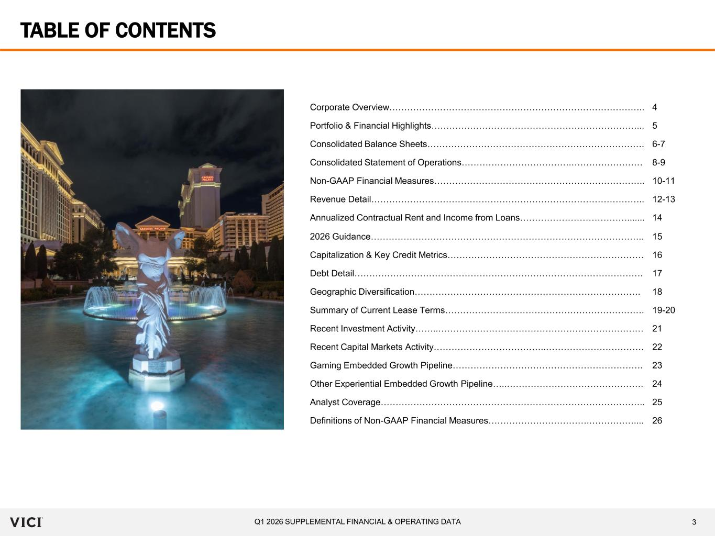
3Q1 2026 SUPPLEMENTAL FINANCIAL & OPERATING DATA TABLE OF CONTENTS Corporate Overview………………………………………………………………………….. 4 Portfolio & Financial Highlights……………………………………………………………... 5 Consolidated Balance Sheets………………………………………………………………. 6-7 Consolidated Statement of Operations……………………………….…………………… 8-9 Non-GAAP Financial Measures…………………………………………………………….. 10-11 Revenue Detail……………………………………………………………………………….. 12-13 Annualized Contractual Rent and Income from Loans………………………………....... 14 2026 Guidance……………………………………………………………………………….. 15 Capitalization & Key Credit Metrics………………………………………………………… 16 Debt Detail……………………………………………………………………………………. 17 Geographic Diversification…………………………………………………………………. 18 Summary of Current Lease Terms…………………………………………………………. 19-20 Recent Investment Activity……..…………………………………………………………… 21 Recent Capital Markets Activity………………………………..…………………………… 22 Gaming Embedded Growth Pipeline………………………………………………………. 23 Other Experiential Embedded Growth Pipeline…..………………………………………. 24 Analyst Coverage…………………………………………………………………………….. 25 Definitions of Non-GAAP Financial Measures…………………………….…………….... 26

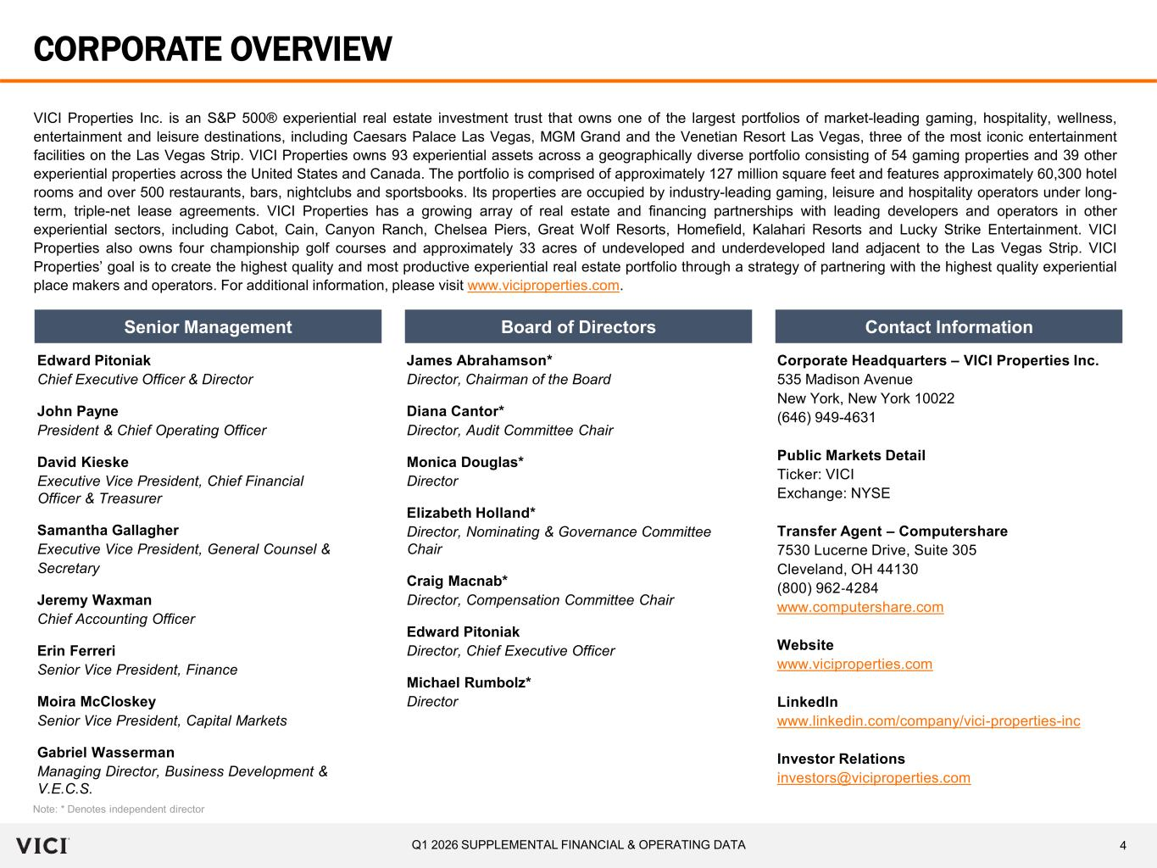
4Q1 2026 SUPPLEMENTAL FINANCIAL & OPERATING DATA CORPORATE OVERVIEW VICI Properties Inc. is an S&P 500® experiential real estate investment trust that owns one of the largest portfolios of market-leading gaming, hospitality, wellness, entertainment and leisure destinations, including Caesars Palace Las Vegas, MGM Grand and the Venetian Resort Las Vegas, three of the most iconic entertainment facilities on the Las Vegas Strip. VICI Properties owns 93 experiential assets across a geographically diverse portfolio consisting of 54 gaming properties and 39 other experiential properties across the United States and Canada. The portfolio is comprised of approximately 127 million square feet and features approximately 60,300 hotel rooms and over 500 restaurants, bars, nightclubs and sportsbooks. Its properties are occupied by industry-leading gaming, leisure and hospitality operators under long- term, triple-net lease agreements. VICI Properties has a growing array of real estate and financing partnerships with leading developers and operators in other experiential sectors, including Cabot, Cain, Canyon Ranch, Chelsea Piers, Great Wolf Resorts, Homefield, Kalahari Resorts and Lucky Strike Entertainment. VICI Properties also owns four championship golf courses and approximately 33 acres of undeveloped and underdeveloped land adjacent to the Las Vegas Strip. VICI Properties’ goal is to create the highest quality and most productive experiential real estate portfolio through a strategy of partnering with the highest quality experiential place makers and operators. For additional information, please visit www.viciproperties.com. Senior Management Board of Directors Contact Information Edward Pitoniak Chief Executive Officer & Director John Payne President & Chief Operating Officer David Kieske Executive Vice President, Chief Financial Officer & Treasurer Samantha Gallagher Executive Vice President, General Counsel & Secretary Jeremy Waxman Chief Accounting Officer Erin Ferreri Senior Vice President, Finance Moira McCloskey Senior Vice President, Capital Markets Gabriel Wasserman Managing Director, Business Development & V.E.C.S. James Abrahamson* Director, Chairman of the Board Diana Cantor* Director, Audit Committee Chair Monica Douglas* Director Elizabeth Holland* Director, Nominating & Governance Committee Chair Craig Macnab* Director, Compensation Committee Chair Edward Pitoniak Director, Chief Executive Officer Michael Rumbolz* Director Note: * Denotes independent director Corporate Headquarters – VICI Properties Inc. 535 Madison Avenue New York, New York 10022 (646) 949-4631 Public Markets Detail Ticker: VICI Exchange: NYSE Transfer Agent – Computershare 7530 Lucerne Drive, Suite 305 Cleveland, OH 44130 (800) 962‐4284 www.computershare.com Website www.viciproperties.com LinkedIn www.linkedin.com/company/vici-properties-inc Investor Relations investors@viciproperties.com

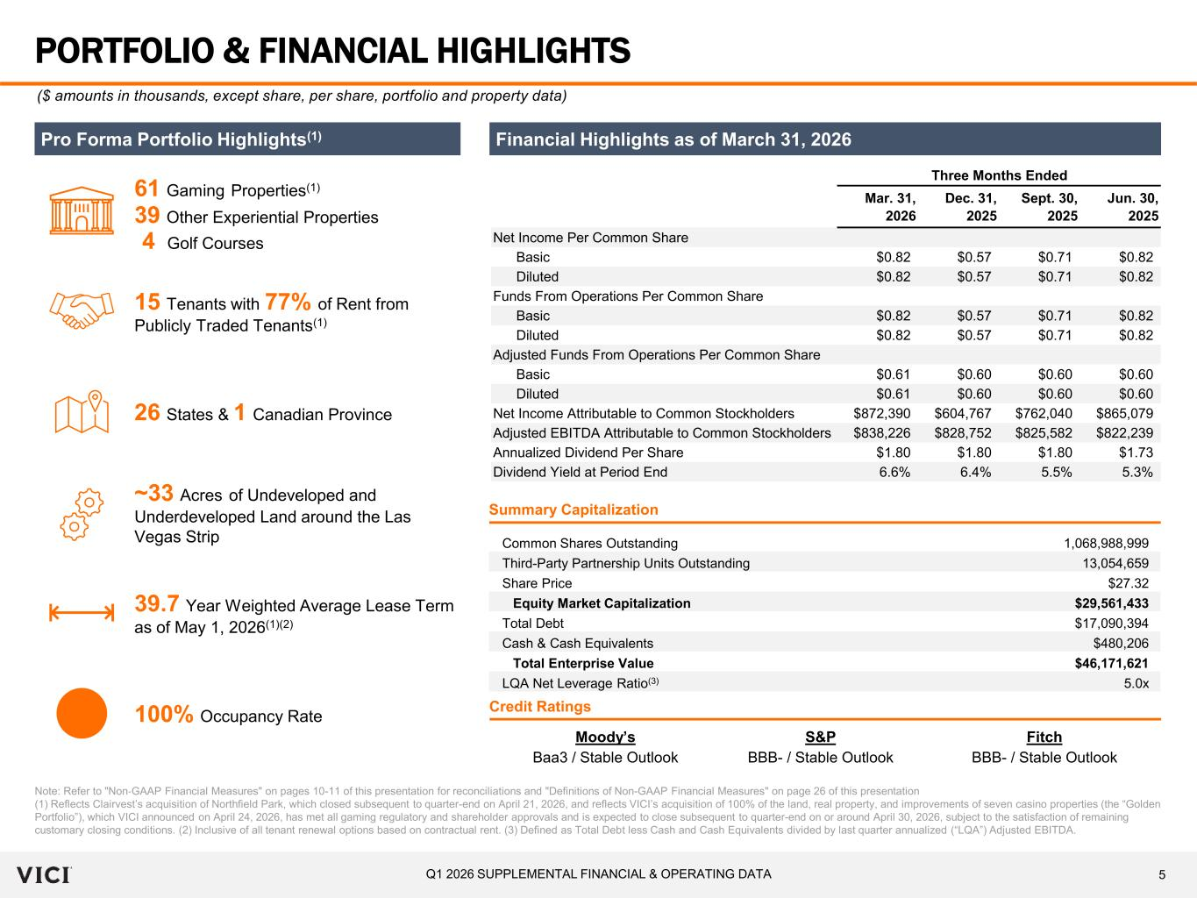
5Q1 2026 SUPPLEMENTAL FINANCIAL & OPERATING DATA Three Months Ended Mar. 31, 2026 Dec. 31, 2025 Sept. 30, 2025 Jun. 30, 2025 Net Income Per Common Share Basic $0.82 $0.57 $0.71 $0.82 Diluted $0.82 $0.57 $0.71 $0.82 Funds From Operations Per Common Share Basic $0.82 $0.57 $0.71 $0.82 Diluted $0.82 $0.57 $0.71 $0.82 Adjusted Funds From Operations Per Common Share Basic $0.61 $0.60 $0.60 $0.60 Diluted $0.61 $0.60 $0.60 $0.60 Net Income Attributable to Common Stockholders $872,390 $604,767 $762,040 $865,079 Adjusted EBITDA Attributable to Common Stockholders $838,226 $828,752 $825,582 $822,239 Annualized Dividend Per Share $1.80 $1.80 $1.80 $1.73 Dividend Yield at Period End 6.6% 6.4% 5.5% 5.3% PORTFOLIO & FINANCIAL HIGHLIGHTS Note: Refer to "Non‐GAAP Financial Measures" on pages 10-11 of this presentation for reconciliations and "Definitions of Non-GAAP Financial Measures" on page 26 of this presentation (1) Reflects Clairvest’s acquisition of Northfield Park, which closed subsequent to quarter-end on April 21, 2026, and reflects VICI’s acquisition of 100% of the land, real property, and improvements of seven casino properties (the “Golden Portfolio”), which VICI announced on April 24, 2026, has met all gaming regulatory and shareholder approvals and is expected to close subsequent to quarter-end on or around April 30, 2026, subject to the satisfaction of remaining customary closing conditions. (2) Inclusive of all tenant renewal options based on contractual rent. (3) Defined as Total Debt less Cash and Cash Equivalents divided by last quarter annualized (“LQA”) Adjusted EBITDA. ($ amounts in thousands, except share, per share, portfolio and property data) Financial Highlights as of March 31, 2026 Common Shares Outstanding 1,068,988,999 Third-Party Partnership Units Outstanding 13,054,659 Share Price $27.32 Equity Market Capitalization $29,561,433 Total Debt $17,090,394 Cash & Cash Equivalents $480,206 Total Enterprise Value $46,171,621 LQA Net Leverage Ratio(3) 5.0x Summary Capitalization Pro Forma Portfolio Highlights(1) 61 Gaming Properties(1) ~33 Acres of Undeveloped and Underdeveloped Land around the Las Vegas Strip 26 States & 1 Canadian Province 39.7 Year Weighted Average Lease Term as of May 1, 2026(1)(2) 100% Occupancy Rate 15 Tenants with 77% of Rent from Publicly Traded Tenants(1) Moody’s S&P Fitch Baa3 / Stable Outlook BBB- / Stable Outlook BBB- / Stable Outlook Credit Ratings 39 Other Experiential Properties 4 Golf Courses

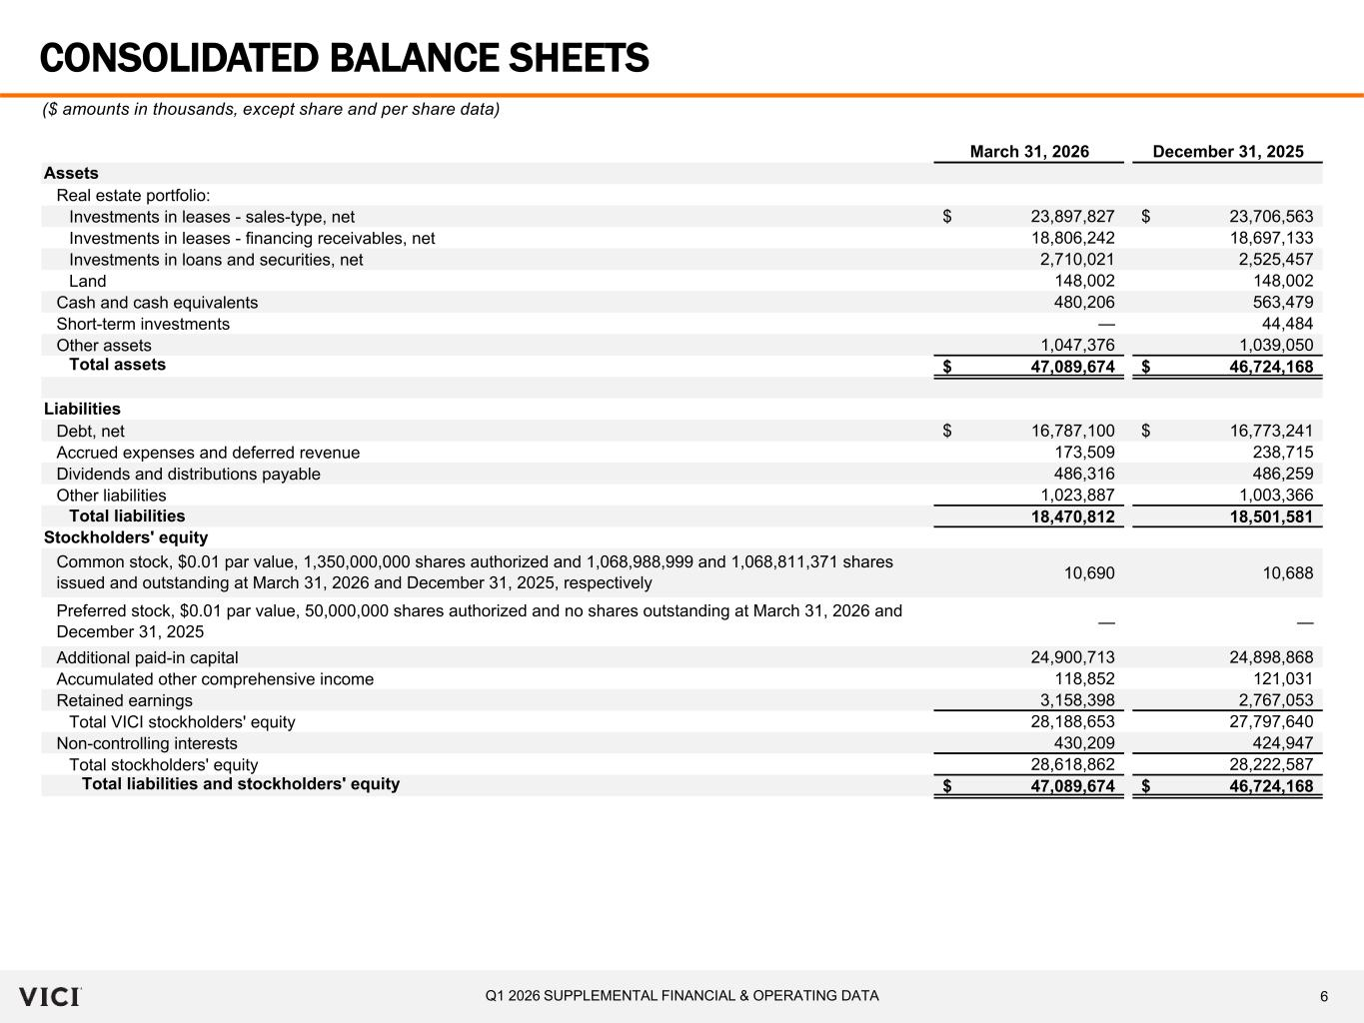
6Q1 2026 SUPPLEMENTAL FINANCIAL & OPERATING DATA March 31, 2026 December 31, 2025 Assets Real estate portfolio: Investments in leases - sales-type, net 23,897,827$ 23,706,563$ Investments in leases - financing receivables, net 18,806,242 18,697,133 Investments in loans and securities, net 2,710,021 2,525,457 Land 148,002 148,002 Cash and cash equivalents 480,206 563,479 Short-term investments — 44,484 Other assets 1,047,376 1,039,050 Total assets 47,089,674$ 46,724,168$ Liabilities Debt, net 16,787,100$ 16,773,241$ Accrued expenses and deferred revenue 173,509 238,715 Dividends and distributions payable 486,316 486,259 Other liabilities 1,023,887 1,003,366 Total liabilities 18,470,812 18,501,581 Stockholders' equity 10,690 10,688 — — Additional paid-in capital 24,900,713 24,898,868 Accumulated other comprehensive income 118,852 121,031 Retained earnings 3,158,398 2,767,053 Total VICI stockholders' equity 28,188,653 27,797,640 Non-controlling interests 430,209 424,947 Total stockholders' equity 28,618,862 28,222,587 Total liabilities and stockholders' equity 47,089,674$ 46,724,168$ Common stock, $0.01 par value, 1,350,000,000 shares authorized and 1,068,988,999 and 1,068,811,371 shares issued and outstanding at March 31, 2026 and December 31, 2025, respectively Preferred stock, $0.01 par value, 50,000,000 shares authorized and no shares outstanding at March 31, 2026 and December 31, 2025 CONSOLIDATED BALANCE SHEETS ($ amounts in thousands, except share and per share data)

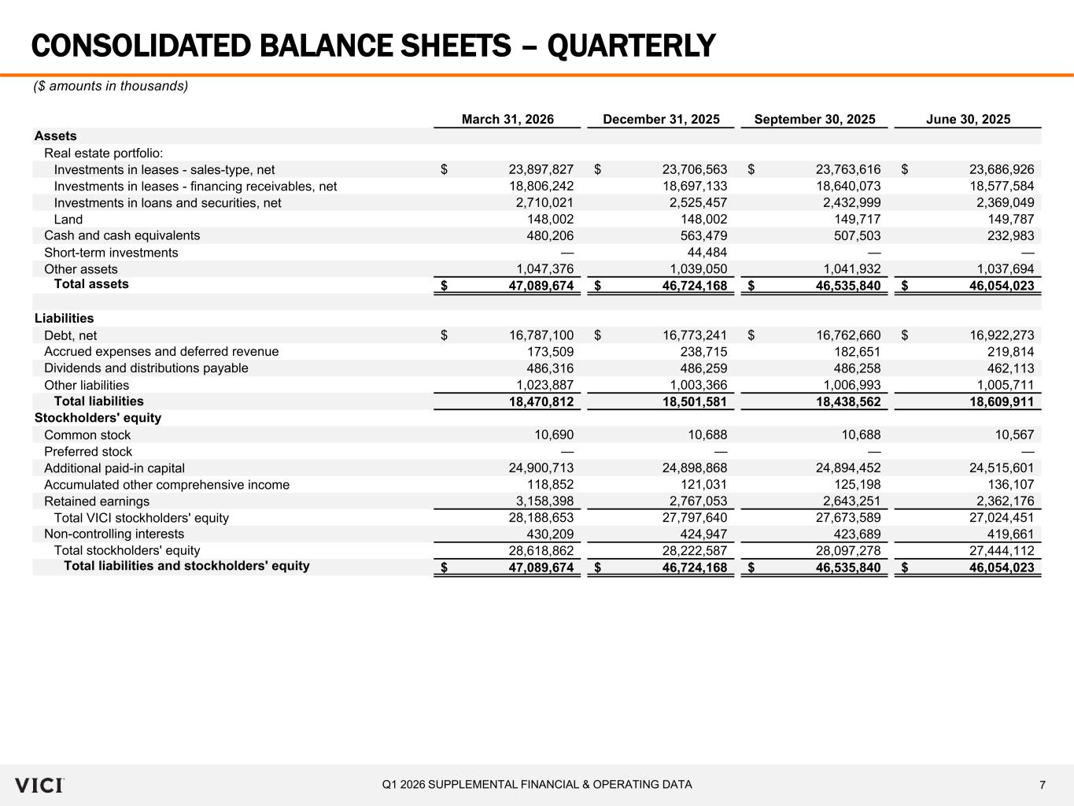
7Q1 2026 SUPPLEMENTAL FINANCIAL & OPERATING DATA March 31, 2026 December 31, 2025 September 30, 2025 June 30, 2025 Assets Real estate portfolio: Investments in leases - sales-type, net 23,897,827$ 23,706,563$ 23,763,616$ 23,686,926$ Investments in leases - financing receivables, net 18,806,242 18,697,133 18,640,073 18,577,584 Investments in loans and securities, net 2,710,021 2,525,457 2,432,999 2,369,049 Land 148,002 148,002 149,717 149,787 Cash and cash equivalents 480,206 563,479 507,503 232,983 Short-term investments — 44,484 — — Other assets 1,047,376 1,039,050 1,041,932 1,037,694 Total assets 47,089,674$ 46,724,168$ 46,535,840$ 46,054,023$ Liabilities Debt, net 16,787,100$ 16,773,241$ 16,762,660$ 16,922,273$ Accrued expenses and deferred revenue 173,509 238,715 182,651 219,814 Dividends and distributions payable 486,316 486,259 486,258 462,113 Other liabilities 1,023,887 1,003,366 1,006,993 1,005,711 Total liabilities 18,470,812 18,501,581 18,438,562 18,609,911 Stockholders' equity Common stock 10,690 10,688 10,688 10,567 Preferred stock — — — — Additional paid-in capital 24,900,713 24,898,868 24,894,452 24,515,601 Accumulated other comprehensive income 118,852 121,031 125,198 136,107 Retained earnings 3,158,398 2,767,053 2,643,251 2,362,176 Total VICI stockholders' equity 28,188,653 27,797,640 27,673,589 27,024,451 Non-controlling interests 430,209 424,947 423,689 419,661 Total stockholders' equity 28,618,862 28,222,587 28,097,278 27,444,112 Total liabilities and stockholders' equity 47,089,674$ 46,724,168$ 46,535,840$ 46,054,023$ CONSOLIDATED BALANCE SHEETS – QUARTERLY ($ amounts in thousands)

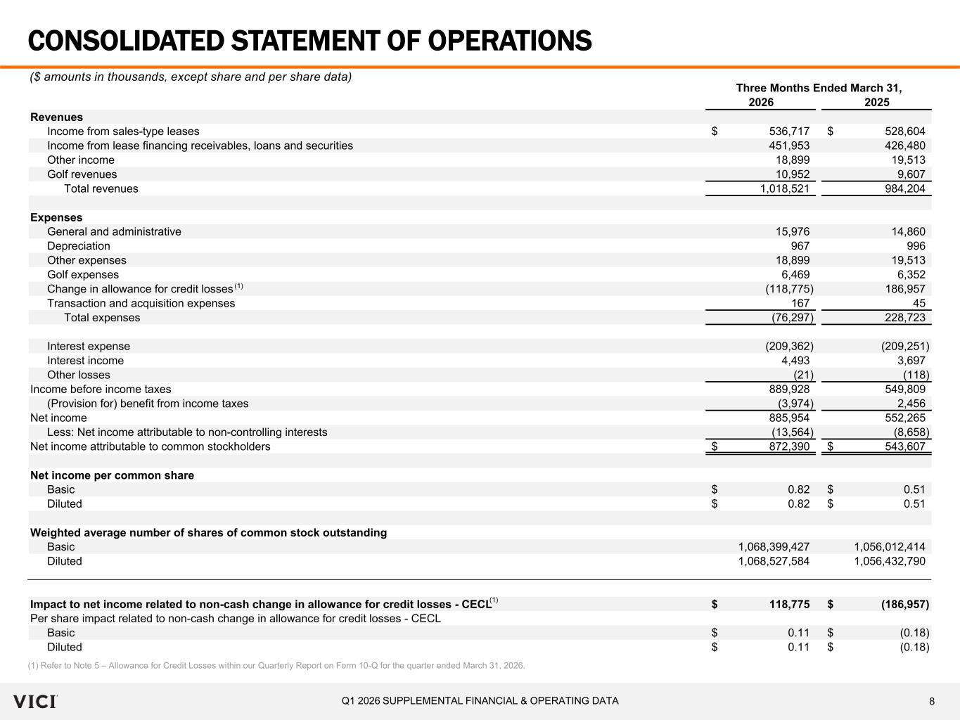
8Q1 2026 SUPPLEMENTAL FINANCIAL & OPERATING DATA Three Months Ended March 31, 2026 2025 Revenues Income from sales-type leases 536,717$ 528,604$ Income from lease financing receivables, loans and securities 451,953 426,480 Other income 18,899 19,513 Golf revenues 10,952 9,607 Total revenues 1,018,521 984,204 Expenses General and administrative 15,976 14,860 Depreciation 967 996 Other expenses 18,899 19,513 Golf expenses 6,469 6,352 Change in allowance for credit losses (118,775) 186,957 Transaction and acquisition expenses 167 45 Total expenses (76,297) 228,723 Interest expense (209,362) (209,251) Interest income 4,493 3,697 Other losses (21) (118) Income before income taxes 889,928 549,809 (Provision for) benefit from income taxes (3,974) 2,456 Net income 885,954 552,265 Less: Net income attributable to non-controlling interests (13,564) (8,658) Net income attributable to common stockholders 872,390$ 543,607$ Net income per common share Basic 0.82$ 0.51$ Diluted 0.82$ 0.51$ Weighted average number of shares of common stock outstanding Basic 1,068,399,427 1,056,012,414 Diluted 1,068,527,584 1,056,432,790 Impact to net income related to non-cash change in allowance for credit losses - CECL 118,775$ (186,957)$ Per share impact related to non-cash change in allowance for credit losses - CECL Basic 0.11$ (0.18)$ Diluted 0.11$ (0.18)$ CONSOLIDATED STATEMENT OF OPERATIONS ($ amounts in thousands, except share and per share data) (1) Refer to Note 5 – Allowance for Credit Losses within our Quarterly Report on Form 10-Q for the quarter ended March 31, 2026. (1) (1)

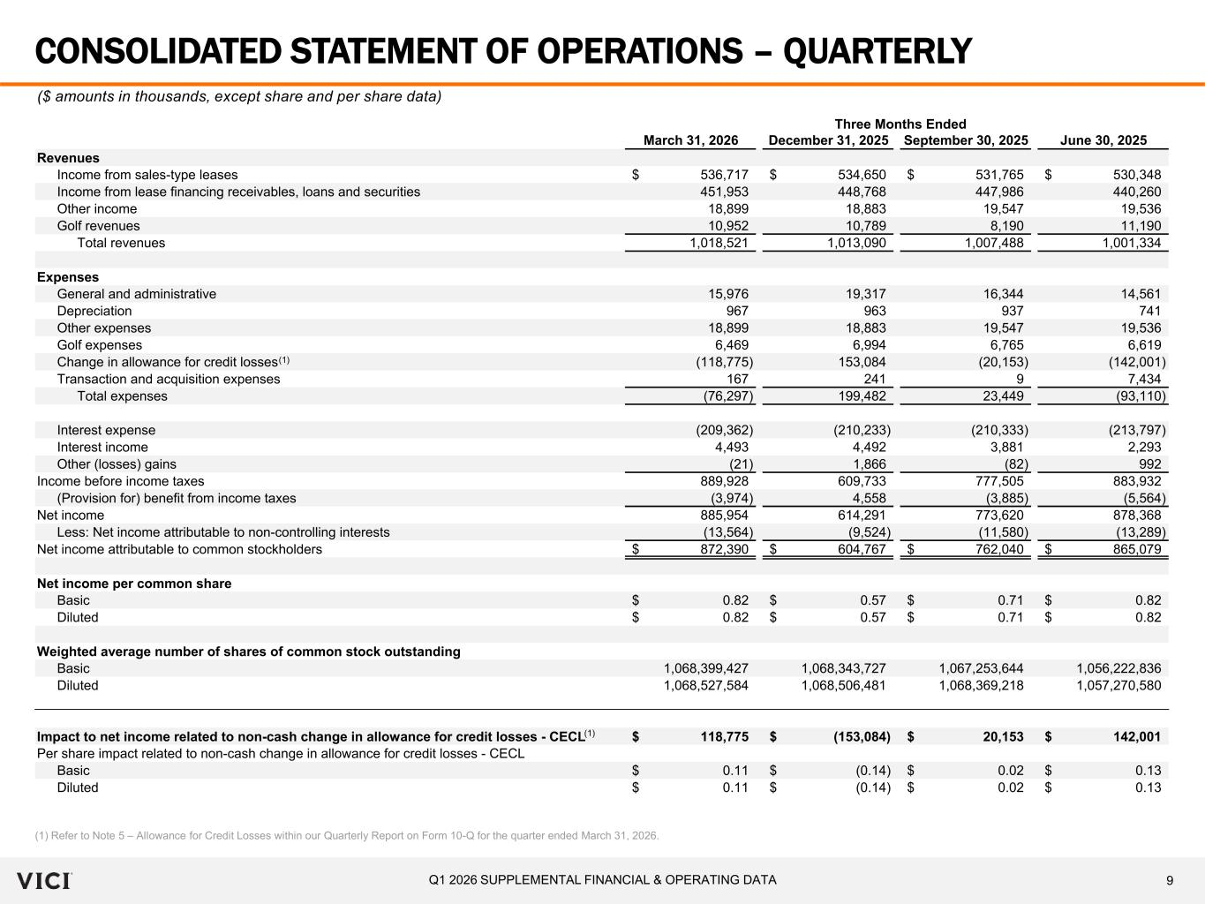
9Q1 2026 SUPPLEMENTAL FINANCIAL & OPERATING DATA Three Months Ended March 31, 2026 December 31, 2025 September 30, 2025 June 30, 2025 Revenues Income from sales-type leases 536,717$ 534,650$ 531,765$ 530,348$ Income from lease financing receivables, loans and securities 451,953 448,768 447,986 440,260 Other income 18,899 18,883 19,547 19,536 Golf revenues 10,952 10,789 8,190 11,190 Total revenues 1,018,521 1,013,090 1,007,488 1,001,334 Expenses General and administrative 15,976 19,317 16,344 14,561 Depreciation 967 963 937 741 Other expenses 18,899 18,883 19,547 19,536 Golf expenses 6,469 6,994 6,765 6,619 Change in allowance for credit losses (118,775) 153,084 (20,153) (142,001) Transaction and acquisition expenses 167 241 9 7,434 Total expenses (76,297) 199,482 23,449 (93,110) Interest expense (209,362) (210,233) (210,333) (213,797) Interest income 4,493 4,492 3,881 2,293 Other (losses) gains (21) 1,866 (82) 992 Income before income taxes 889,928 609,733 777,505 883,932 (Provision for) benefit from income taxes (3,974) 4,558 (3,885) (5,564) Net income 885,954 614,291 773,620 878,368 Less: Net income attributable to non-controlling interests (13,564) (9,524) (11,580) (13,289) Net income attributable to common stockholders 872,390$ 604,767$ 762,040$ 865,079$ Net income per common share Basic 0.82$ 0.57$ 0.71$ 0.82$ Diluted 0.82$ 0.57$ 0.71$ 0.82$ Weighted average number of shares of common stock outstanding Basic 1,068,399,427 1,068,343,727 1,067,253,644 1,056,222,836 Diluted 1,068,527,584 1,068,506,481 1,068,369,218 1,057,270,580 Impact to net income related to non-cash change in allowance for credit losses - CECL 118,775$ (153,084)$ 20,153$ 142,001$ Per share impact related to non-cash change in allowance for credit losses - CECL Basic 0.11$ (0.14)$ 0.02$ 0.13$ Diluted 0.11$ (0.14)$ 0.02$ 0.13$ CONSOLIDATED STATEMENT OF OPERATIONS – QUARTERLY ($ amounts in thousands, except share and per share data) (1) (1) (1) Refer to Note 5 – Allowance for Credit Losses within our Quarterly Report on Form 10-Q for the quarter ended March 31, 2026.

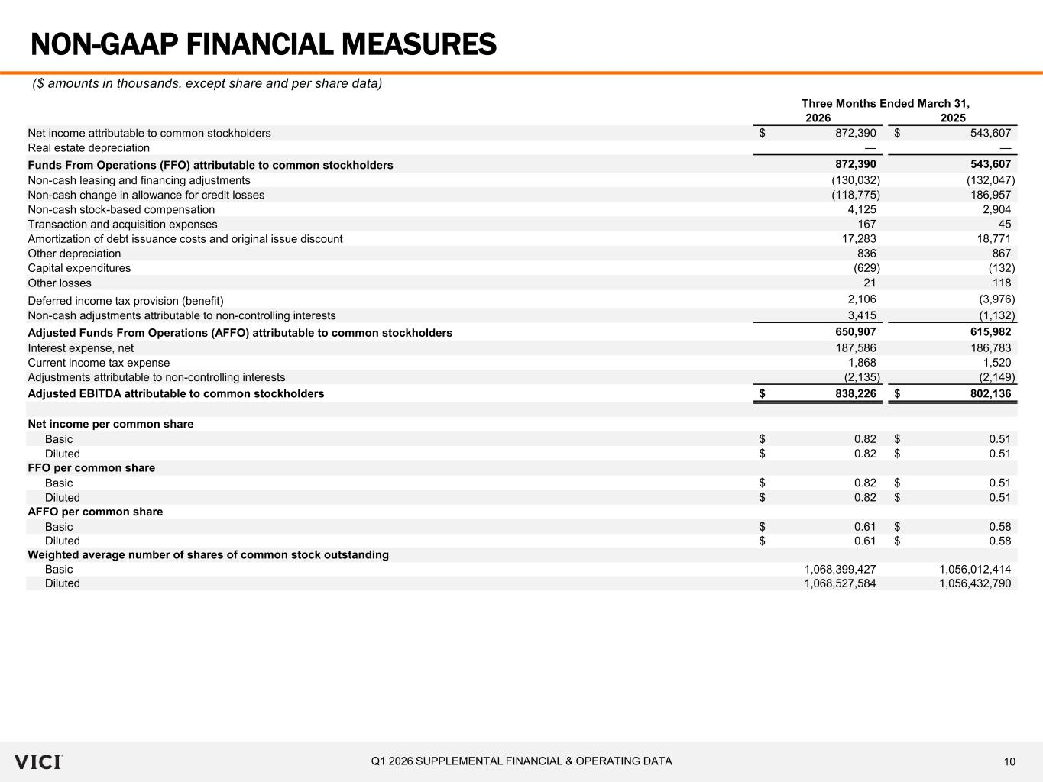
10Q1 2026 SUPPLEMENTAL FINANCIAL & OPERATING DATA Three Months Ended March 31, 2026 2025 Net income attributable to common stockholders 872,390$ 543,607$ Real estate depreciation — — Funds From Operations (FFO) attributable to common stockholders 872,390 543,607 Non-cash leasing and financing adjustments (130,032) (132,047) Non-cash change in allowance for credit losses (118,775) 186,957 Non-cash stock-based compensation 4,125 2,904 Transaction and acquisition expenses 167 45 Amortization of debt issuance costs and original issue discount 17,283 18,771 Other depreciation 836 867 Capital expenditures (629) (132) Other losses 21 118 Deferred income tax provision (benefit) 2,106 (3,976) Non-cash adjustments attributable to non-controlling interests 3,415 (1,132) Adjusted Funds From Operations (AFFO) attributable to common stockholders 650,907 615,982 Interest expense, net 187,586 186,783 Current income tax expense 1,868 1,520 Adjustments attributable to non-controlling interests (2,135) (2,149) Adjusted EBITDA attributable to common stockholders 838,226$ 802,136$ Net income per common share Basic 0.82$ 0.51$ Diluted 0.82$ 0.51$ FFO per common share Basic 0.82$ 0.51$ Diluted 0.82$ 0.51$ AFFO per common share Basic 0.61$ 0.58$ Diluted 0.61$ 0.58$ Weighted average number of shares of common stock outstanding Basic 1,068,399,427 1,056,012,414 Diluted 1,068,527,584 1,056,432,790 NON-GAAP FINANCIAL MEASURES ($ amounts in thousands, except share and per share data)

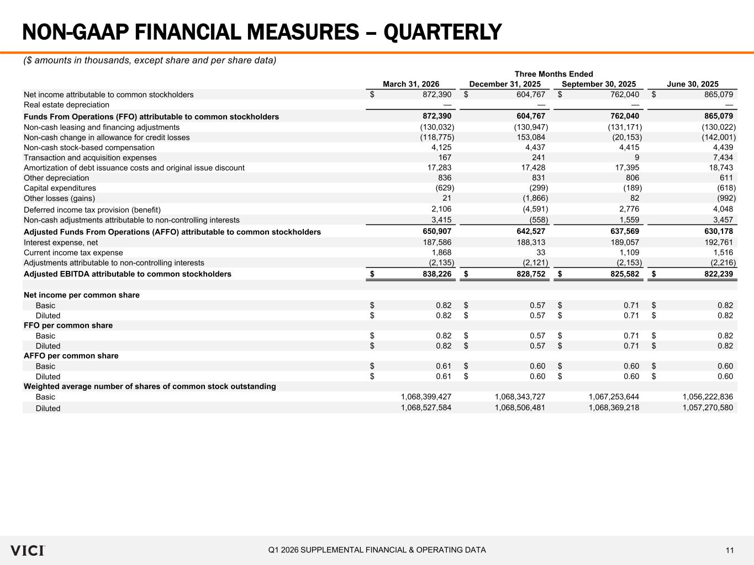
11Q1 2026 SUPPLEMENTAL FINANCIAL & OPERATING DATA Three Months Ended March 31, 2026 December 31, 2025 September 30, 2025 June 30, 2025 Net income attributable to common stockholders 872,390$ 604,767$ 762,040$ 865,079$ Real estate depreciation — — — — Funds From Operations (FFO) attributable to common stockholders 872,390 604,767 762,040 865,079 Non-cash leasing and financing adjustments (130,032) (130,947) (131,171) (130,022) Non-cash change in allowance for credit losses (118,775) 153,084 (20,153) (142,001) Non-cash stock-based compensation 4,125 4,437 4,415 4,439 Transaction and acquisition expenses 167 241 9 7,434 Amortization of debt issuance costs and original issue discount 17,283 17,428 17,395 18,743 Other depreciation 836 831 806 611 Capital expenditures (629) (299) (189) (618) Other losses (gains) 21 (1,866) 82 (992) Deferred income tax provision (benefit) 2,106 (4,591) 2,776 4,048 Non-cash adjustments attributable to non-controlling interests 3,415 (558) 1,559 3,457 Adjusted Funds From Operations (AFFO) attributable to common stockholders 650,907 642,527 637,569 630,178 Interest expense, net 187,586 188,313 189,057 192,761 Current income tax expense 1,868 33 1,109 1,516 Adjustments attributable to non-controlling interests (2,135) (2,121) (2,153) (2,216) Adjusted EBITDA attributable to common stockholders 838,226$ 828,752$ 825,582$ 822,239$ Net income per common share Basic 0.82$ 0.57$ 0.71$ 0.82$ Diluted 0.82$ 0.57$ 0.71$ 0.82$ FFO per common share Basic 0.82$ 0.57$ 0.71$ 0.82$ Diluted 0.82$ 0.57$ 0.71$ 0.82$ AFFO per common share Basic 0.61$ 0.60$ 0.60$ 0.60$ Diluted 0.61$ 0.60$ 0.60$ 0.60$ Weighted average number of shares of common stock outstanding Basic 1,068,399,427 1,068,343,727 1,067,253,644 1,056,222,836 Diluted 1,068,527,584 1,068,506,481 1,068,369,218 1,057,270,580 NON-GAAP FINANCIAL MEASURES – QUARTERLY ($ amounts in thousands, except share and per share data)

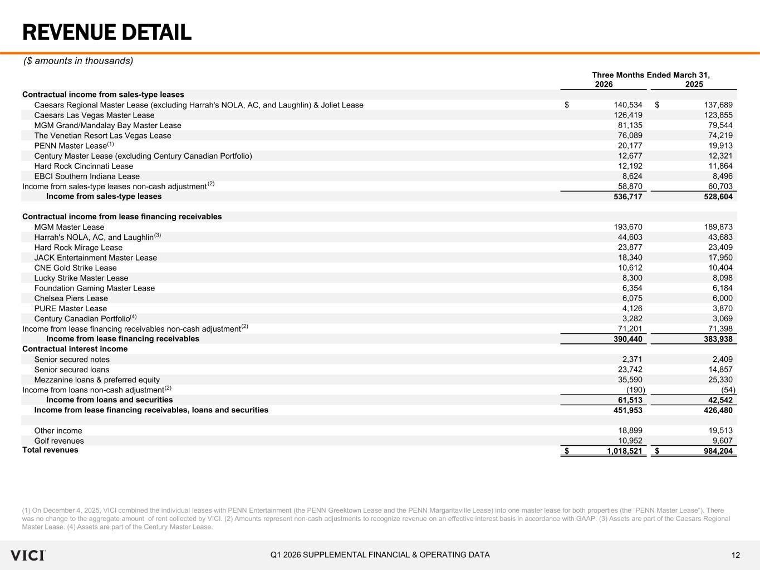
12Q1 2026 SUPPLEMENTAL FINANCIAL & OPERATING DATA Three Months Ended March 31, 2026 2025 Contractual income from sales-type leases Caesars Regional Master Lease (excluding Harrah's NOLA, AC, and Laughlin) & Joliet Lease 140,534$ 137,689$ Caesars Las Vegas Master Lease 126,419 123,855 MGM Grand/Mandalay Bay Master Lease 81,135 79,544 The Venetian Resort Las Vegas Lease 76,089 74,219 PENN Master Lease 20,177 19,913 Century Master Lease (excluding Century Canadian Portfolio) 12,677 12,321 Hard Rock Cincinnati Lease 12,192 11,864 EBCI Southern Indiana Lease 8,624 8,496 Income from sales-type leases non-cash adjustment 58,870 60,703 Income from sales-type leases 536,717 528,604 Contractual income from lease financing receivables MGM Master Lease 193,670 189,873 Harrah's NOLA, AC, and Laughlin 44,603 43,683 Hard Rock Mirage Lease 23,877 23,409 JACK Entertainment Master Lease 18,340 17,950 CNE Gold Strike Lease 10,612 10,404 Lucky Strike Master Lease 8,300 8,098 Foundation Gaming Master Lease 6,354 6,184 Chelsea Piers Lease 6,075 6,000 PURE Master Lease 4,126 3,870 Century Canadian Portfolio 3,282 3,069 Income from lease financing receivables non-cash adjustment 71,201 71,398 Income from lease financing receivables 390,440 383,938 Contractual interest income Senior secured notes 2,371 2,409 Senior secured loans 23,742 14,857 Mezzanine loans & preferred equity 35,590 25,330 Income from loans non-cash adjustment (190) (54) Income from loans and securities 61,513 42,542 Income from lease financing receivables, loans and securities 451,953 426,480 Other income 18,899 19,513 Golf revenues 10,952 9,607 Total revenues 1,018,521$ 984,204$ REVENUE DETAIL (1) On December 4, 2025, VICI combined the individual leases with PENN Entertainment (the PENN Greektown Lease and the PENN Margaritaville Lease) into one master lease for both properties (the “PENN Master Lease”). There was no change to the aggregate amount of rent collected by VICI. (2) Amounts represent non-cash adjustments to recognize revenue on an effective interest basis in accordance with GAAP. (3) Assets are part of the Caesars Regional Master Lease. (4) Assets are part of the Century Master Lease. ($ amounts in thousands) (2) (2) (2) (3) (4) (1)

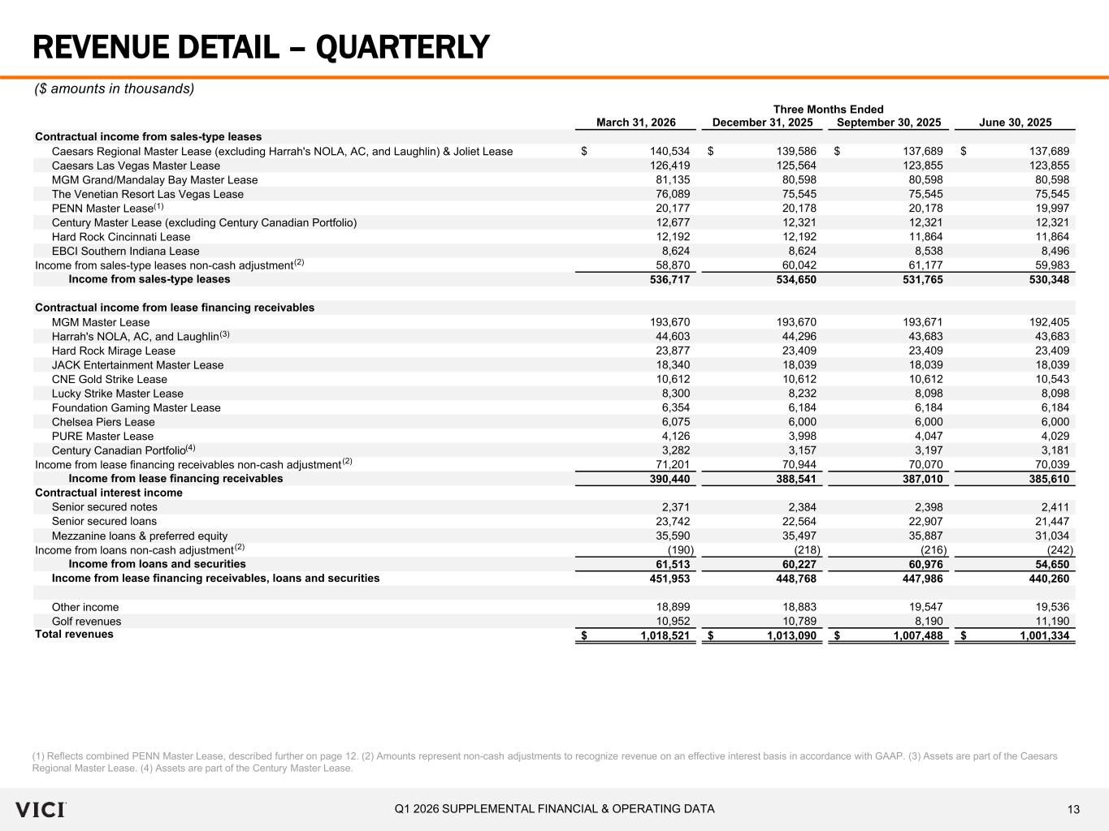
13Q1 2026 SUPPLEMENTAL FINANCIAL & OPERATING DATA Three Months Ended March 31, 2026 December 31, 2025 September 30, 2025 June 30, 2025 Contractual income from sales-type leases Caesars Regional Master Lease (excluding Harrah's NOLA, AC, and Laughlin) & Joliet Lease 140,534$ 139,586$ 137,689$ 137,689$ Caesars Las Vegas Master Lease 126,419 125,564 123,855 123,855 MGM Grand/Mandalay Bay Master Lease 81,135 80,598 80,598 80,598 The Venetian Resort Las Vegas Lease 76,089 75,545 75,545 75,545 PENN Master Lease 20,177 20,178 20,178 19,997 Century Master Lease (excluding Century Canadian Portfolio) 12,677 12,321 12,321 12,321 Hard Rock Cincinnati Lease 12,192 12,192 11,864 11,864 EBCI Southern Indiana Lease 8,624 8,624 8,538 8,496 Income from sales-type leases non-cash adjustment 58,870 60,042 61,177 59,983 Income from sales-type leases 536,717 534,650 531,765 530,348 Contractual income from lease financing receivables MGM Master Lease 193,670 193,670 193,671 192,405 Harrah's NOLA, AC, and Laughlin 44,603 44,296 43,683 43,683 Hard Rock Mirage Lease 23,877 23,409 23,409 23,409 JACK Entertainment Master Lease 18,340 18,039 18,039 18,039 CNE Gold Strike Lease 10,612 10,612 10,612 10,543 Lucky Strike Master Lease 8,300 8,232 8,098 8,098 Foundation Gaming Master Lease 6,354 6,184 6,184 6,184 Chelsea Piers Lease 6,075 6,000 6,000 6,000 PURE Master Lease 4,126 3,998 4,047 4,029 Century Canadian Portfolio 3,282 3,157 3,197 3,181 Income from lease financing receivables non-cash adjustment 71,201 70,944 70,070 70,039 Income from lease financing receivables 390,440 388,541 387,010 385,610 Contractual interest income Senior secured notes 2,371 2,384 2,398 2,411 Senior secured loans 23,742 22,564 22,907 21,447 Mezzanine loans & preferred equity 35,590 35,497 35,887 31,034 Income from loans non-cash adjustment (190) (218) (216) (242) Income from loans and securities 61,513 60,227 60,976 54,650 Income from lease financing receivables, loans and securities 451,953 448,768 447,986 440,260 Other income 18,899 18,883 19,547 19,536 Golf revenues 10,952 10,789 8,190 11,190 Total revenues 1,018,521$ 1,013,090$ 1,007,488$ 1,001,334$ REVENUE DETAIL – QUARTERLY ($ amounts in thousands) (1) Reflects combined PENN Master Lease, described further on page 12. (2) Amounts represent non-cash adjustments to recognize revenue on an effective interest basis in accordance with GAAP. (3) Assets are part of the Caesars Regional Master Lease. (4) Assets are part of the Century Master Lease. (2) (2) (2) (3) (4) (1)

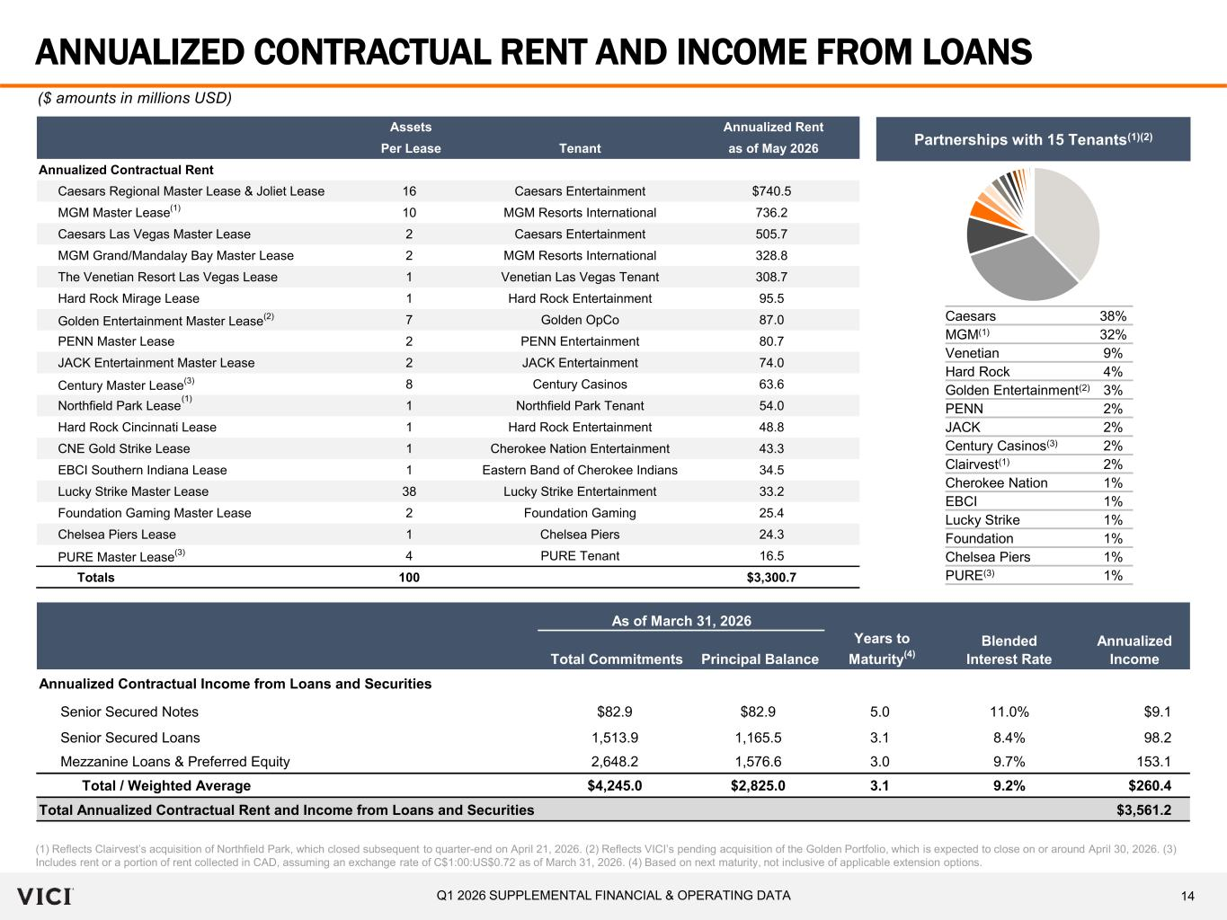
14Q1 2026 SUPPLEMENTAL FINANCIAL & OPERATING DATA Assets Annualized Rent Per Lease Tenant as of May 2026 Annualized Contractual Rent Caesars Regional Master Lease & Joliet Lease 16 Caesars Entertainment $740.5 MGM Master Lease 10 MGM Resorts International 736.2 Caesars Las Vegas Master Lease 2 Caesars Entertainment 505.7 MGM Grand/Mandalay Bay Master Lease 2 MGM Resorts International 328.8 The Venetian Resort Las Vegas Lease 1 Venetian Las Vegas Tenant 308.7 Hard Rock Mirage Lease 1 Hard Rock Entertainment 95.5 Golden Entertainment Master Lease (2) 7 Golden OpCo 87.0 PENN Master Lease 2 PENN Entertainment 80.7 JACK Entertainment Master Lease 2 JACK Entertainment 74.0 Century Master Lease (3) 8 Century Casinos 63.6 Northfield Park Lease 1 Northfield Park Tenant 54.0 Hard Rock Cincinnati Lease 1 Hard Rock Entertainment 48.8 CNE Gold Strike Lease 1 Cherokee Nation Entertainment 43.3 EBCI Southern Indiana Lease 1 Eastern Band of Cherokee Indians 34.5 Lucky Strike Master Lease 38 Lucky Strike Entertainment 33.2 Foundation Gaming Master Lease 2 Foundation Gaming 25.4 Chelsea Piers Lease 1 Chelsea Piers 24.3 PURE Master Lease (3) 4 PURE Tenant 16.5 Totals 100 $3,300.7 ANNUALIZED CONTRACTUAL RENT AND INCOME FROM LOANS (1) Reflects Clairvest’s acquisition of Northfield Park, which closed subsequent to quarter-end on April 21, 2026. (2) Reflects VICI’s pending acquisition of the Golden Portfolio, which is expected to close on or around April 30, 2026. (3) Includes rent or a portion of rent collected in CAD, assuming an exchange rate of C$1:00:US$0.72 as of March 31, 2026. (4) Based on next maturity, not inclusive of applicable extension options. ($ amounts in millions USD) Caesars 38% MGM(1) 32% Venetian 9% Hard Rock 4% Golden Entertainment(2) 3% PENN 2% JACK 2% Century Casinos(3) 2% Clairvest(1) 2% Cherokee Nation 1% EBCI 1% Lucky Strike 1% Foundation 1% Chelsea Piers 1% PURE(3) 1% Partnerships with 15 Tenants(1)(2) (1) (1) As of March 31, 2026 Total Commitments Principal Balance Years to Maturity (4) Blended Interest Rate Annualized Income Annualized Contractual Income from Loans and Securities Senior Secured Notes $82.9 $82.9 5.0 11.0% $9.1 Senior Secured Loans 1,513.9 1,165.5 3.1 8.4% 98.2 Mezzanine Loans & Preferred Equity 2,648.2 1,576.6 3.0 9.7% 153.1 Total / Weighted Average $4,245.0 $2,825.0 3.1 9.2% $260.4 Total Annualized Contractual Rent and Income from Loans and Securities $3,561.2

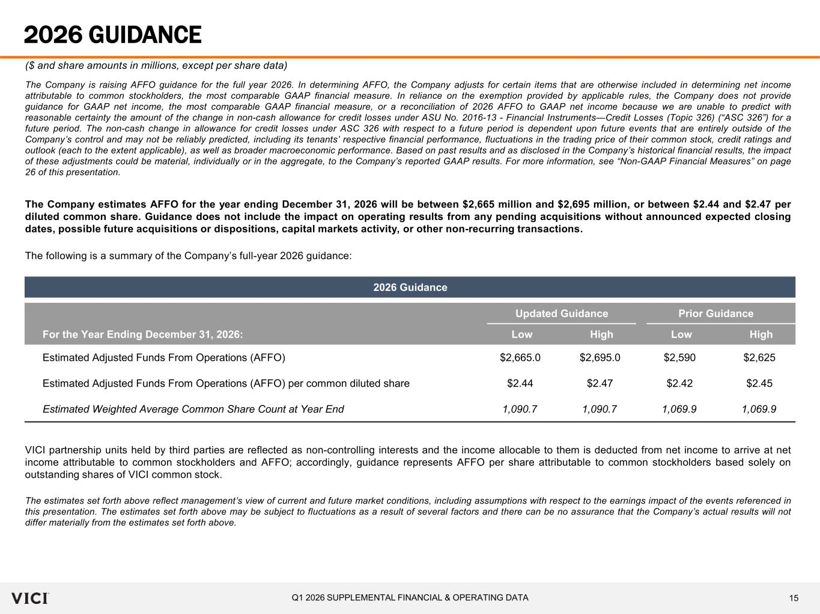
15Q1 2026 SUPPLEMENTAL FINANCIAL & OPERATING DATA 2026 GUIDANCE ($ and share amounts in millions, except per share data) The Company is raising AFFO guidance for the full year 2026. In determining AFFO, the Company adjusts for certain items that are otherwise included in determining net income attributable to common stockholders, the most comparable GAAP financial measure. In reliance on the exemption provided by applicable rules, the Company does not provide guidance for GAAP net income, the most comparable GAAP financial measure, or a reconciliation of 2026 AFFO to GAAP net income because we are unable to predict with reasonable certainty the amount of the change in non-cash allowance for credit losses under ASU No. 2016-13 - Financial Instruments—Credit Losses (Topic 326) (“ASC 326”) for a future period. The non-cash change in allowance for credit losses under ASC 326 with respect to a future period is dependent upon future events that are entirely outside of the Company’s control and may not be reliably predicted, including its tenants’ respective financial performance, fluctuations in the trading price of their common stock, credit ratings and outlook (each to the extent applicable), as well as broader macroeconomic performance. Based on past results and as disclosed in the Company’s historical financial results, the impact of these adjustments could be material, individually or in the aggregate, to the Company’s reported GAAP results. For more information, see “Non-GAAP Financial Measures” on page 26 of this presentation. The Company estimates AFFO for the year ending December 31, 2026 will be between $2,665 million and $2,695 million, or between $2.44 and $2.47 per diluted common share. Guidance does not include the impact on operating results from any pending acquisitions without announced expected closing dates, possible future acquisitions or dispositions, capital markets activity, or other non-recurring transactions. The following is a summary of the Company’s full-year 2026 guidance: VICI partnership units held by third parties are reflected as non-controlling interests and the income allocable to them is deducted from net income to arrive at net income attributable to common stockholders and AFFO; accordingly, guidance represents AFFO per share attributable to common stockholders based solely on outstanding shares of VICI common stock. The estimates set forth above reflect management’s view of current and future market conditions, including assumptions with respect to the earnings impact of the events referenced in this presentation. The estimates set forth above may be subject to fluctuations as a result of several factors and there can be no assurance that the Company’s actual results will not differ materially from the estimates set forth above. 2026 Guidance Updated Guidance Prior Guidance For the Year Ending December 31, 2026: Low High Low High Estimated Adjusted Funds From Operations (AFFO) $2,665.0 $2,695.0 $2,590 $2,625 Estimated Adjusted Funds From Operations (AFFO) per common diluted share $2.44 $2.47 $2.42 $2.45 Estimated Weighted Average Common Share Count at Year End 1,090.7 1,090.7 1,069.9 1,069.9

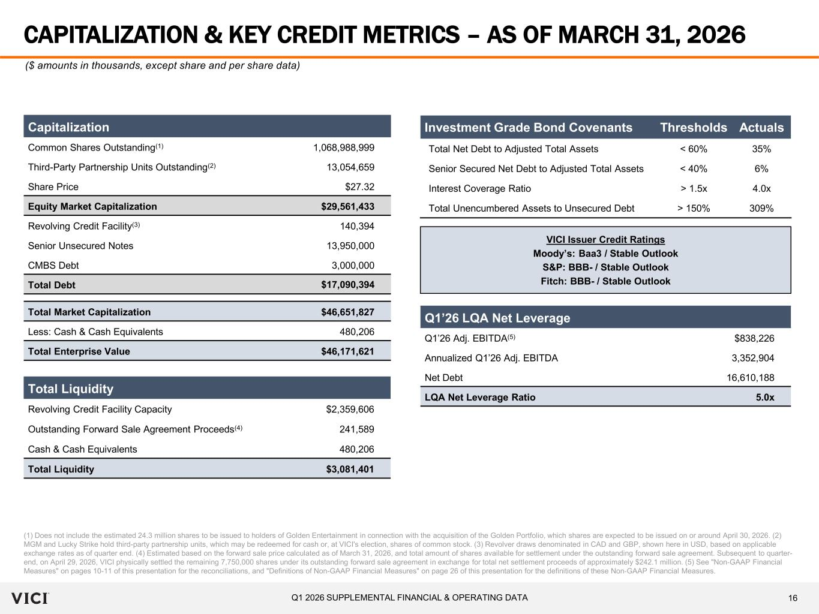
16Q1 2026 SUPPLEMENTAL FINANCIAL & OPERATING DATA CAPITALIZATION & KEY CREDIT METRICS – AS OF MARCH 31, 2026 (1) Does not include the estimated 24.3 million shares to be issued to holders of Golden Entertainment in connection with the acquisition of the Golden Portfolio, which shares are expected to be issued on or around April 30, 2026. (2) MGM and Lucky Strike hold third-party partnership units, which may be redeemed for cash or, at VICI's election, shares of common stock. (3) Revolver draws denominated in CAD and GBP, shown here in USD, based on applicable exchange rates as of quarter end. (4) Estimated based on the forward sale price calculated as of March 31, 2026, and total amount of shares available for settlement under the outstanding forward sale agreement. Subsequent to quarter- end, on April 29, 2026, VICI physically settled the remaining 7,750,000 shares under its outstanding forward sale agreement in exchange for total net settlement proceeds of approximately $242.1 million. (5) See "Non‐GAAP Financial Measures" on pages 10-11 of this presentation for the reconciliations, and "Definitions of Non-GAAP Financial Measures" on page 26 of this presentation for the definitions of these Non‐GAAP Financial Measures. ($ amounts in thousands, except share and per share data) Capitalization Common Shares Outstanding(1) 1,068,988,999 Third-Party Partnership Units Outstanding(2) 13,054,659 Share Price $27.32 Equity Market Capitalization $29,561,433 Revolving Credit Facility(3) 140,394 Senior Unsecured Notes 13,950,000 CMBS Debt 3,000,000 Total Debt $17,090,394 Total Market Capitalization $46,651,827 Less: Cash & Cash Equivalents 480,206 Total Enterprise Value $46,171,621 Q1’26 LQA Net Leverage Q1’26 Adj. EBITDA(5) $838,226 Annualized Q1’26 Adj. EBITDA 3,352,904 Net Debt 16,610,188 LQA Net Leverage Ratio 5.0x VICI Issuer Credit Ratings Moody’s: Baa3 / Stable Outlook S&P: BBB- / Stable Outlook Fitch: BBB- / Stable Outlook Investment Grade Bond Covenants Thresholds Actuals Total Net Debt to Adjusted Total Assets < 60% 35% Senior Secured Net Debt to Adjusted Total Assets < 40% 6% Interest Coverage Ratio > 1.5x 4.0x Total Unencumbered Assets to Unsecured Debt > 150% 309% Total Liquidity Revolving Credit Facility Capacity $2,359,606 Outstanding Forward Sale Agreement Proceeds(4) 241,589 Cash & Cash Equivalents 480,206 Total Liquidity $3,081,401

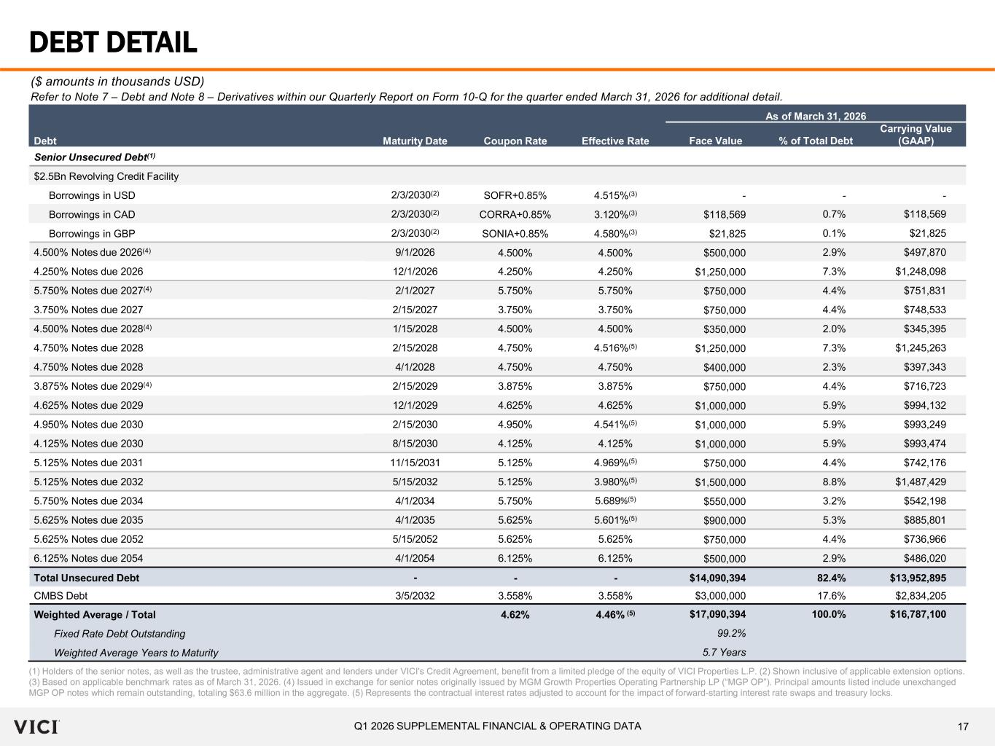
17Q1 2026 SUPPLEMENTAL FINANCIAL & OPERATING DATA DEBT DETAIL (1) Holders of the senior notes, as well as the trustee, administrative agent and lenders under VICI's Credit Agreement, benefit from a limited pledge of the equity of VICI Properties L.P. (2) Shown inclusive of applicable extension options. (3) Based on applicable benchmark rates as of March 31, 2026. (4) Issued in exchange for senior notes originally issued by MGM Growth Properties Operating Partnership LP (“MGP OP”). Principal amounts listed include unexchanged MGP OP notes which remain outstanding, totaling $63.6 million in the aggregate. (5) Represents the contractual interest rates adjusted to account for the impact of forward-starting interest rate swaps and treasury locks. ($ amounts in thousands USD) Refer to Note 7 – Debt and Note 8 – Derivatives within our Quarterly Report on Form 10-Q for the quarter ended March 31, 2026 for additional detail. As of March 31, 2026 Debt Maturity Date Coupon Rate Effective Rate Face Value % of Total Debt Carrying Value (GAAP) Senior Unsecured Debt(1) $2.5Bn Revolving Credit Facility Borrowings in USD 2/3/2030(2) SOFR+0.85% 4.515%(3) - - - Borrowings in CAD 2/3/2030(2) CORRA+0.85% 3.120%(3) $118,569 0.7% $118,569 Borrowings in GBP 2/3/2030(2) SONIA+0.85% 4.580%(3) $21,825 0.1% $21,825 4.500% Notes due 2026(4) 9/1/2026 4.500% 4.500% $500,000 2.9% $497,870 4.250% Notes due 2026 12/1/2026 4.250% 4.250% $1,250,000 7.3% $1,248,098 5.750% Notes due 2027(4) 2/1/2027 5.750% 5.750% $750,000 4.4% $751,831 3.750% Notes due 2027 2/15/2027 3.750% 3.750% $750,000 4.4% $748,533 4.500% Notes due 2028(4) 1/15/2028 4.500% 4.500% $350,000 2.0% $345,395 4.750% Notes due 2028 2/15/2028 4.750% 4.516%(5) $1,250,000 7.3% $1,245,263 4.750% Notes due 2028 4/1/2028 4.750% 4.750% $400,000 2.3% $397,343 3.875% Notes due 2029(4) 2/15/2029 3.875% 3.875% $750,000 4.4% $716,723 4.625% Notes due 2029 12/1/2029 4.625% 4.625% $1,000,000 5.9% $994,132 4.950% Notes due 2030 2/15/2030 4.950% 4.541%(5) $1,000,000 5.9% $993,249 4.125% Notes due 2030 8/15/2030 4.125% 4.125% $1,000,000 5.9% $993,474 5.125% Notes due 2031 11/15/2031 5.125% 4.969%(5) $750,000 4.4% $742,176 5.125% Notes due 2032 5/15/2032 5.125% 3.980%(5) $1,500,000 8.8% $1,487,429 5.750% Notes due 2034 4/1/2034 5.750% 5.689%(5) $550,000 3.2% $542,198 5.625% Notes due 2035 4/1/2035 5.625% 5.601%(5) $900,000 5.3% $885,801 5.625% Notes due 2052 5/15/2052 5.625% 5.625% $750,000 4.4% $736,966 6.125% Notes due 2054 4/1/2054 6.125% 6.125% $500,000 2.9% $486,020 Total Unsecured Debt - - - $14,090,394 82.4% $13,952,895 CMBS Debt 3/5/2032 3.558% 3.558% $3,000,000 17.6% $2,834,205 Weighted Average / Total 4.62% 4.46% (5) $17,090,394 100.0% $16,787,100 Fixed Rate Debt Outstanding 99.2% Weighted Average Years to Maturity 5.7 Years

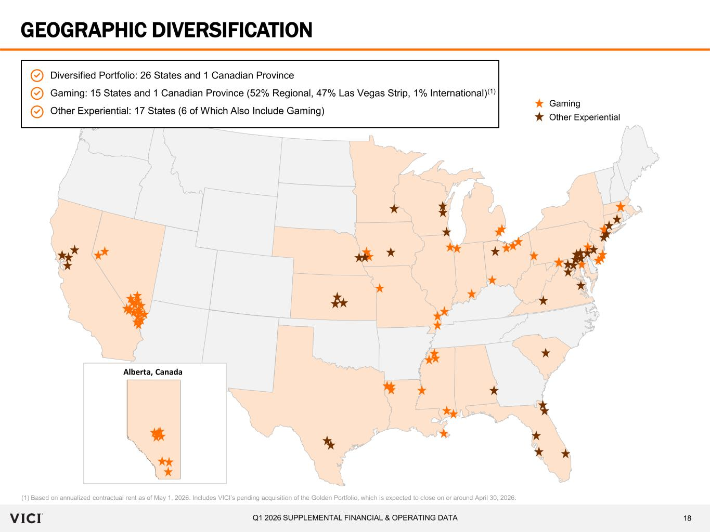
18Q1 2026 SUPPLEMENTAL FINANCIAL & OPERATING DATA GEOGRAPHIC DIVERSIFICATION (1) Based on annualized contractual rent as of May 1, 2026. Includes VICI’s pending acquisition of the Golden Portfolio, which is expected to close on or around April 30, 2026. Diversified Portfolio: 26 States and 1 Canadian Province Gaming: 15 States and 1 Canadian Province (52% Regional, 47% Las Vegas Strip, 1% International)(1) Other Experiential: 17 States (6 of Which Also Include Gaming) Alberta, Canada Gaming Other Experiential

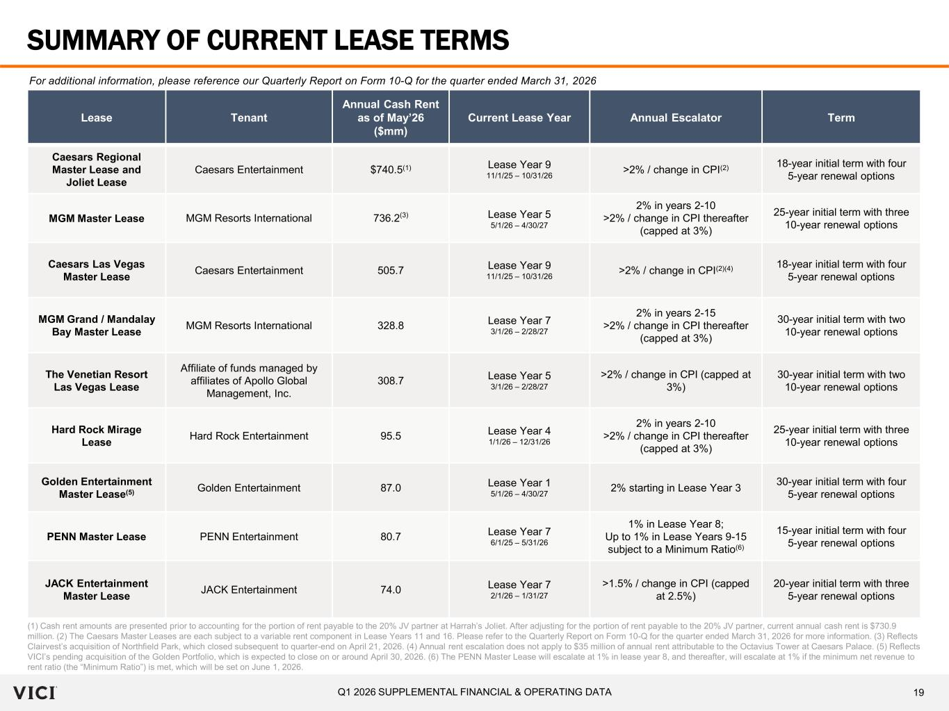
19Q1 2026 SUPPLEMENTAL FINANCIAL & OPERATING DATA SUMMARY OF CURRENT LEASE TERMS (1) Cash rent amounts are presented prior to accounting for the portion of rent payable to the 20% JV partner at Harrah’s Joliet. After adjusting for the portion of rent payable to the 20% JV partner, current annual cash rent is $730.9 million. (2) The Caesars Master Leases are each subject to a variable rent component in Lease Years 11 and 16. Please refer to the Quarterly Report on Form 10-Q for the quarter ended March 31, 2026 for more information. (3) Reflects Clairvest’s acquisition of Northfield Park, which closed subsequent to quarter-end on April 21, 2026. (4) Annual rent escalation does not apply to $35 million of annual rent attributable to the Octavius Tower at Caesars Palace. (5) Reflects VICI’s pending acquisition of the Golden Portfolio, which is expected to close on or around April 30, 2026. (6) The PENN Master Lease will escalate at 1% in lease year 8, and thereafter, will escalate at 1% if the minimum net revenue to rent ratio (the “Minimum Ratio”) is met, which will be set on June 1, 2026. Lease Tenant Annual Cash Rent as of May’26 ($mm) Current Lease Year Annual Escalator Term Caesars Regional Master Lease and Joliet Lease Caesars Entertainment $740.5(1) Lease Year 9 11/1/25 – 10/31/26 >2% / change in CPI(2) 18-year initial term with four 5-year renewal options MGM Master Lease MGM Resorts International 736.2(3) Lease Year 5 5/1/26 – 4/30/27 2% in years 2-10 >2% / change in CPI thereafter (capped at 3%) 25-year initial term with three 10-year renewal options Caesars Las Vegas Master Lease Caesars Entertainment 505.7 Lease Year 9 11/1/25 – 10/31/26 >2% / change in CPI(2)(4) 18-year initial term with four 5-year renewal options MGM Grand / Mandalay Bay Master Lease MGM Resorts International 328.8 Lease Year 7 3/1/26 – 2/28/27 2% in years 2-15 >2% / change in CPI thereafter (capped at 3%) 30-year initial term with two 10-year renewal options The Venetian Resort Las Vegas Lease Affiliate of funds managed by affiliates of Apollo Global Management, Inc. 308.7 Lease Year 5 3/1/26 – 2/28/27 >2% / change in CPI (capped at 3%) 30-year initial term with two 10-year renewal options Hard Rock Mirage Lease Hard Rock Entertainment 95.5 Lease Year 4 1/1/26 – 12/31/26 2% in years 2-10 >2% / change in CPI thereafter (capped at 3%) 25-year initial term with three 10-year renewal options Golden Entertainment Master Lease(5) Golden Entertainment 87.0 Lease Year 1 5/1/26 – 4/30/27 2% starting in Lease Year 3 30-year initial term with four 5-year renewal options PENN Master Lease PENN Entertainment 80.7 Lease Year 7 6/1/25 – 5/31/26 1% in Lease Year 8; Up to 1% in Lease Years 9-15 subject to a Minimum Ratio(6) 15-year initial term with four 5-year renewal options JACK Entertainment Master Lease JACK Entertainment 74.0 Lease Year 7 2/1/26 – 1/31/27 >1.5% / change in CPI (capped at 2.5%) 20-year initial term with three 5-year renewal options For additional information, please reference our Quarterly Report on Form 10-Q for the quarter ended March 31, 2026

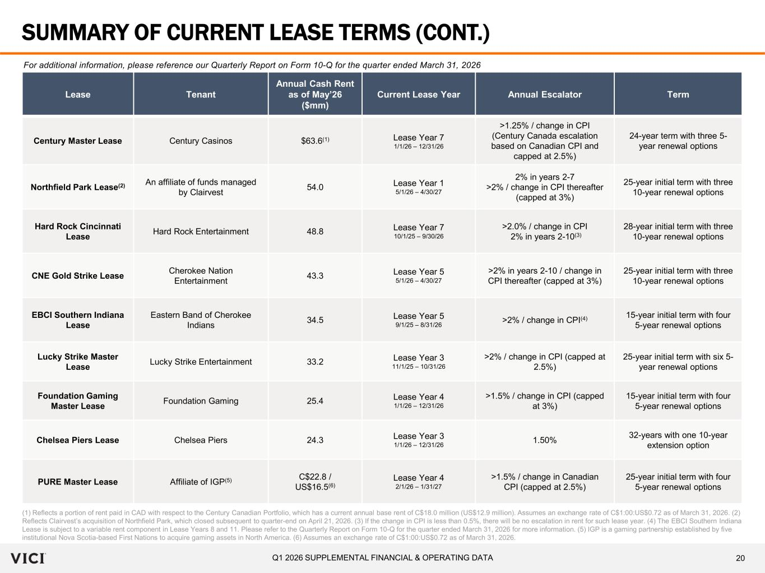
20Q1 2026 SUPPLEMENTAL FINANCIAL & OPERATING DATA SUMMARY OF CURRENT LEASE TERMS (CONT.) Lease Tenant Annual Cash Rent as of May’26 ($mm) Current Lease Year Annual Escalator Term Century Master Lease Century Casinos $63.6(1) Lease Year 7 1/1/26 – 12/31/26 >1.25% / change in CPI (Century Canada escalation based on Canadian CPI and capped at 2.5%) 24-year term with three 5- year renewal options Northfield Park Lease(2) An affiliate of funds managed by Clairvest 54.0 Lease Year 1 5/1/26 – 4/30/27 2% in years 2-7 >2% / change in CPI thereafter (capped at 3%) 25-year initial term with three 10-year renewal options Hard Rock Cincinnati Lease Hard Rock Entertainment 48.8 Lease Year 7 10/1/25 – 9/30/26 >2.0% / change in CPI 2% in years 2-10(3) 28-year initial term with three 10-year renewal options CNE Gold Strike Lease Cherokee Nation Entertainment 43.3 Lease Year 5 5/1/26 – 4/30/27 >2% in years 2-10 / change in CPI thereafter (capped at 3%) 25-year initial term with three 10-year renewal options EBCI Southern Indiana Lease Eastern Band of Cherokee Indians 34.5 Lease Year 5 9/1/25 – 8/31/26 >2% / change in CPI(4) 15-year initial term with four 5-year renewal options Lucky Strike Master Lease Lucky Strike Entertainment 33.2 Lease Year 3 11/1/25 – 10/31/26 >2% / change in CPI (capped at 2.5%) 25-year initial term with six 5- year renewal options Foundation Gaming Master Lease Foundation Gaming 25.4 Lease Year 4 1/1/26 – 12/31/26 >1.5% / change in CPI (capped at 3%) 15-year initial term with four 5-year renewal options Chelsea Piers Lease Chelsea Piers 24.3 Lease Year 3 1/1/26 – 12/31/26 1.50% 32-years with one 10-year extension option PURE Master Lease Affiliate of IGP(5) C$22.8 / US$16.5(6) Lease Year 4 2/1/26 – 1/31/27 >1.5% / change in Canadian CPI (capped at 2.5%) 25-year initial term with four 5-year renewal options (1) Reflects a portion of rent paid in CAD with respect to the Century Canadian Portfolio, which has a current annual base rent of C$18.0 million (US$12.9 million). Assumes an exchange rate of C$1:00:US$0.72 as of March 31, 2026. (2) Reflects Clairvest’s acquisition of Northfield Park, which closed subsequent to quarter-end on April 21, 2026. (3) If the change in CPI is less than 0.5%, there will be no escalation in rent for such lease year. (4) The EBCI Southern Indiana Lease is subject to a variable rent component in Lease Years 8 and 11. Please refer to the Quarterly Report on Form 10-Q for the quarter ended March 31, 2026 for more information. (5) IGP is a gaming partnership established by five institutional Nova Scotia-based First Nations to acquire gaming assets in North America. (6) Assumes an exchange rate of C$1:00:US$0.72 as of March 31, 2026. For additional information, please reference our Quarterly Report on Form 10-Q for the quarter ended March 31, 2026

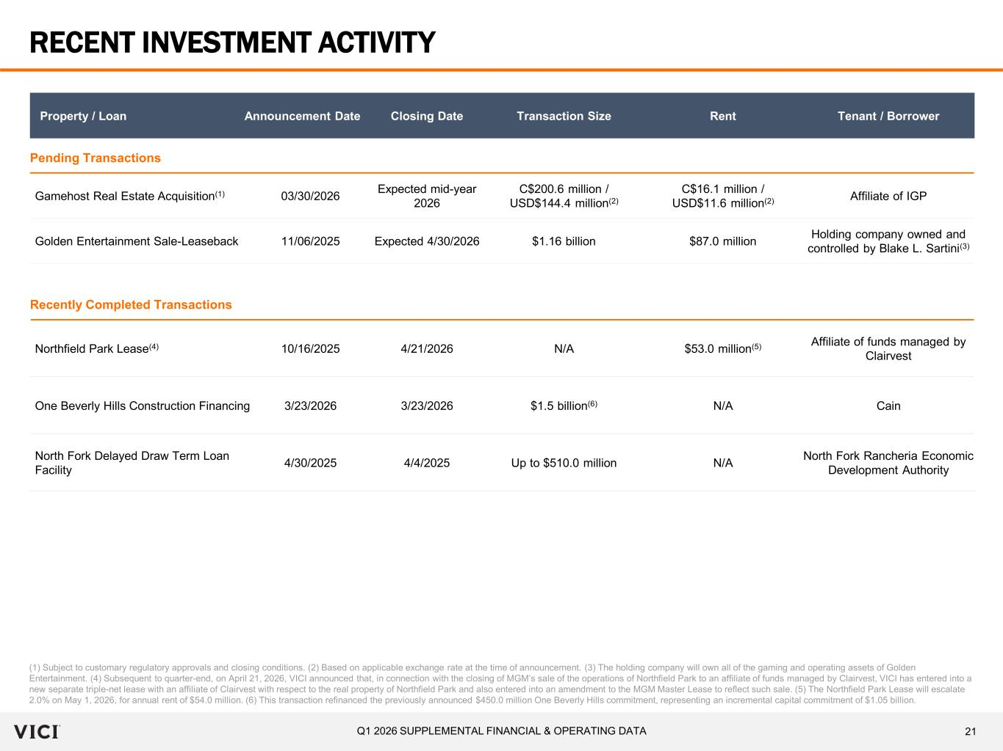
21Q1 2026 SUPPLEMENTAL FINANCIAL & OPERATING DATA RECENT INVESTMENT ACTIVITY (1) Subject to customary regulatory approvals and closing conditions. (2) Based on applicable exchange rate at the time of announcement. (3) The holding company will own all of the gaming and operating assets of Golden Entertainment. (4) Subsequent to quarter-end, on April 21, 2026, VICI announced that, in connection with the closing of MGM’s sale of the operations of Northfield Park to an affiliate of funds managed by Clairvest, VICI has entered into a new separate triple-net lease with an affiliate of Clairvest with respect to the real property of Northfield Park and also entered into an amendment to the MGM Master Lease to reflect such sale. (5) The Northfield Park Lease will escalate 2.0% on May 1, 2026, for annual rent of $54.0 million. (6) This transaction refinanced the previously announced $450.0 million One Beverly Hills commitment, representing an incremental capital commitment of $1.05 billion. Property / Loan Announcement Date Closing Date Transaction Size Rent Tenant / Borrower Pending Transactions Gamehost Real Estate Acquisition(1) 03/30/2026 Expected mid-year 2026 C$200.6 million / USD$144.4 million(2) C$16.1 million / USD$11.6 million(2) Affiliate of IGP Golden Entertainment Sale-Leaseback 11/06/2025 Expected 4/30/2026 $1.16 billion $87.0 million Holding company owned and controlled by Blake L. Sartini(3) Recently Completed Transactions Northfield Park Lease(4) 10/16/2025 4/21/2026 N/A $53.0 million(5) Affiliate of funds managed by Clairvest One Beverly Hills Construction Financing 3/23/2026 3/23/2026 $1.5 billion(6) N/A Cain North Fork Delayed Draw Term Loan Facility 4/30/2025 4/4/2025 Up to $510.0 million N/A North Fork Rancheria Economic Development Authority

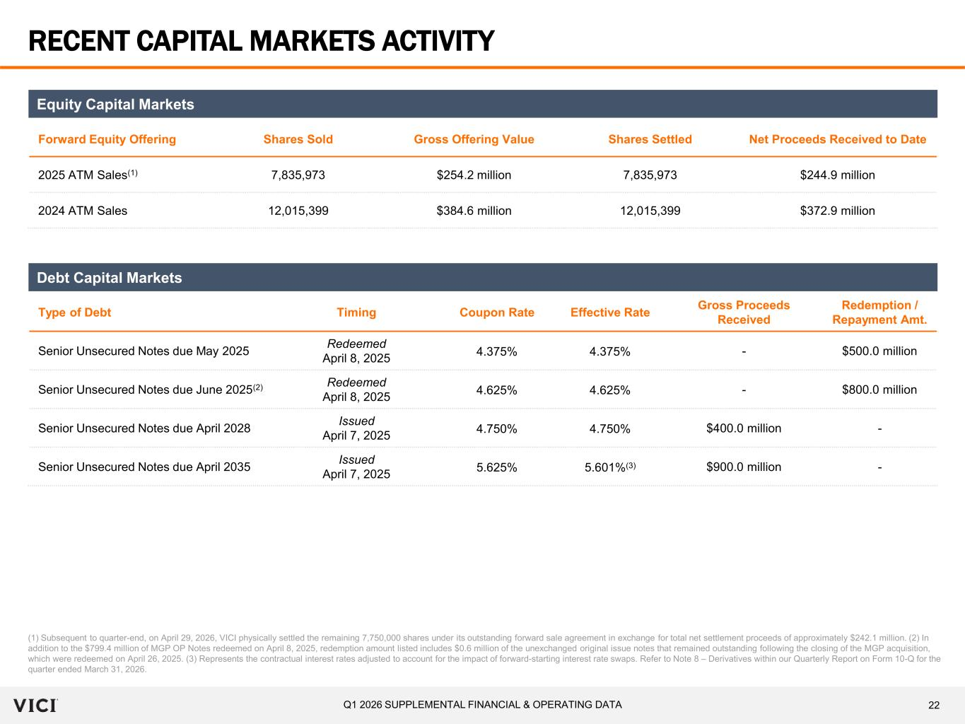
22Q1 2026 SUPPLEMENTAL FINANCIAL & OPERATING DATA RECENT CAPITAL MARKETS ACTIVITY (1) Subsequent to quarter-end, on April 29, 2026, VICI physically settled the remaining 7,750,000 shares under its outstanding forward sale agreement in exchange for total net settlement proceeds of approximately $242.1 million. (2) In addition to the $799.4 million of MGP OP Notes redeemed on April 8, 2025, redemption amount listed includes $0.6 million of the unexchanged original issue notes that remained outstanding following the closing of the MGP acquisition, which were redeemed on April 26, 2025. (3) Represents the contractual interest rates adjusted to account for the impact of forward-starting interest rate swaps. Refer to Note 8 – Derivatives within our Quarterly Report on Form 10-Q for the quarter ended March 31, 2026. Forward Equity Offering Shares Sold Gross Offering Value Shares Settled Net Proceeds Received to Date 2025 ATM Sales(1) 7,835,973 $254.2 million 7,835,973 $244.9 million 2024 ATM Sales 12,015,399 $384.6 million 12,015,399 $372.9 million Equity Capital Markets Type of Debt Timing Coupon Rate Effective Rate Gross Proceeds Received Redemption / Repayment Amt. Senior Unsecured Notes due May 2025 Redeemed April 8, 2025 4.375% 4.375% - $500.0 million Senior Unsecured Notes due June 2025(2) Redeemed April 8, 2025 4.625% 4.625% - $800.0 million Senior Unsecured Notes due April 2028 Issued April 7, 2025 4.750% 4.750% $400.0 million - Senior Unsecured Notes due April 2035 Issued April 7, 2025 5.625% 5.601%(3) $900.0 million - Debt Capital Markets

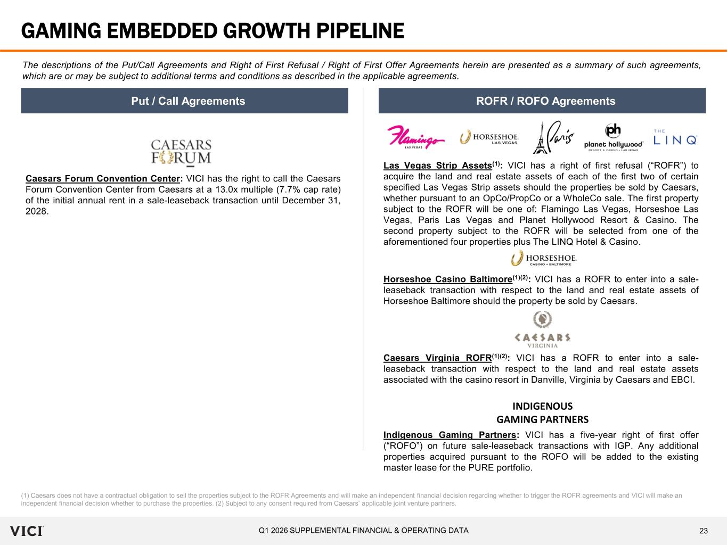
23Q1 2026 SUPPLEMENTAL FINANCIAL & OPERATING DATA GAMING EMBEDDED GROWTH PIPELINE The descriptions of the Put/Call Agreements and Right of First Refusal / Right of First Offer Agreements herein are presented as a summary of such agreements, which are or may be subject to additional terms and conditions as described in the applicable agreements. Put / Call Agreements ROFR / ROFO Agreements (1) Caesars does not have a contractual obligation to sell the properties subject to the ROFR Agreements and will make an independent financial decision regarding whether to trigger the ROFR agreements and VICI will make an independent financial decision whether to purchase the properties. (2) Subject to any consent required from Caesars’ applicable joint venture partners. Caesars Forum Convention Center: VICI has the right to call the Caesars Forum Convention Center from Caesars at a 13.0x multiple (7.7% cap rate) of the initial annual rent in a sale-leaseback transaction until December 31, 2028. Las Vegas Strip Assets(1): VICI has a right of first refusal (“ROFR”) to acquire the land and real estate assets of each of the first two of certain specified Las Vegas Strip assets should the properties be sold by Caesars, whether pursuant to an OpCo/PropCo or a WholeCo sale. The first property subject to the ROFR will be one of: Flamingo Las Vegas, Horseshoe Las Vegas, Paris Las Vegas and Planet Hollywood Resort & Casino. The second property subject to the ROFR will be selected from one of the aforementioned four properties plus The LINQ Hotel & Casino. Horseshoe Casino Baltimore(1)(2): VICI has a ROFR to enter into a sale- leaseback transaction with respect to the land and real estate assets of Horseshoe Baltimore should the property be sold by Caesars. Caesars Virginia ROFR(1)(2): VICI has a ROFR to enter into a sale- leaseback transaction with respect to the land and real estate assets associated with the casino resort in Danville, Virginia by Caesars and EBCI. Indigenous Gaming Partners: VICI has a five-year right of first offer (“ROFO”) on future sale-leaseback transactions with IGP. Any additional properties acquired pursuant to the ROFO will be added to the existing master lease for the PURE portfolio. INDIGENOUS GAMING PARTNERS

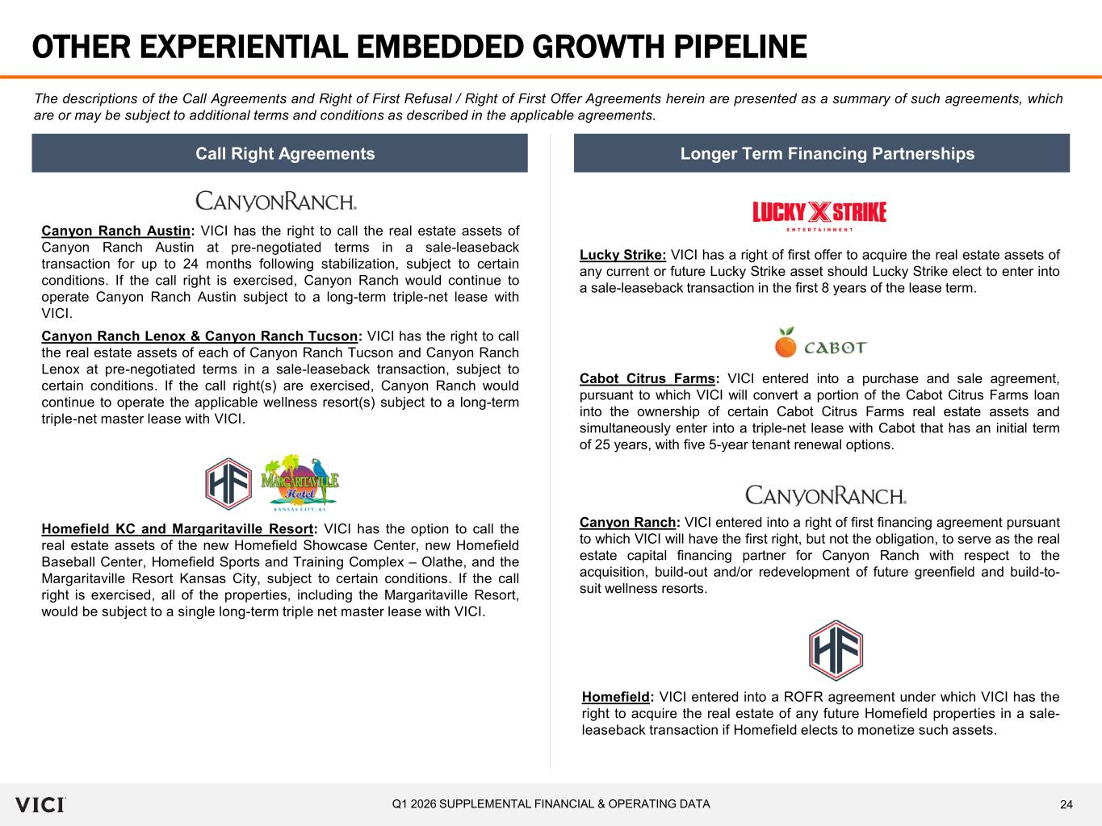
24Q1 2026 SUPPLEMENTAL FINANCIAL & OPERATING DATA OTHER EXPERIENTIAL EMBEDDED GROWTH PIPELINE The descriptions of the Call Agreements and Right of First Refusal / Right of First Offer Agreements herein are presented as a summary of such agreements, which are or may be subject to additional terms and conditions as described in the applicable agreements. Canyon Ranch Lenox & Canyon Ranch Tucson: VICI has the right to call the real estate assets of each of Canyon Ranch Tucson and Canyon Ranch Lenox at pre-negotiated terms in a sale-leaseback transaction, subject to certain conditions. If the call right(s) are exercised, Canyon Ranch would continue to operate the applicable wellness resort(s) subject to a long-term triple-net master lease with VICI. Call Right Agreements Longer Term Financing Partnerships Canyon Ranch Austin: VICI has the right to call the real estate assets of Canyon Ranch Austin at pre-negotiated terms in a sale-leaseback transaction for up to 24 months following stabilization, subject to certain conditions. If the call right is exercised, Canyon Ranch would continue to operate Canyon Ranch Austin subject to a long-term triple-net lease with VICI. Cabot Citrus Farms: VICI entered into a purchase and sale agreement, pursuant to which VICI will convert a portion of the Cabot Citrus Farms loan into the ownership of certain Cabot Citrus Farms real estate assets and simultaneously enter into a triple-net lease with Cabot that has an initial term of 25 years, with five 5-year tenant renewal options. Canyon Ranch: VICI entered into a right of first financing agreement pursuant to which VICI will have the first right, but not the obligation, to serve as the real estate capital financing partner for Canyon Ranch with respect to the acquisition, build-out and/or redevelopment of future greenfield and build-to- suit wellness resorts. Lucky Strike: VICI has a right of first offer to acquire the real estate assets of any current or future Lucky Strike asset should Lucky Strike elect to enter into a sale-leaseback transaction in the first 8 years of the lease term. Homefield KC and Margaritaville Resort: VICI has the option to call the real estate assets of the new Homefield Showcase Center, new Homefield Baseball Center, Homefield Sports and Training Complex – Olathe, and the Margaritaville Resort Kansas City, subject to certain conditions. If the call right is exercised, all of the properties, including the Margaritaville Resort, would be subject to a single long-term triple net master lease with VICI. Homefield: VICI entered into a ROFR agreement under which VICI has the right to acquire the real estate of any future Homefield properties in a sale- leaseback transaction if Homefield elects to monetize such assets.

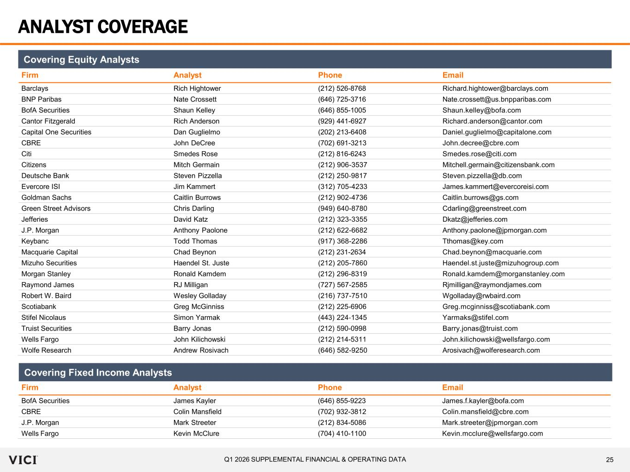
25Q1 2026 SUPPLEMENTAL FINANCIAL & OPERATING DATA ANALYST COVERAGE Firm Analyst Phone Email Barclays Rich Hightower (212) 526-8768 Richard.hightower@barclays.com BNP Paribas Nate Crossett (646) 725-3716 Nate.crossett@us.bnpparibas.com BofA Securities Shaun Kelley (646) 855-1005 Shaun.kelley@bofa.com Cantor Fitzgerald Rich Anderson (929) 441-6927 Richard.anderson@cantor.com Capital One Securities Dan Guglielmo (202) 213-6408 Daniel.guglielmo@capitalone.com CBRE John DeCree (702) 691-3213 John.decree@cbre.com Citi Smedes Rose (212) 816-6243 Smedes.rose@citi.com Citizens Mitch Germain (212) 906-3537 Mitchell.germain@citizensbank.com Deutsche Bank Steven Pizzella (212) 250‐9817 Steven.pizzella@db.com Evercore ISI Jim Kammert (312) 705-4233 James.kammert@evercoreisi.com Goldman Sachs Caitlin Burrows (212) 902-4736 Caitlin.burrows@gs.com Green Street Advisors Chris Darling (949) 640-8780 Cdarling@greenstreet.com Jefferies David Katz (212) 323-3355 Dkatz@jefferies.com J.P. Morgan Anthony Paolone (212) 622-6682 Anthony.paolone@jpmorgan.com Keybanc Todd Thomas (917) 368-2286 Tthomas@key.com Macquarie Capital Chad Beynon (212) 231-2634 Chad.beynon@macquarie.com Mizuho Securities Haendel St. Juste (212) 205-7860 Haendel.st.juste@mizuhogroup.com Morgan Stanley Ronald Kamdem (212) 296-8319 Ronald.kamdem@morganstanley.com Raymond James RJ Milligan (727) 567-2585 Rjmilligan@raymondjames.com Robert W. Baird Wesley Golladay (216) 737-7510 Wgolladay@rwbaird.com Scotiabank Greg McGinniss (212) 225-6906 Greg.mcginniss@scotiabank.com Stifel Nicolaus Simon Yarmak (443) 224‐1345 Yarmaks@stifel.com Truist Securities Barry Jonas (212) 590-0998 Barry.jonas@truist.com Wells Fargo John Kilichowski (212) 214-5311 John.kilichowski@wellsfargo.com Wolfe Research Andrew Rosivach (646) 582-9250 Arosivach@wolferesearch.com Firm Analyst Phone Email BofA Securities James Kayler (646) 855-9223 James.f.kayler@bofa.com CBRE Colin Mansfield (702) 932-3812 Colin.mansfield@cbre.com J.P. Morgan Mark Streeter (212) 834-5086 Mark.streeter@jpmorgan.com Wells Fargo Kevin McClure (704) 410-1100 Kevin.mcclure@wellsfargo.com Covering Fixed Income Analysts Covering Equity Analysts

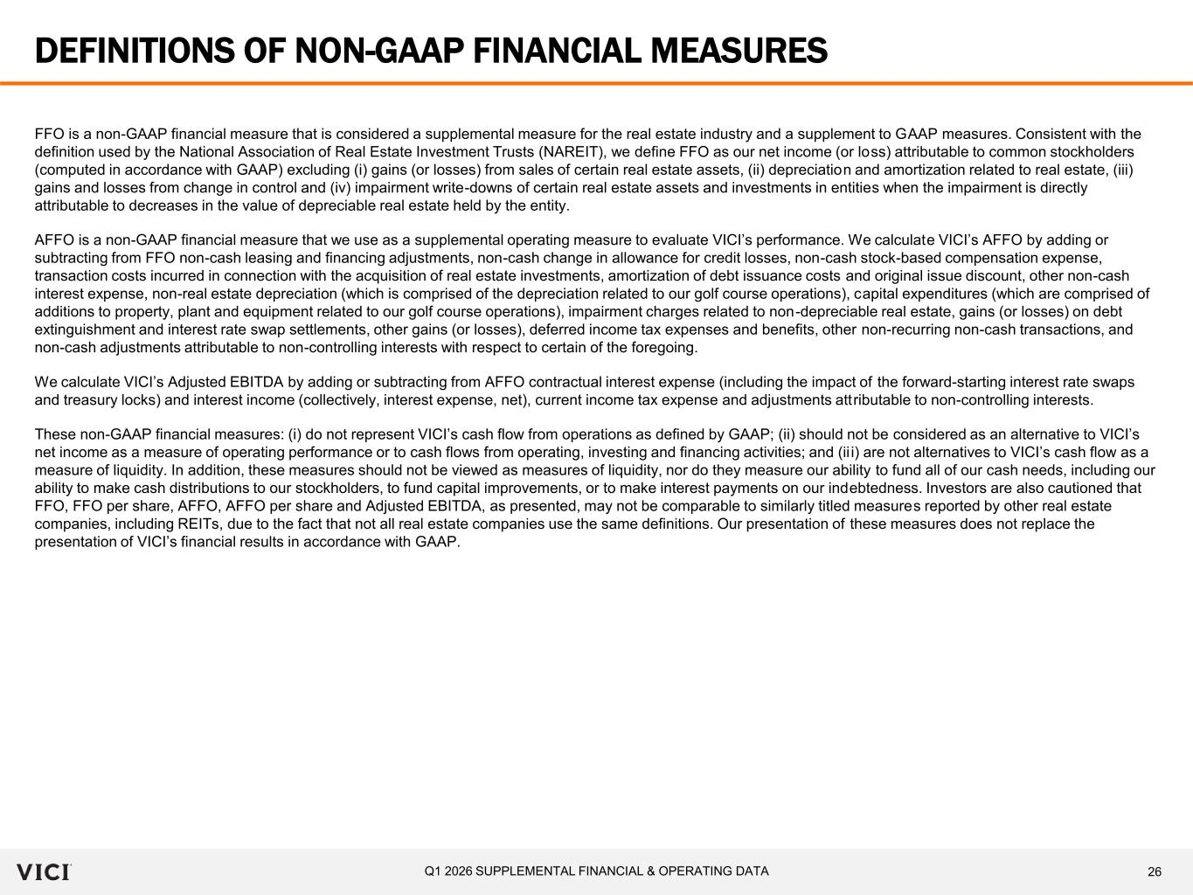
26Q1 2026 SUPPLEMENTAL FINANCIAL & OPERATING DATA DEFINITIONS OF NON-GAAP FINANCIAL MEASURES FFO is a non-GAAP financial measure that is considered a supplemental measure for the real estate industry and a supplement to GAAP measures. Consistent with the definition used by the National Association of Real Estate Investment Trusts (NAREIT), we define FFO as our net income (or loss) attributable to common stockholders (computed in accordance with GAAP) excluding (i) gains (or losses) from sales of certain real estate assets, (ii) depreciation and amortization related to real estate, (iii) gains and losses from change in control and (iv) impairment write-downs of certain real estate assets and investments in entities when the impairment is directly attributable to decreases in the value of depreciable real estate held by the entity. AFFO is a non-GAAP financial measure that we use as a supplemental operating measure to evaluate VICI’s performance. We calculate VICI’s AFFO by adding or subtracting from FFO non-cash leasing and financing adjustments, non-cash change in allowance for credit losses, non-cash stock-based compensation expense, transaction costs incurred in connection with the acquisition of real estate investments, amortization of debt issuance costs and original issue discount, other non-cash interest expense, non-real estate depreciation (which is comprised of the depreciation related to our golf course operations), capital expenditures (which are comprised of additions to property, plant and equipment related to our golf course operations), impairment charges related to non-depreciable real estate, gains (or losses) on debt extinguishment and interest rate swap settlements, other gains (or losses), deferred income tax expenses and benefits, other non-recurring non-cash transactions, and non-cash adjustments attributable to non-controlling interests with respect to certain of the foregoing. We calculate VICI’s Adjusted EBITDA by adding or subtracting from AFFO contractual interest expense (including the impact of the forward-starting interest rate swaps and treasury locks) and interest income (collectively, interest expense, net), current income tax expense and adjustments attributable to non-controlling interests. These non-GAAP financial measures: (i) do not represent VICI’s cash flow from operations as defined by GAAP; (ii) should not be considered as an alternative to VICI’s net income as a measure of operating performance or to cash flows from operating, investing and financing activities; and (ii i) are not alternatives to VICI’s cash flow as a measure of liquidity. In addition, these measures should not be viewed as measures of liquidity, nor do they measure our ability to fund all of our cash needs, including our ability to make cash distributions to our stockholders, to fund capital improvements, or to make interest payments on our indebtedness. Investors are also cautioned that FFO, FFO per share, AFFO, AFFO per share and Adjusted EBITDA, as presented, may not be comparable to similarly titled measures reported by other real estate companies, including REITs, due to the fact that not all real estate companies use the same definitions. Our presentation of these measures does not replace the presentation of VICI’s financial results in accordance with GAAP.

