SEC Form 3
FORM 3 | UNITED STATES SECURITIES AND EXCHANGE COMMISSION  Washington, D.C. 20549  INITIAL STATEMENT OF BENEFICIAL OWNERSHIP OF SECURITIES  Filed pursuant to Section 16(a) of the Securities Exchange Act of 1934  or Section 30(h) of the Investment Company Act of 1940
  OMB APPROVAL
  OMB Number: | 3235-0104
  Estimated average burden
  hours per response: | 0.5
1. Name and Address of Reporting Person*  (Street) | 2. Date of Event Requiring Statement (Month/Day/Year)  09/18/2026 | 3. Issuer Name and Ticker or Trading Symbol  VICI PROPERTIES INC. [ VICI ]  Foreign Trading Symbol
  Sullivan John M
  (Last) | (First) | (Middle)
  C/O VICI PROPERTIES INC.
  535 MADISON AVE, 28TH FL
  NEW YORK | NY | 10022
  (City) | (State) | (Zip)
 |  | 4. Relationship of Reporting Person(s) to Issuer  (Check all applicable) | 5. If Amendment, Date of Original Filed (Month/Day/Year)
   | Director |  | 10% Owner
   | Officer (give title below) |  | Other (specify below)
6. Individual or Joint/Group Filing (Check Applicable Line)
Form filed by One Reporting Person
Form filed by More than One Reporting Person

Table I - Non-Derivative Securities Beneficially Owned
1. Title of Security (Instr. 4) | 2. Amount of Securities Beneficially Owned (Instr. 4) | 3. Ownership Form: Direct (D) or Indirect (I) (Instr. 5) | 4. Nature of Indirect Beneficial Ownership (Instr. 5)
Table II - Derivative Securities Beneficially Owned
(e.g., puts, calls, warrants, options, convertible securities)
1. Title of Derivative Security (Instr. 4) | 2. Date Exercisable and Expiration Date (Month/Day/Year) |  | 3. Title and Amount of Securities Underlying Derivative Security (Instr. 4) |  | 4. Conversion or Exercise Price of Derivative Security | 5. Ownership Form: Direct (D) or Indirect (I) (Instr. 5) | 6. Nature of Indirect Beneficial Ownership (Instr. 5)
1. Title of Derivative Security (Instr. 4) | Date Exercisable | Expiration Date | Title | Amount or Number of Shares | 4. Conversion or Exercise Price of Derivative Security | 5. Ownership Form: Direct (D) or Indirect (I) (Instr. 5) | 6. Nature of Indirect Beneficial Ownership (Instr. 5)
Explanation of Responses:
Remarks:
Exhibit 24.1 Power of Attorney
No securities are beneficially owned.
 | /s/ Samantha Sacks Gallagher, as attorney-in-fact for John M. Sullivan | 09/28/2026
 | ** Signature of Reporting Person | Date
Reminder: Report on a separate line for each class of securities beneficially owned directly or indirectly.
* If the form is filed by more than one reporting person, see Instruction 5 (b)(v).
** Intentional misstatements or omissions of facts constitute Federal Criminal Violations See 18 U.S.C. 1001 and 15 U.S.C. 78ff(a).
Note: File three copies of this Form, one of which must be manually signed. If space is insufficient, see Instruction 6 for procedure.
Persons who respond to the collection of information contained in this form are not required to respond unless the form displays a currently valid OMB Number.
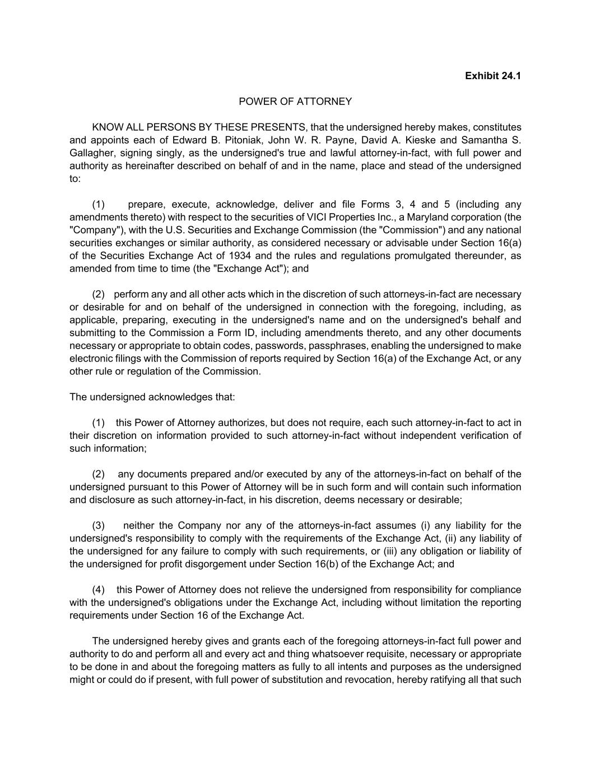
Exhibit 24.1 POWER OF ATTORNEY KNOW ALL PERSONS BY THESE PRESENTS, that the undersigned hereby makes, constitutes and appoints each of Edward B. Pitoniak, John W. R. Payne, David A. Kieske and Samantha S. Gallagher, signing singly, as the undersigned's true and lawful attorney-in-fact, with full power and authority as hereinafter described on behalf of and in the name, place and stead of the undersigned to: (1) prepare, execute, acknowledge, deliver and file Forms 3, 4 and 5 (including any amendments thereto) with respect to the securities of VICI Properties Inc., a Maryland corporation (the "Company"), with the U.S. Securities and Exchange Commission (the "Commission") and any national securities exchanges or similar authority, as considered necessary or advisable under Section 16(a) of the Securities Exchange Act of 1934 and the rules and regulations promulgated thereunder, as amended from time to time (the "Exchange Act"); and (2) perform any and all other acts which in the discretion of such attorneys-in-fact are necessary or desirable for and on behalf of the undersigned in connection with the foregoing, including, as applicable, preparing, executing in the undersigned's name and on the undersigned's behalf and submitting to the Commission a Form ID, including amendments thereto, and any other documents necessary or appropriate to obtain codes, passwords, passphrases, enabling the undersigned to make electronic filings with the Commission of reports required by Section 16(a) of the Exchange Act, or any other rule or regulation of the Commission. The undersigned acknowledges that: (1) this Power of Attorney authorizes, but does not require, each such attorney-in-fact to act in their discretion on information provided to such attorney-in-fact without independent verification of such information; (2) any documents prepared and/or executed by any of the attorneys-in-fact on behalf of the undersigned pursuant to this Power of Attorney will be in such form and will contain such information and disclosure as such attorney-in-fact, in his discretion, deems necessary or desirable; (3) neither the Company nor any of the attorneys-in-fact assumes (i) any liability for the undersigned's responsibility to comply with the requirements of the Exchange Act, (ii) any liability of the undersigned for any failure to comply with such requirements, or (iii) any obligation or liability of the undersigned for profit disgorgement under Section 16(b) of the Exchange Act; and (4) this Power of Attorney does not relieve the undersigned from responsibility for compliance with the undersigned's obligations under the Exchange Act, including without limitation the reporting requirements under Section 16 of the Exchange Act. The undersigned hereby gives and grants each of the foregoing attorneys-in-fact full power and authority to do and perform all and every act and thing whatsoever requisite, necessary or appropriate to be done in and about the foregoing matters as fully to all intents and purposes as the undersigned might or could do if present, with full power of substitution and revocation, hereby ratifying all that such

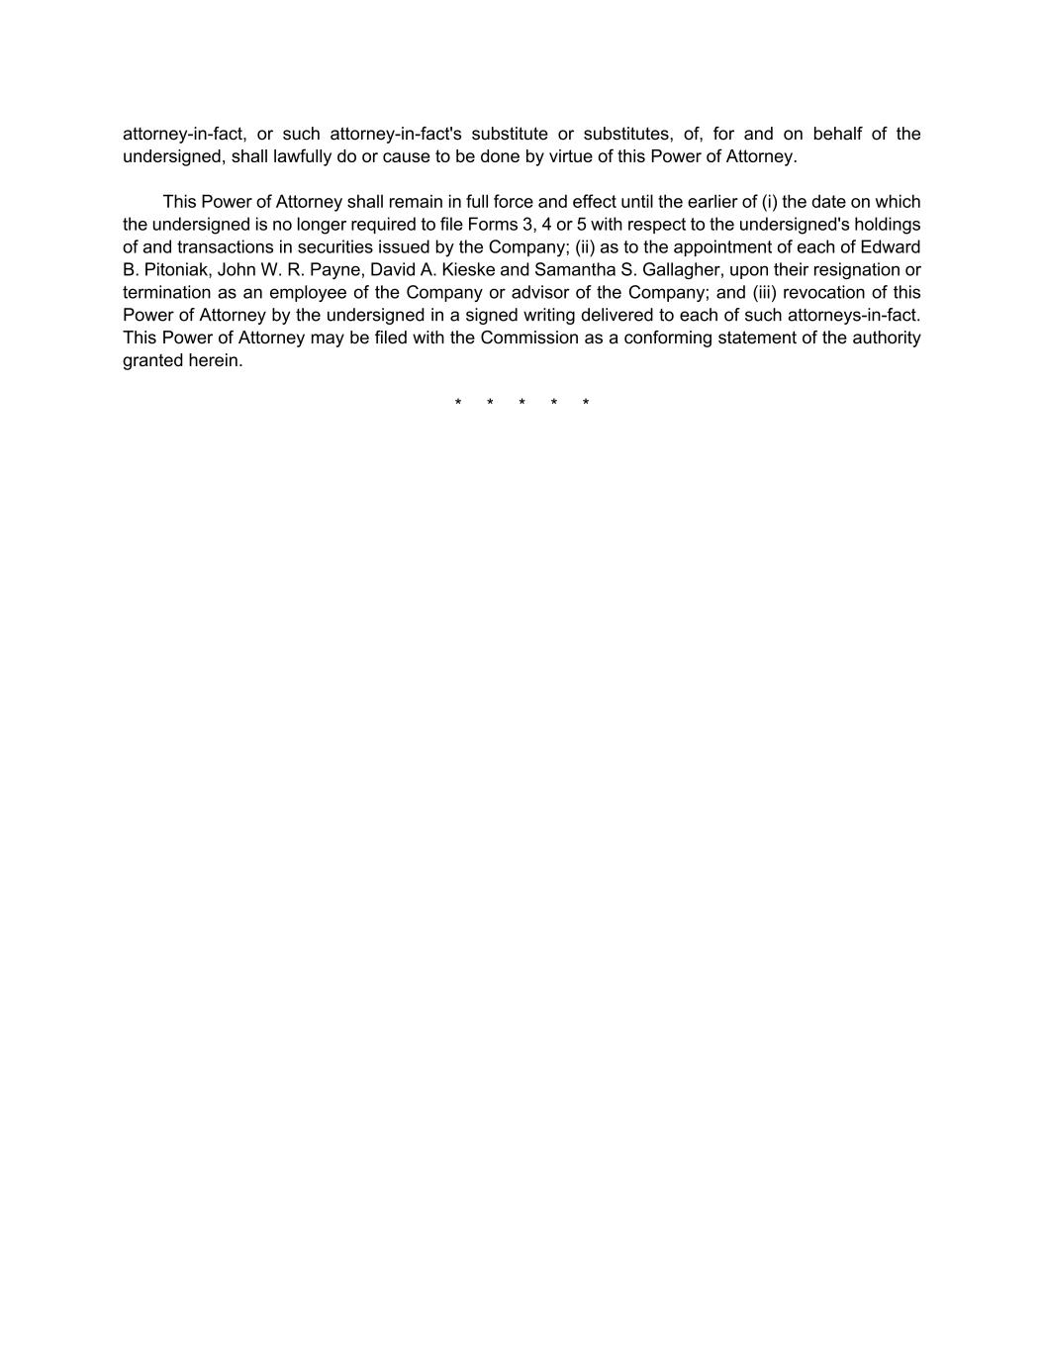
attorney-in-fact, or such attorney-in-fact's substitute or substitutes, of, for and on behalf of the undersigned, shall lawfully do or cause to be done by virtue of this Power of Attorney. This Power of Attorney shall remain in full force and effect until the earlier of (i) the date on which the undersigned is no longer required to file Forms 3, 4 or 5 with respect to the undersigned's holdings of and transactions in securities issued by the Company; (ii) as to the appointment of each of Edward B. Pitoniak, John W. R. Payne, David A. Kieske and Samantha S. Gallagher, upon their resignation or termination as an employee of the Company or advisor of the Company; and (iii) revocation of this Power of Attorney by the undersigned in a signed writing delivered to each of such attorneys-in-fact. This Power of Attorney may be filed with the Commission as a conforming statement of the authority granted herein. * * * * *

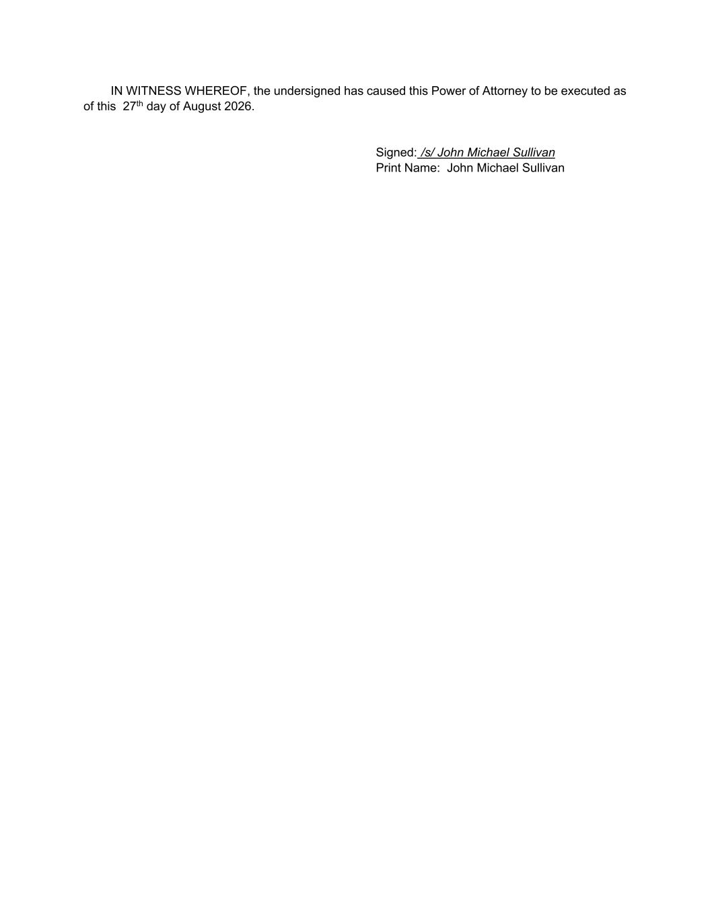
IN WITNESS WHEREOF, the undersigned has caused this Power of Attorney to be executed as of this 27th day of August 2026. Signed: /s/ John Michael Sullivan Print Name: John Michael Sullivan

