UNITED STATES
SECURITIES AND EXCHANGE COMMISSION
WASHINGTON, D.C. 20549
__________________________________________________
FORM 8-K
__________________________________________________

CURRENT REPORT PURSUANT TO
SECTION 13 OR 15(d) OF THE
SECURITIES EXCHANGE ACT OF 1934
Date of report (Date of earliest event reported): July 29, 2026
__________________________________________________
VICI Properties Inc.
VICI Properties L.P.
(Exact Name of Registrant as Specified in its Charter)
__________________________________________________
Maryland (VICI Properties Inc.) |  |  |  |  |  | 001-38372 |  |  |  |  |  | 81-4177147
Delaware (VICI Properties L.P.) |  |  |  |  |  | 333-264352-01 |  |  |  |  |  | 35-2576503
(State or Other Jurisdiction  of Incorporation) |  |  |  |  |  | (Commission  File Number) |  |  |  |  |  | (IRS Employer  Identification No.)
535 Madison Avenue
New York, New York 10022
(Address of Principal Executive Offices) (Zip Code)
Registrant’s telephone number, including area code: (646) 949-4631
Not Applicable
(Former Name or Former Address, if Changed Since Last Report)
__________________________________________________
Check the appropriate box below if the Form 8-K filing is intended to simultaneously satisfy the filing obligation of the registrant under any of the following provisions:
☐ |  |  | Written communications pursuant to Rule 425 under the Securities Act (17 CFR 230.425)
☐ |  |  | Soliciting material pursuant to Rule 14a-12 under the Exchange Act (17 CFR 240.14a-12)
☐ |  |  | Pre-commencement communications pursuant to Rule 14d-2(b) under the Exchange Act (17 CFR 240.14d-2(b))
☐ |  |  | Pre-commencement communications pursuant to Rule 13e-4(c) under the Exchange Act (17 CFR 240.13e-4(c))
Securities registered pursuant to Section 12(b) of the Act:
Title of each class |  |  |  |  |  | Trading Symbol |  |  |  |  |  | Name of each exchange on which registered
Common stock, $0.01 par value |  |  |  |  |  | VICI |  |  |  |  |  | New York Stock Exchange
Indicate by check mark whether the registrant is an emerging growth company as defined in Rule 405 of the Securities Act of 1933 (§230.405 of this chapter) or Rule 12b-2 of the Securities Exchange Act of 1934 (§240.12b-2 of this chapter).
VICI Properties Inc. |  |  | ☐ |  |  | Emerging growth company
VICI Properties L.P. |  |  | ☐ |  |  | Emerging growth company
If an emerging growth company, indicate by check mark if the registrant has elected not to use the extended transition period for complying with any new or revised financial accounting standards provided pursuant to Section 13(a) of the Exchange Act.
VICI Properties Inc. |  |  | ☐
VICI Properties L.P. |  |  | ☐

Item 2.02. |  |  | Results of Operations and Financial Condition.
On July 29, 2026, VICI Properties Inc. (the “Company”) issued a press release announcing its consolidated financial results for the three and six months ended June 30, 2026, and made available supplemental financial and operating information concerning the Company as of June 30, 2026. A copy of the press release and a copy of this supplemental information are furnished herewith as Exhibit 99.1 and Exhibit 99.2, respectively, to this Current Report on Form 8-K and are incorporated herein by reference.
Item 7.01. |  |  | Regulation FD Disclosure.
The disclosure contained in Item 2.02 is incorporated herein by reference.
The information included in Item 2.02 and Item 7.01 of this Current Report on Form 8-K, including Exhibit 99.1 and Exhibit 99.2, is being furnished and shall not be deemed “filed” for purposes of Section 18 of the Securities Exchange Act of 1934, as amended (the “Exchange Act”), or otherwise subject to the liabilities of that Section, nor shall it be deemed incorporated by reference into any of the Company’s filings under the Securities Act of 1933, as amended, or the Exchange Act, whether made before or after the date hereof and regardless of any general incorporation language in such filings, except to the extent expressly set forth by specific reference in such a filing. The furnishing of the information included in Item 7.01 of this Current Report on Form 8-K shall not be deemed an admission as to the materiality of any information herein that is required to be disclosed solely by reason of Regulation FD.
Item 9.01. |  |  | Financial Statements and Exhibits.
(d) Exhibits
Exhibit  No. |  |  |  |  |  | Description
99.1 |  |  |  |  |  | Press Release, dated July 29, 2026
99.2 |  |  |  |  |  | Supplemental Financial & Operating Data, Second Quarter Ended June 30, 2026
104 |  |  |  |  |  | Cover Page Interactive Data File (embedded within the Inline XBRL document)

SIGNATURES
Pursuant to the requirements of the Securities Exchange Act of 1934, each registrant has duly caused this report to be signed on its behalf by the undersigned hereunto duly authorized.
 |  |  | VICI PROPERTIES INC.
Date: July 29, 2026 |  |  | By: |  |  | /s/ SAMANTHA S. GALLAGHER
 |  |  |  |  |  | Samantha S. Gallagher
 |  |  |  |  |  | Executive Vice President, General Counsel and Secretary
 |  |  | VICI PROPERTIES L.P.
Date: July 29, 2026 |  |  | By: |  |  | /s/ SAMANTHA S. GALLAGHER
 |  |  |  |  |  | Samantha S. Gallagher
 |  |  |  |  |  | Secretary

Exhibit 99.1

VICI PROPERTIES INC. ANNOUNCES SECOND QUARTER 2026 RESULTS
- Announced Partnership with Club Med on the Acquisition and Redevelopment of Carambola Beach Resort in St. Croix -
- Added Clairvest, Golden Entertainment, and Club Med to Diversified Tenant Roster -
- Updates Guidance for Full Year 2026 -

NEW YORK, NY – July 29, 2026 – VICI Properties Inc. (NYSE: VICI) (“VICI Properties”, “VICI” or the “Company”), an experiential real estate investment trust, today reported results for the quarter ended June 30, 2026. All per share amounts included herein are on a per diluted common share basis unless otherwise stated.
Second Quarter 2026 Financial and Operating Highlights
•Total revenues increased 5.7% year-over-year to $1.1 billion
•Net income attributable to common stockholders decreased 39.1% year-over-year to $526.5 million and, on a per share basis, decreased 41.0% year-over-year to $0.48 due to the impact of the change in the CECL allowance for the quarter ended June 30, 2026
•AFFO attributable to common stockholders increased 7.8% year-over-year to $679.6 million and, on a per share basis, increased 4.6% year-over-year to $0.62
•Entered into a lease with an affiliate of funds managed by Clairvest in connection with its acquisition of the operations of MGM Northfield Park in Northfield, Ohio, adding VICI’s 14th tenant
•Closed the previously announced $1.16 billion acquisition of seven Nevada casino properties from Golden Entertainment and entered into a master lease with an entity owned and controlled by Blake L. Sartini, adding VICI’s 15th tenant
•Announced a build-to-suit transaction with Club Med whereby VICI acquired the Carambola Beach Resort in St. Croix for $20.3 million and leased it back to Club Med pursuant to a triple-net lease, adding VICI’s 16th tenant. As part of the transaction, VICI will fund approximately $55.2 million for redevelopment of the property
•Completed the acquisition of two gaming assets and two adjacent limited-service hotels in Alberta, Canada, for C$200.6 million (approximately US$141.0 million), in connection with the closing of Pure Casino Entertainment’s take-private acquisition of Gamehost Inc.
•Ended the quarter with $288.1 million in cash and cash equivalents
•Updated AFFO guidance for full year 2026 to between $2,675 million and $2,695 million, or between $2.45 and $2.47 per diluted share
CEO Comments
Edward Pitoniak, Chief Executive Officer of VICI Properties, said, “The second quarter of 2026 was emblematic of VICI’s enduring strategic focus on developing and expanding relationships. With the commencement of our lease with Clairvest at Northfield Park, the closing of our acquisition of the Golden Entertainment casino portfolio, and the acquisition and planned redevelopment of Carambola Beach Resort (St. Croix, US Virgin Islands) with Club Med, we welcomed our 14th, 15th and 16th tenants, respectively. Each one of these new tenants is an experienced operator that broadens and strengthens the diversity of VICI’s rent roll. In the case of Club Med, we are expanding our investment practice categorically and geographically, with a global hospitality brand committed to global growth. We believe that our investment in Club Med St. Croix is an ideal start to our long-term partnership. Furthermore, in the second quarter, we grew our quarterly revenue by 5.7% and our AFFO per share by 4.6% year-over-year, and we remain confident that VICI’s partner-driven model will continue to generate attractive, durable growth for our shareholders.”

Second Quarter 2026 Financial Results
Total Revenues
Total revenues were $1.1 billion for the quarter, an increase of 5.7% compared to $1.0 billion for the quarter ended June 30, 2025. Total revenues for the quarter included $139.1 million of non-cash leasing and financing adjustments and $18.9 million of other income.
Net Income Attributable to Common Stockholders
Net income attributable to common stockholders was $526.5 million for the quarter, or $0.48 per share, compared to $865.1 million, or $0.82 per share, for the quarter ended June 30, 2025. The year-over-year decrease in net income was driven, on an absolute basis, by the $413.1 million aggregate change in the CECL allowance for the quarter ended June 30, 2026 compared to the quarter ended June 30, 2025.
Funds from Operations (“FFO”)
FFO attributable to common stockholders was $526.5 million for the quarter, or $0.48 per share, compared to $865.1 million, or $0.82 per share, for the quarter ended June 30, 2025. The year-over-year decrease in FFO was driven, on an absolute basis, by the $413.1 million aggregate change in the CECL allowance for the quarter ended June 30, 2026 compared to the quarter ended June 30, 2025.
Adjusted Funds from Operations (“AFFO”)
AFFO attributable to common stockholders was $679.6 million for the quarter, an increase of 7.8% compared to $630.2 million for the quarter ended June 30, 2025. AFFO per share was $0.62 for the quarter, an increase of 4.6% compared to $0.60 for the quarter ended June 30, 2025.
Second Quarter 2026 Investment Activity
Investment Activity
On April 21, 2026, VICI entered into a new triple-net lease agreement (the “Northfield Park Lease”) with an affiliate of funds managed by Clairvest Group Inc. (“Clairvest”) with respect to the real property of MGM Northfield Park, located in Northfield, Ohio (“Northfield Park”), in connection with MGM Resorts International’s (NYSE: MGM) (“MGM”) previously announced agreement to sell the operations of Northfield Park to an affiliate of Clairvest. In connection with closing, VICI entered into an amendment to the existing MGM Master Lease in order to account for MGM’s divestiture of the operations of Northfield Park and to reduce the annual base rent under the MGM Master Lease by the initial base rent under the Northfield Park Lease. The Northfield Park Lease had an initial annual base rent of $53.0 million at closing (which increased to $54.0 million following a 2.0% escalation on May 1, 2026) and a 25-year lease term with three 10-year tenant renewal options, with other economic terms substantially similar to the MGM Master Lease, including escalation of 2.0% per annum on May 1st each year (with escalation equal to the greater of 2.0% and the change in CPI (capped at 3.0%) beginning at the same time as the MGM Master Lease in 2032). The Northfield Park Lease is guaranteed by an affiliate of funds managed by Clairvest that owns the operations of Northfield Park, with additional credit support provided by financial covenants within the lease.
2
On April 30, 2026, VICI closed the previously announced $1.16 billion acquisition of 100% of the land, real property and improvements of seven casino properties from Golden Entertainment, Inc. (NASDAQ: GDEN) (“Golden Entertainment”). VICI entered into a triple-net master lease (the “Golden Entertainment Master Lease”) with a newly formed entity owned and controlled by Blake L. Sartini, former chairman and chief executive officer of Golden Entertainment, which concurrently acquired the operating business of Golden Entertainment (“Golden OpCo”). The Golden Entertainment Master Lease has an initial total annual rent of $87.0 million, representing an acquisition cap rate of 7.5%, and an initial term of 30 years, with four 5-year tenant renewal options. Rent under the Golden Entertainment Master Lease will escalate annually at 2.0% beginning in Lease Year 3. The obligations of Golden OpCo under the Golden Entertainment Master Lease are guaranteed by a holding company owned and controlled by Mr. Sartini which owns all of the gaming and operating assets of Golden Entertainment, with additional credit support provided by financial covenants within the lease. Upon the closing of this transaction, prior Golden Entertainment shareholders received approximately 24.3 million shares of newly issued VICI common stock in exchange for the outstanding shares of Golden Entertainment stock, which represented an agreed-upon exchange ratio of 0.902 per share of Golden Entertainment’s common stock based on VICI’s 10-day volume weighted average price as of November 5, 2025, as well as cash consideration that was payable by an affiliate of the Golden OpCo. In connection with the closing of the transaction, VICI assumed and immediately retired Golden Entertainment’s outstanding $426.0 million of debt using a combination of cash on hand and net proceeds from the settlement of outstanding forward sale agreements.
On June 15, 2026, VICI and Club Med Group (“Club Med”) announced a partnership to acquire the Carambola Beach Resort in St. Croix, U.S. Virgin Islands (the “Carambola Resort”). VICI has acquired the Carambola Resort for $20.3 million and leased it to Club Med under a triple-net lease and will fund Club Med's planned $55.2 million redevelopment of the Carambola Resort through a build-to-suit structure. Construction is expected to commence in the summer of 2026 with a targeted reopening in the fourth quarter of 2027. Upon completion, the Carambola Resort will join Club Med's Exclusive Collection, the brand's portfolio of premium all-inclusive resorts.
On June 24, 2026, VICI completed the previously announced C$200.6 million (US$141.0 million based on the exchange rate at the time of the transaction closing) acquisition of the real estate assets of Deerfoot Inn & Casino, Great Northern Casino and two limited-service hotels that are adjacent to the Great Northern Casino (collectively, the “Gamehost Portfolio”) located in Alberta, Canada, in connection with the closing of Pure Casino Entertainment Limited Partnership’s (“PURE”) take-private acquisition of Gamehost Inc.(“Gamehost”). VICI funded the acquisition with a combination of cash on hand and through a Canadian dollar-denominated draw on its multicurrency revolving credit facility. Simultaneous with the closing of the acquisition, the Gamehost Portfolio was added to the existing triple-net master lease agreement between VICI and PURE (the “PURE Master Lease”) and annual rent increased by C$16.1 million (US$11.3 million based on the exchange rate at the time of the transaction closing). The Gamehost Portfolio rent will escalate at 1.0% on February 1, 2028, and subsequent escalation will conform to the PURE Master Lease thereafter at the greater of 1.5% or the change in Canadian CPI (capped at 2.5%). Additionally, the term of the PURE Master Lease was extended such that the PURE Master Lease has a full 25-years remaining in the initial base lease term, with four 5-year tenant renewal options. The tenants’ obligations under the PURE Master Lease continue to be guaranteed by Indigenous Gaming Partners, Inc.
Second Quarter 2026 Capital Markets Activity
On April 29, 2026, VICI physically settled the remaining 7,750,000 shares under its outstanding forward sale agreement in exchange for total net settlement proceeds of approximately $242.1 million.
3
On June 23, 2026, VICI drew C$185.0 million on its revolving credit facility to fund a portion of the purchase price of the Gamehost Portfolio acquisition.
During the three months ended June 30, 2026, VICI entered into forward-starting interest rate swap agreements with an aggregate notional amount of $150.0 million. As of quarter end, VICI has entered into a total of $600.0 million of forward-starting interest rate swap agreements, intended to reduce the variability in future cash flows for a forecasted issuance of long-term debt.
The following table details the issuance of outstanding shares of common stock, including restricted common stock:
 |  |  |  |  |  | Six Months Ended June 30,
Common Stock Outstanding |  |  |  |  |  | 2026 |  |  |  |  |  | 2025
Beginning Balance January 1, |  |  |  |  |  | 1,068,811,371 |  |  |  |  |  | 1,056,366,685
Issuance of common stock in connection with the Golden Entertainment Transaction |  |  |  |  |  | 24,296,255 |  |  |  |  |  | —
Issuance of common stock upon physical settlement of forward sale agreements |  |  |  |  |  | 7,750,000 |  |  |  |  |  | —
Issuance of restricted and unrestricted common stock under the stock incentive program, net of forfeitures |  |  |  |  |  | 217,280 |  |  |  |  |  | 339,078
Ending Balance June 30, |  |  |  |  |  | 1,101,074,906 |  |  |  |  |  | 1,056,705,763
The following table reconciles the weighted-average shares of common stock outstanding used in the calculation of basic earnings per share to the weighted-average shares of common stock outstanding used in the calculation of diluted earnings per share:
 |  |  | Three Months Ended June 30, |  |  |  |  |  |  |  |  |  |  |  | Six Months Ended June 30,
(In thousands) |  |  | 2026 |  |  |  |  |  | 2025 |  |  |  |  |  | 2026 |  |  |  |  |  | 2025
Determination of shares:
Weighted-average shares of common stock outstanding |  |  | 1,090,197 |  |  |  |  |  | 1,056,223 |  |  |  |  |  | 1,079,358 |  |  |  |  |  | 1,056,118
Assumed conversion of restricted stock |  |  | 40 |  |  |  |  |  | 669 |  |  |  |  |  | 84 |  |  |  |  |  | 530
Assumed settlement of forward sale agreements |  |  | — |  |  |  |  |  | 379 |  |  |  |  |  | — |  |  |  |  |  | 204
Diluted weighted-average shares of common stock outstanding |  |  | 1,090,237 |  |  |  |  |  | 1,057,271 |  |  |  |  |  | 1,079,442 |  |  |  |  |  | 1,056,852
Balance Sheet and Liquidity
As of June 30, 2026, the Company had approximately $17.2 billion in total debt and approximately $2.5 billion in liquidity, comprised of $288.1 million in cash and cash equivalents and approximately $2.2 billion of availability under its revolving credit facility.
4
The Company’s outstanding indebtedness as of June 30, 2026 was as follows:
($ in millions USD) |  |  | June 30, 2026
Revolving Credit Facility
USD Borrowings |  |  | $ | —
CAD Borrowings (1) |  |  | 246.5
GBP Borrowings (1) |  |  | 21.9
4.500% Notes Due 2026 |  |  | 500.0
4.250% Notes Due 2026 |  |  | 1,250.0
5.750% Notes Due 2027 |  |  | 750.0
3.750% Notes Due 2027 |  |  | 750.0
4.500% Notes Due 2028 |  |  | 350.0
4.750% Notes Due 2028 |  |  | 1,250.0
4.750% Notes Due 2028 |  |  | 400.0
3.875% Notes Due 2029 |  |  | 750.0
4.625% Notes Due 2029 |  |  | 1,000.0
4.950% Notes Due 2030 |  |  | 1,000.0
4.125% Notes Due 2030 |  |  | 1,000.0
5.125% Notes Due 2031 |  |  | 750.0
5.125% Notes Due 2032 |  |  | 1,500.0
5.750% Notes Due 2034 |  |  | 550.0
5.625% Notes Due 2035 |  |  | 900.0
5.625% Notes Due 2052 |  |  | 750.0
6.125% Notes Due 2054 |  |  | 500.0
Total Unsecured Debt Outstanding |  |  | $ | 14,218.4
CMBS Debt Due 2032 |  |  | $ | 3,000.0
Total Debt Outstanding |  |  | $ | 17,218.4
Cash and Cash Equivalents |  |  | $ | 288.1
Net Debt |  |  | $ | 16,930.3
___________________
(1) Based on applicable exchange rates as of June 30, 2026.
Dividends
On June 4, 2026, the Company declared a regular quarterly cash dividend of $0.45 per share. The Q2 2026 dividend was paid on July 9, 2026 to stockholders of record as of the close of business on June 18, 2026 and totaled in aggregate approximately $495.3 million.
2026 Guidance
The Company is updating its AFFO guidance for the full year 2026. In determining AFFO, the Company adjusts for certain items that are otherwise included in determining net income attributable to common stockholders, the most comparable generally accepted accounting principles in the United States (“GAAP”) financial measure. In reliance on the exception provided by applicable rules, the Company does not provide guidance for GAAP net income, the most comparable GAAP financial measure, or a reconciliation of 2026 AFFO to GAAP net income because we are unable to predict with reasonable certainty the amount of the change in non-cash allowance for credit losses under ASU No. 2016-13 - Financial Instruments—Credit Losses (Topic 326) (“ASC 326”) for a future period. The non-cash change in allowance for credit losses under ASC 326 with respect to a future period is dependent upon future events that are entirely outside of the Company’s control and may not be reliably predicted, including its tenants’ respective financial performance, fluctuations in the trading price of their common stock, credit ratings and
5
outlook (each to the extent applicable), as well as broader macroeconomic performance. Based on past results and, as disclosed in our historical financial results, the impact of these adjustments could be material, individually or in the aggregate, to the Company’s reported GAAP results. For more information, see “Non-GAAP Financial Measures.”
The Company estimates AFFO for the year ending December 31, 2026 will be between $2,675 million and $2,695 million, or between $2.45 and $2.47 per diluted common share. Guidance does not include the impact on operating results from any pending acquisitions without announced expected closing dates, possible future acquisitions or dispositions, capital markets activity, or other non-recurring transactions.
The following is a summary of the Company’s updated full-year 2026 guidance:
 |  |  |  |  |  | Updated Guidance |  |  |  |  |  |  |  |  |  |  |  | Prior Guidance
For the Year Ending December 31, 2026: |  |  |  |  |  | Low |  |  |  |  |  | High |  |  |  |  |  | Low |  |  |  |  |  | High
Estimated Adjusted Funds From Operations (AFFO) (in millions) |  |  |  |  |  | $2,675 |  |  |  |  |  | $2,695 |  |  |  |  |  | $2,665 |  |  |  |  |  | $2,695
Estimated Adjusted Funds From Operations (AFFO) per diluted share |  |  |  |  |  | $2.45 |  |  |  |  |  | $2.47 |  |  |  |  |  | $2.44 |  |  |  |  |  | $2.47
Estimated Weighted Average Share Count for the Year (in millions) |  |  |  |  |  | 1,090.3 |  |  |  |  |  | 1,090.3 |  |  |  |  |  | 1,090.7 |  |  |  |  |  | 1,090.7
VICI partnership units held by third parties are reflected as non-controlling interests and the income allocable to them is deducted from net income to arrive at net income attributable to common stockholders and AFFO; accordingly, guidance represents AFFO per share attributable to common stockholders based solely on outstanding shares of VICI common stock.
The estimates set forth above reflect management’s view of current and future market conditions, including assumptions with respect to the earnings impact of the events referenced in this release. The estimates set forth above may be subject to fluctuations as a result of several factors and there can be no assurance that the Company’s actual results will not differ materially from the estimates set forth above.
Supplemental Information
In addition to this release, the Company has furnished Supplemental Financial Information, which is available on our website in the “Investors” section, under the menu heading “Financials”. This additional information is being provided as a supplement to the information in this release and our other filings with the SEC. The Company has no obligation to update any of the information provided to conform to actual results or changes in the Company’s portfolio, capital structure or future expectations, except as may be required by applicable law.
Conference Call and Webcast
The Company will host a conference call and audio webcast on Thursday, July 30, 2026 at 10:00 a.m. Eastern Time (ET). Please visit the VICI Properties website (https://investors.viciproperties.com/news-events/events) to listen to the earnings call via a live webcast. Listeners who wish to participate in the question and answer session may do so via telephone by pre-registering on the Company’s earnings call registration webpage (https://register-conf.media-server.com/register/BI0d4c1813f7fa4085ae557ba8cb179bad). All registrants will receive dial-in information and a PIN allowing them to access the live call. An on-demand replay of the earnings call will be available on the Company’s website (https://investors.viciproperties.com/news-events/events) immediately following the conclusion of the live call for a period of one year.
6
About VICI Properties
VICI Properties Inc. is an S&P 500® experiential real estate investment trust that owns one of the largest portfolios of market-leading gaming, hospitality, wellness, entertainment and leisure destinations, including Caesars Palace Las Vegas, MGM Grand and the Venetian Resort Las Vegas, three of the most iconic entertainment facilities on the Las Vegas Strip. VICI Properties owns 103 experiential assets across a geographically diverse portfolio consisting of 63 gaming properties and 40 other experiential properties across the United States and Canada. The portfolio is comprised of approximately 130 million square feet and features approximately 66,000 hotel rooms and over 700 restaurants, bars, nightclubs and sportsbooks. Its properties are occupied by industry-leading gaming, leisure and hospitality operators under long-term, triple-net lease agreements. VICI Properties has a growing array of real estate and financing partnerships with leading operators in other experiential sectors, including Cabot, Cain, Canyon Ranch, Chelsea Piers, Club Med, Great Wolf Resorts, Homefield, Kalahari Resorts and Lucky Strike Entertainment. VICI Properties also owns four championship golf courses and approximately 33 acres of undeveloped and underdeveloped land adjacent to the Las Vegas Strip. VICI Properties’ goal is to create the highest quality and most productive experiential real estate portfolio through a strategy of partnering with the highest quality experiential place makers and operators. For additional information, please visit www.viciproperties.com.
Forward-Looking Statements
This press release contains forward-looking statements within the meaning of the federal securities laws. You can identify these statements by our use of the words “anticipates,” “assumes,” “believes,” “estimates,” “expects,” “guidance,” “intends,” “plans,” “projects,” and similar expressions that do not relate to historical matters. All statements other than statements of historical fact are forward-looking statements. You should exercise caution in interpreting and relying on forward-looking statements because they involve known and unknown risks, uncertainties, and other factors which are, in some cases, beyond the Company’s control and could materially affect actual results, performance, or achievements, which could differ materially from those set forth in the forward-looking statements and may be affected by a variety of risks. Among those risks, uncertainties and other factors are: the impact of changes in general economic conditions and market developments, including inflation, interest rate changes and volatility, tariffs and trade barriers, supply chain disruptions, changes in consumer spending, consumer confidence levels, unemployment levels, governmental action (including significant layoffs or reductions in force among federal government employees or a prolonged U.S. federal government shutdown), and depressed real estate prices resulting from the severity and duration of any downturn or recession in the U.S. or global economy; our ability to successfully pursue and consummate transactions, including investments in, and acquisitions of, real estate and to obtain debt financing for such investments at attractive interest rates, or at all; risks associated with our pending and completed transactions, including our ability or failure to realize the anticipated benefits thereof; our dependence on our tenants at our properties and their affiliates that serve as guarantors of the lease payments, and the negative consequences any material adverse effect on their respective businesses could have on us; the possibility that any pending or future transactions may not be consummated on the terms or timeframes contemplated, or at all, including our ability to obtain the financing necessary to complete any acquisitions on the terms we expect in a timely manner, or at all, the ability of the parties to satisfy the conditions set forth in the definitive transaction documents, including the receipt of, or delays in obtaining, governmental and regulatory approvals and consents required to consummate such transactions, or other delays or impediments to completing the transactions; the anticipated benefits of certain arrangements with certain tenants in connection with our funding of “same store” capital improvements in exchange for increased rent pursuant to the terms of our agreements with such tenants, which we refer to as the Partner Property Growth Fund strategy; our decision and ability to exercise our purchase rights under our put-call agreements, call agreements, right of first refusal agreements and right of first offer
7
agreements; the credit risk of our tenants and borrowers in connection with the rental and other obligations owed to us under applicable leases, related guarantees, or loan agreements, including risks distinct to our lending activities with respect to development and construction loans for non-stabilized properties; our dependence on the gaming industry, which is characterized by, among other things, a high degree of competition, extensive regulation, and sensitivity to changes in consumer behavior and discretionary spending; our ability to pursue our business and growth strategies may be limited by the requirement that we distribute 90% of our REIT taxable income in order to qualify for taxation as a REIT and that we distribute 100% of our REIT taxable income in order to avoid current entity-level U.S. federal income taxes; the impact of extensive regulation from gaming and other regulatory authorities, including developments relating to the regulation of emerging alternative platforms; the ability of our tenants to obtain and maintain regulatory approvals in connection with the operation of our properties, or the imposition of conditions to such regulatory approvals; the possibility that our tenants may choose not to renew their respective lease agreements following the initial or subsequent terms of the leases; restrictions on our ability to sell our properties subject to the lease agreements; our tenants and any guarantors’ historical results may not be a reliable indicator of their future results; our substantial amount of indebtedness and ability to service, refinance (at attractive interest rates, or at all), and otherwise fulfill our obligations under such indebtedness; our historical financial information may not be reliable indicators of our future results of operations, financial condition and cash flows; the possibility that we identify significant environmental, tax, legal or other issues, including additional costs or liabilities, that materially and adversely impact the value of assets acquired or secured as collateral (or other benefits we expect to receive) in any of our pending and completed transactions; the impact of changes to tax laws and regulations, including U.S. federal income tax laws, state tax laws or global tax laws; the impact of changes in governmental or regulatory actions and initiatives; the possibility of adverse tax consequences as a result of our pending and completed transactions, including pursuant to tax protection agreements to which we are a party; increased volatility in our stock price, including as a result of our pending and completed transactions; our inability to maintain our qualification for taxation as a REIT; the impact of climate change, natural disasters or other severe weather events, war or conflict, geopolitical uncertainty, tariffs and trade barriers, public health conditions, uncertainty or civil unrest, violence or terrorist activities or threats on our properties, or in areas where our properties are located, or globally, and changes in economic conditions or heightened travel security, and any measures instituted in response to these events; the impact of reduced travel demand or increased costs of travel affecting visitation and operating performance at the properties operated by our tenants, particularly in destination markets such as Las Vegas; the loss of the services of key personnel; the inability to attract, retain and motivate employees; the costs and liabilities associated with environmental compliance; failure to establish and maintain an effective system of integrated internal controls; the risks related to us or our tenants not having adequate insurance to cover potential losses; the potential impact on the amount of our cash distributions if we determine to sell or divest any of our properties in the future or are unable to redeploy capital returned from investments at attractive rates, or at all; our ability to continue to make distributions to holders of our common stock or maintain anticipated levels of distributions over time, including our reliance on distributions received from our subsidiaries, including VICI OP, to make such distributions to our stockholders; and competition for transaction opportunities, including from other REITs, investment companies, private equity firms and hedge funds, sovereign funds, lenders, gaming companies and other investors that may have greater resources and access to capital and a lower cost of capital or different investment parameters than us.
Although the Company believes that in making such forward-looking statements its expectations are based upon reasonable assumptions, such statements may be influenced by factors that could cause actual outcomes and results to be materially different from those projected. The Company cannot assure you that the assumptions upon which these statements are based will prove to have been correct. Additional important factors that may affect the Company’s business, results of operations and financial
8
position are described from time to time in the Company’s Annual Report on Form 10-K for the year ended December 31, 2025, Quarterly Reports on Form 10-Q and the Company’s other filings with the Securities and Exchange Commission. The Company does not undertake any obligation to update or revise any forward-looking statement, whether as a result of new information, future events, or otherwise, except as may be required by applicable law.
Non-GAAP Financial Measures
This press release presents Funds From Operations (“FFO”), FFO per share, Adjusted Funds From Operations (“AFFO”), AFFO per share and Adjusted EBITDA, which are not required by, or presented in accordance with, generally accepted accounting principles in the United States (“GAAP”). These are non-GAAP financial measures and should not be construed as alternatives to net income or as an indicator of operating performance (as determined in accordance with GAAP). We believe FFO, FFO per share, AFFO, AFFO per share and Adjusted EBITDA provide a meaningful perspective of the underlying operating performance of our business.
FFO is a non-GAAP financial measure that is considered a supplemental measure for the real estate industry and a supplement to GAAP measures. Consistent with the definition used by the National Association of Real Estate Investment Trusts (Nareit), we define FFO as our net income (or loss) attributable to common stockholders (computed in accordance with GAAP) excluding (i) gains (or losses) from sales of certain real estate assets, (ii) depreciation and amortization related to real estate, (iii) gains and losses from change in control and (iv) impairment write-downs of certain real estate assets and investments in entities when the impairment is directly attributable to decreases in the value of depreciable real estate held by the entity.
AFFO is a non-GAAP financial measure that we use as a supplemental operating measure to evaluate our performance. We calculate AFFO by adding or subtracting from FFO non-cash leasing and financing adjustments, non-cash change in allowance for credit losses, non-cash stock-based compensation expense, transaction costs incurred in connection with the acquisition of real estate investments, amortization of debt issuance costs and original issue discount, other non-cash interest expense, capitalized interest on real estate under development, non-real estate depreciation (which is comprised of the depreciation related to our golf course operations), capital expenditures (which are comprised of additions to property, plant and equipment related to our golf course operations), impairment charges related to non-depreciable real estate, gains (or losses) on debt extinguishment and interest rate swap settlements, other gains (or losses), deferred income tax expenses and benefits, other non-recurring non-cash transactions and non-cash adjustments attributable to non-controlling interest with respect to certain of the foregoing.
We calculate Adjusted EBITDA by adding or subtracting from AFFO contractual interest expense (including the impact of the forward-starting interest rate swaps and treasury locks) and interest income (collectively, interest expense, net), current income tax expense and adjustments attributable to non-controlling interests.
These non-GAAP financial measures: (i) do not represent cash flow from operations as defined by GAAP; (ii) should not be considered as an alternative to net income as a measure of operating performance or to cash flows from operating, investing and financing activities; and (iii) are not alternatives to cash flow as a measure of liquidity. In addition, these measures should not be viewed as measures of liquidity, nor do they measure our ability to fund all of our cash needs, including our ability to make cash distributions to our stockholders, to fund capital improvements, or to make interest payments on our indebtedness. Investors are also cautioned that FFO, FFO per share, AFFO, AFFO per share and Adjusted EBITDA, as presented, may not be comparable to similarly titled measures reported by other real estate companies, including REITs, due to the fact that not all real estate
9
companies use the same definitions. Our presentation of these measures does not replace the presentation of our financial results in accordance with GAAP.
Reconciliations of net income to FFO, FFO per share, AFFO, AFFO per share and Adjusted EBITDA are included in this release.

10
VICI Properties Inc.
Consolidated Balance Sheets
(In thousands)

 |  |  | June 30, 2026 |  |  |  |  |  | December 31, 2025
Assets
Real estate portfolio:
Investments in leases - sales-type, net |  |  | $ | 24,577,355 |  |  |  |  | $ | 23,706,563
Investments in leases - financing receivables, net |  |  | 19,280,057 |  |  |  |  |  | 18,697,133
Investments in loans and securities, net |  |  | 2,917,311 |  |  |  |  |  | 2,525,457
Real estate under development |  |  | 23,272 |  |  |  |  |  | —
Land |  |  | 148,002 |  |  |  |  |  | 148,002
Cash and cash equivalents |  |  | 288,063 |  |  |  |  |  | 563,479
Short-term investments |  |  | — |  |  |  |  |  | 44,484
Other assets |  |  | 1,037,160 |  |  |  |  |  | 1,039,050
Total assets |  |  | $ | 48,271,220 |  |  |  |  | $ | 46,724,168
Liabilities
Debt, net |  |  | $ | 16,931,155 |  |  |  |  | $ | 16,773,241
Accrued expenses and deferred revenue |  |  | 220,415 |  |  |  |  |  | 238,715
Dividends and distributions payable |  |  | 500,755 |  |  |  |  |  | 486,259
Other liabilities |  |  | 1,016,184 |  |  |  |  |  | 1,003,366
Total liabilities |  |  | 18,668,509 |  |  |  |  |  | 18,501,581
Stockholders’ equity
Common stock |  |  | 11,011 |  |  |  |  |  | 10,688
Preferred stock |  |  | — |  |  |  |  |  | —
Additional paid-in capital |  |  | 25,854,906 |  |  |  |  |  | 24,898,868
Accumulated other comprehensive income |  |  | 115,412 |  |  |  |  |  | 121,031
Retained earnings |  |  | 3,189,420 |  |  |  |  |  | 2,767,053
Total VICI stockholders’ equity |  |  | 29,170,749 |  |  |  |  |  | 27,797,640
Non-controlling interests |  |  | 431,962 |  |  |  |  |  | 424,947
Total stockholders’ equity |  |  | 29,602,711 |  |  |  |  |  | 28,222,587
Total liabilities and stockholders’ equity |  |  | $ | 48,271,220 |  |  |  |  | $ | 46,724,168
________________________________________
Note: As of June 30, 2026 and December 31, 2025, our Investments in leases - sales-type, Investments in leases - financing receivables, Investments in loans and securities and Other assets (sales-type sub-leases) are net of allowance for credit losses of $1,014.8 million, $769.0 million, $92.1 million and $27.0 million, respectively, and $919.2 million, $769.9 million, $56.4 million and $23.9 million, respectively.

11
VICI Properties Inc.
Consolidated Statement of Operations
(In thousands, except share and per share data)

 |  |  | Three Months Ended June 30, |  |  |  |  |  |  |  |  |  |  |  | Six Months Ended June 30,
 |  |  | 2026 |  |  |  |  |  | 2025 |  |  |  |  |  | 2026 |  |  |  |  |  | 2025
Revenues
Income from sales-type leases |  |  | $ | 549,202 |  |  |  |  | $ | 530,348 |  |  |  |  | $ | 1,085,919 |  |  |  |  | $ | 1,058,952
Income from lease financing receivables, loans and securities |  |  | 478,395 |  |  |  |  |  | 440,260 |  |  |  |  |  | 930,348 |  |  |  |  |  | 866,740
Other income |  |  | 18,915 |  |  |  |  |  | 19,536 |  |  |  |  |  | 37,814 |  |  |  |  |  | 39,049
Golf revenues |  |  | 11,993 |  |  |  |  |  | 11,190 |  |  |  |  |  | 22,945 |  |  |  |  |  | 20,797
Total revenues |  |  | 1,058,505 |  |  |  |  |  | 1,001,334 |  |  |  |  |  | 2,077,026 |  |  |  |  |  | 1,985,538
Expenses
General and administrative |  |  | 15,429 |  |  |  |  |  | 14,561 |  |  |  |  |  | 31,405 |  |  |  |  |  | 29,421
Depreciation |  |  | 998 |  |  |  |  |  | 741 |  |  |  |  |  | 1,965 |  |  |  |  |  | 1,737
Other expenses |  |  | 18,915 |  |  |  |  |  | 19,536 |  |  |  |  |  | 37,814 |  |  |  |  |  | 39,049
Golf expenses |  |  | 7,395 |  |  |  |  |  | 6,619 |  |  |  |  |  | 13,864 |  |  |  |  |  | 12,971
Change in allowance for credit losses |  |  | 271,059 |  |  |  |  |  | (142,001) |  |  |  |  |  | 152,284 |  |  |  |  |  | 44,956
Transaction and acquisition expenses |  |  | 1,815 |  |  |  |  |  | 7,434 |  |  |  |  |  | 1,982 |  |  |  |  |  | 7,479
Total expenses |  |  | 315,611 |  |  |  |  |  | (93,110) |  |  |  |  |  | 239,314 |  |  |  |  |  | 135,613
Interest expense |  |  | (209,927) |  |  |  |  |  | (213,797) |  |  |  |  |  | (419,289) |  |  |  |  |  | (423,048)
Interest income |  |  | 2,228 |  |  |  |  |  | 2,293 |  |  |  |  |  | 6,721 |  |  |  |  |  | 5,990
Other (losses) gains |  |  | (345) |  |  |  |  |  | 992 |  |  |  |  |  | (366) |  |  |  |  |  | 874
Income before income taxes |  |  | 534,850 |  |  |  |  |  | 883,932 |  |  |  |  |  | 1,424,778 |  |  |  |  |  | 1,433,741
Benefit from (provision for) income taxes |  |  | 461 |  |  |  |  |  | (5,564) |  |  |  |  |  | (3,513) |  |  |  |  |  | (3,108)
Net income |  |  | 535,311 |  |  |  |  |  | 878,368 |  |  |  |  |  | 1,421,265 |  |  |  |  |  | 1,430,633
Less: Net income attributable to non-controlling interests |  |  | (8,790) |  |  |  |  |  | (13,289) |  |  |  |  |  | (22,354) |  |  |  |  |  | (21,947)
Net income attributable to common stockholders |  |  | $ | 526,521 |  |  |  |  | $ | 865,079 |  |  |  |  | $ | 1,398,911 |  |  |  |  | $ | 1,408,686
Net income per common share
Basic |  |  | $ | 0.48 |  |  |  |  | $ | 0.82 |  |  |  |  | $ | 1.30 |  |  |  |  | $ | 1.33
Diluted |  |  | $ | 0.48 |  |  |  |  | $ | 0.82 |  |  |  |  | $ | 1.30 |  |  |  |  | $ | 1.33
Weighted average number of shares of common stock outstanding
Basic |  |  | 1,090,197,080 |  |  |  |  |  | 1,056,222,836 |  |  |  |  |  | 1,079,358,468 |  |  |  |  |  | 1,056,118,206
Diluted |  |  | 1,090,236,611 |  |  |  |  |  | 1,057,270,580 |  |  |  |  |  | 1,079,442,313 |  |  |  |  |  | 1,056,852,269

12
VICI Properties Inc.
Reconciliation of Net Income to FFO, FFO per Share, AFFO, AFFO per Share and Adjusted EBITDA
(In thousands, except share and per share data)

 |  |  | Three Months Ended June 30, |  |  |  |  |  |  |  |  |  |  |  | Six Months Ended June 30,
 |  |  | 2026 |  |  |  |  |  | 2025 |  |  |  |  |  | 2026 |  |  |  |  |  | 2025
Net income attributable to common stockholders |  |  | $ | 526,521 |  |  |  |  | $ | 865,079 |  |  |  |  | $ | 1,398,911 |  |  |  |  | $ | 1,408,686
Real estate depreciation |  |  | — |  |  |  |  |  | — |  |  |  |  |  | — |  |  |  |  |  | —
FFO attributable to common stockholders |  |  | 526,521 |  |  |  |  |  | 865,079 |  |  |  |  |  | 1,398,911 |  |  |  |  |  | 1,408,686
Non-cash leasing and financing adjustments |  |  | (139,145) |  |  |  |  |  | (130,022) |  |  |  |  |  | (269,177) |  |  |  |  |  | (262,069)
Non-cash change in allowance for credit losses |  |  | 271,059 |  |  |  |  |  | (142,001) |  |  |  |  |  | 152,284 |  |  |  |  |  | 44,956
Non-cash stock-based compensation |  |  | 4,609 |  |  |  |  |  | 4,439 |  |  |  |  |  | 8,734 |  |  |  |  |  | 7,343
Transaction and acquisition expenses |  |  | 1,815 |  |  |  |  |  | 7,434 |  |  |  |  |  | 1,982 |  |  |  |  |  | 7,479
Amortization of debt issuance costs and original issue discount |  |  | 17,406 |  |  |  |  |  | 18,743 |  |  |  |  |  | 34,689 |  |  |  |  |  | 37,514
Capitalized interest on real estate under development |  |  | (56) |  |  |  |  |  | — |  |  |  |  |  | (56) |  |  |  |  |  | —
Other depreciation |  |  | 866 |  |  |  |  |  | 611 |  |  |  |  |  | 1,702 |  |  |  |  |  | 1,478
Capital expenditures |  |  | (131) |  |  |  |  |  | (618) |  |  |  |  |  | (760) |  |  |  |  |  | (750)
Other losses (gains) (1) |  |  | 345 |  |  |  |  |  | (992) |  |  |  |  |  | 366 |  |  |  |  |  | (874)
Deferred income tax (benefit) provision |  |  | (2,096) |  |  |  |  |  | 4,048 |  |  |  |  |  | 10 |  |  |  |  |  | 72
Non-cash adjustments attributable to non-controlling interests |  |  | (1,557) |  |  |  |  |  | 3,457 |  |  |  |  |  | 1,858 |  |  |  |  |  | 2,325
AFFO attributable to common stockholders |  |  | 679,636 |  |  |  |  |  | 630,178 |  |  |  |  |  | 1,330,543 |  |  |  |  |  | 1,246,160
Interest expense, net |  |  | 190,349 |  |  |  |  |  | 192,761 |  |  |  |  |  | 377,935 |  |  |  |  |  | 379,544
Current income tax expense |  |  | 1,635 |  |  |  |  |  | 1,516 |  |  |  |  |  | 3,503 |  |  |  |  |  | 3,036
Adjustments attributable to non-controlling interests |  |  | (2,118) |  |  |  |  |  | (2,216) |  |  |  |  |  | (4,253) |  |  |  |  |  | (4,365)
Adjusted EBITDA attributable to common stockholders |  |  | $ | 869,502 |  |  |  |  | $ | 822,239 |  |  |  |  | $ | 1,707,728 |  |  |  |  | $ | 1,624,375
Net income per common share
Basic |  |  | $ | 0.48 |  |  |  |  | $ | 0.82 |  |  |  |  | $ | 1.30 |  |  |  |  | $ | 1.33
Diluted |  |  | $ | 0.48 |  |  |  |  | $ | 0.82 |  |  |  |  | $ | 1.30 |  |  |  |  | $ | 1.33
FFO per common share
Basic |  |  | $ | 0.48 |  |  |  |  | $ | 0.82 |  |  |  |  | $ | 1.30 |  |  |  |  | $ | 1.33
Diluted |  |  | $ | 0.48 |  |  |  |  | $ | 0.82 |  |  |  |  | $ | 1.30 |  |  |  |  | $ | 1.33
AFFO per common share
Basic |  |  | $ | 0.62 |  |  |  |  | $ | 0.60 |  |  |  |  | $ | 1.23 |  |  |  |  | $ | 1.18
Diluted |  |  | $ | 0.62 |  |  |  |  | $ | 0.60 |  |  |  |  | $ | 1.23 |  |  |  |  | $ | 1.18
Weighted average number of shares of common stock outstanding
Basic |  |  | 1,090,197,080 |  |  |  |  |  | 1,056,222,836 |  |  |  |  |  | 1,079,358,468 |  |  |  |  |  | 1,056,118,206
Diluted |  |  | 1,090,236,611 |  |  |  |  |  | 1,057,270,580 |  |  |  |  |  | 1,079,442,313 |  |  |  |  |  | 1,056,852,269
________________________
(1) Represents non-cash foreign currency remeasurement adjustment and gain on sale of certain land parcels.

13
VICI Properties Inc.
Revenue Breakdown
(In thousands)

 |  |  | Three Months Ended June 30, |  |  |  |  |  |  |  |  |  |  |  | Six Months Ended June 30,
 |  |  | 2026 |  |  |  |  |  | 2025 |  |  |  |  |  | 2026 |  |  |  |  |  | 2025
Contractual income from sales-type leases
Caesars Regional Master Lease (excluding Harrah's NOLA, AC, and Laughlin) & Joliet Lease |  |  | $ | 140,534 |  |  |  |  | $ | 137,689 |  |  |  |  | $ | 281,068 |  |  |  |  | $ | 275,378
Caesars Las Vegas Master Lease |  |  | 126,419 |  |  |  |  |  | 123,855 |  |  |  |  |  | 252,838 |  |  |  |  |  | 247,710
MGM Grand/Mandalay Bay Lease |  |  | 82,210 |  |  |  |  |  | 80,598 |  |  |  |  |  | 163,345 |  |  |  |  |  | 160,142
The Venetian Resort Las Vegas Lease |  |  | 77,175 |  |  |  |  |  | 75,545 |  |  |  |  |  | 153,264 |  |  |  |  |  | 149,764
PENN Master Lease (1) |  |  | 20,244 |  |  |  |  |  | 19,997 |  |  |  |  |  | 40,421 |  |  |  |  |  | 39,910
Century Master Lease (excluding Century Canadian Portfolio) |  |  | 12,677 |  |  |  |  |  | 12,321 |  |  |  |  |  | 25,354 |  |  |  |  |  | 24,642
Hard Rock Cincinnati Lease |  |  | 12,192 |  |  |  |  |  | 11,864 |  |  |  |  |  | 24,384 |  |  |  |  |  | 23,728
Clairvest Northfield Park Lease |  |  | 10,474 |  |  |  |  |  | — |  |  |  |  |  | 10,474
EBCI Southern Indiana Lease |  |  | 8,624 |  |  |  |  |  | 8,496 |  |  |  |  |  | 17,248 |  |  |  |  |  | 16,992
PURE Master Lease (2) |  |  | 222 |  |  |  |  |  | — |  |  |  |  |  | 222 |  |  |  |  |  | —
Income from sales-type leases non-cash adjustment (3) |  |  | 58,431 |  |  |  |  |  | 59,983 |  |  |  |  |  | 117,301 |  |  |  |  |  | 120,686
Income from sales-type leases |  |  | 549,202 |  |  |  |  |  | 530,348 |  |  |  |  |  | 1,085,919 |  |  |  |  |  | 1,058,952
Contractual income from lease financing receivables
MGM Master Lease |  |  | 185,779 |  |  |  |  |  | 192,405 |  |  |  |  |  | 379,449 |  |  |  |  |  | 382,278
Harrah's NOLA, AC, and Laughlin (4) |  |  | 44,603 |  |  |  |  |  | 43,683 |  |  |  |  |  | 89,206 |  |  |  |  |  | 87,366
Hard Rock Mirage Lease |  |  | 23,877 |  |  |  |  |  | 23,409 |  |  |  |  |  | 47,754 |  |  |  |  |  | 46,818
JACK Entertainment Master Lease |  |  | 18,490 |  |  |  |  |  | 18,039 |  |  |  |  |  | 36,830 |  |  |  |  |  | 35,989
Golden Entertainment Master Lease |  |  | 14,500 |  |  |  |  |  | — |  |  |  |  |  | 14,500 |  |  |  |  |  | —
CNE Gold Strike Lease |  |  | 10,754 |  |  |  |  |  | 10,543 |  |  |  |  |  | 21,366 |  |  |  |  |  | 20,947
Lucky Strike Master Lease |  |  | 8,300 |  |  |  |  |  | 8,098 |  |  |  |  |  | 16,600 |  |  |  |  |  | 16,196
Foundation Master Lease |  |  | 6,354 |  |  |  |  |  | 6,184 |  |  |  |  |  | 12,708 |  |  |  |  |  | 12,368
Chelsea Piers Lease |  |  | 6,075 |  |  |  |  |  | 6,000 |  |  |  |  |  | 12,150 |  |  |  |  |  | 12,000
PURE Master Lease |  |  | 4,118 |  |  |  |  |  | 4,029 |  |  |  |  |  | 8,244 |  |  |  |  |  | 7,899
Century Canadian Portfolio (5) |  |  | 3,252 |  |  |  |  |  | 3,181 |  |  |  |  |  | 6,534 |  |  |  |  |  | 6,250
Income from lease financing receivables non-cash adjustment (3) |  |  | 80,743 |  |  |  |  |  | 70,039 |  |  |  |  |  | 151,944 |  |  |  |  |  | 141,437
Income from lease financing receivables |  |  | 406,845 |  |  |  |  |  | 385,610 |  |  |  |  |  | 797,285 |  |  |  |  |  | 769,548
Contractual interest income
Senior secured notes |  |  | 2,565 |  |  |  |  |  | 2,411 |  |  |  |  |  | 4,936 |  |  |  |  |  | 4,820
Senior secured loans |  |  | 25,275 |  |  |  |  |  | 21,447 |  |  |  |  |  | 49,017 |  |  |  |  |  | 36,304
Mezzanine loans & preferred equity |  |  | 43,912 |  |  |  |  |  | 31,034 |  |  |  |  |  | 79,502 |  |  |  |  |  | 56,364
Income from loans non-cash adjustment (3) |  |  | (202) |  |  |  |  |  | (242) |  |  |  |  |  | (392) |  |  |  |  |  | (296)
Income from loans and securities |  |  | 71,550 |  |  |  |  |  | 54,650 |  |  |  |  |  | 133,063 |  |  |  |  |  | 97,192
Income from lease financing receivables, loans and securities |  |  | 478,395 |  |  |  |  |  | 440,260 |  |  |  |  |  | 930,348 |  |  |  |  |  | 866,740
Other income |  |  | 18,915 |  |  |  |  |  | 19,536 |  |  |  |  |  | 37,814 |  |  |  |  |  | 39,049
Golf revenues |  |  | 11,993 |  |  |  |  |  | 11,190 |  |  |  |  |  | 22,945 |  |  |  |  |  | 20,797
Total revenues |  |  | $ | 1,058,505 |  |  |  |  | $ | 1,001,334 |  |  |  |  | $ | 2,077,026 |  |  |  |  | $ | 1,985,538
____________________
(1) On December 4, 2025, VICI combined the individual leases with PENN Entertainment (the PENN Greektown Lease and the PENN Margaritaville Lease) into one master lease for both properties (the “PENN Master Lease”). There was no change to the aggregate amount of rent collected by VICI. (2) Reflects Gamehost Portfolio. (3) Amounts represent non-cash adjustments to recognize revenue on an effective interest basis in accordance with GAAP. (4) Assets are part of the Caesars Regional Master Lease. (5) Assets are part of the Century Master Lease.

14
Investor Contacts:
Investors@viciproperties.com
(646) 949-4631

Or

David Kieske
EVP, Chief Financial Officer
DKieske@viciproperties.com

Moira McCloskey
SVP, Capital Markets
MMcCloskey@viciproperties.com

LinkedIn:
www.linkedin.com/company/vici-properties-inc

Press Release Category: Financial Results

15
Supplemental Financial & Operating Data Second Quarter Ended June 30, 2026 Exhibit 99.2

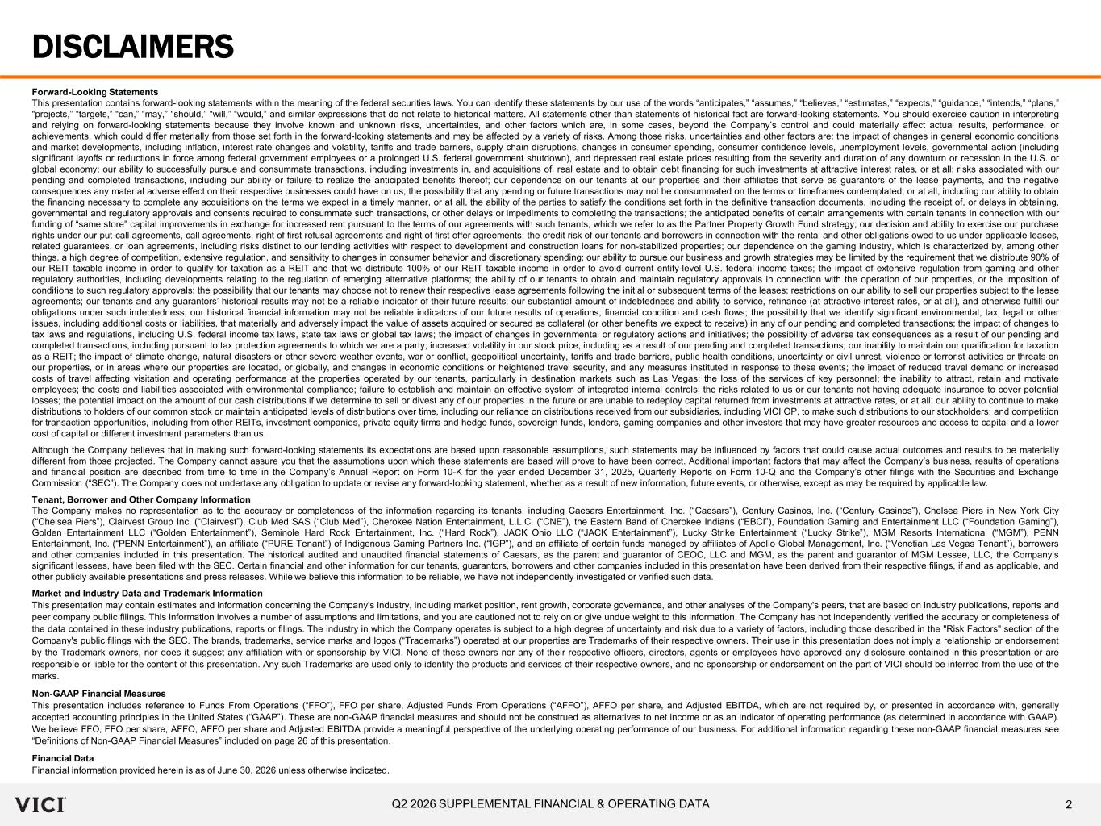
2Q2 2026 SUPPLEMENTAL FINANCIAL & OPERATING DATA Forward-Looking Statements This presentation contains forward-looking statements within the meaning of the federal securities laws. You can identify these statements by our use of the words “anticipates,” “assumes,” “believes,” “estimates,” “expects,” “guidance,” “intends,” “plans,” “projects,” “targets,” “can,” “may,” “should,” “will,” “would,” and similar expressions that do not relate to historical matters. All statements other than statements of historical fact are forward-looking statements. You should exercise caution in interpreting and relying on forward-looking statements because they involve known and unknown risks, uncertainties, and other factors which are, in some cases, beyond the Company’s control and could materially affect actual results, performance, or achievements, which could differ materially from those set forth in the forward-looking statements and may be affected by a variety of risks. Among those risks, uncertainties and other factors are: the impact of changes in general economic conditions and market developments, including inflation, interest rate changes and volatility, tariffs and trade barriers, supply chain disruptions, changes in consumer spending, consumer confidence levels, unemployment levels, governmental action (including significant layoffs or reductions in force among federal government employees or a prolonged U.S. federal government shutdown), and depressed real estate prices resulting from the severity and duration of any downturn or recession in the U.S. or global economy; our ability to successfully pursue and consummate transactions, including investments in, and acquisitions of, real estate and to obtain debt financing for such investments at attractive interest rates, or at all; risks associated with our pending and completed transactions, including our ability or failure to realize the anticipated benefits thereof; our dependence on our tenants at our properties and their affiliates that serve as guarantors of the lease payments, and the negative consequences any material adverse effect on their respective businesses could have on us; the possibility that any pending or future transactions may not be consummated on the terms or timeframes contemplated, or at all, including our ability to obtain the financing necessary to complete any acquisitions on the terms we expect in a timely manner, or at all, the ability of the parties to satisfy the conditions set forth in the definitive transaction documents, including the receipt of, or delays in obtaining, governmental and regulatory approvals and consents required to consummate such transactions, or other delays or impediments to completing the transactions; the anticipated benefits of certain arrangements with certain tenants in connection with our funding of “same store” capital improvements in exchange for increased rent pursuant to the terms of our agreements with such tenants, which we refer to as the Partner Property Growth Fund strategy; our decision and ability to exercise our purchase rights under our put-call agreements, call agreements, right of first refusal agreements and right of first offer agreements; the credit risk of our tenants and borrowers in connection with the rental and other obligations owed to us under applicable leases, related guarantees, or loan agreements, including risks distinct to our lending activities with respect to development and construction loans for non-stabilized properties; our dependence on the gaming industry, which is characterized by, among other things, a high degree of competition, extensive regulation, and sensitivity to changes in consumer behavior and discretionary spending; our ability to pursue our business and growth strategies may be limited by the requirement that we distribute 90% of our REIT taxable income in order to qualify for taxation as a REIT and that we distribute 100% of our REIT taxable income in order to avoid current entity-level U.S. federal income taxes; the impact of extensive regulation from gaming and other regulatory authorities, including developments relating to the regulation of emerging alternative platforms; the ability of our tenants to obtain and maintain regulatory approvals in connection with the operation of our properties, or the imposition of conditions to such regulatory approvals; the possibility that our tenants may choose not to renew their respective lease agreements following the initial or subsequent terms of the leases; restrictions on our ability to sell our properties subject to the lease agreements; our tenants and any guarantors’ historical results may not be a reliable indicator of their future results; our substantial amount of indebtedness and ability to service, refinance (at attractive interest rates, or at all), and otherwise fulfill our obligations under such indebtedness; our historical financial information may not be reliable indicators of our future results of operations, financial condition and cash flows; the possibility that we identify significant environmental, tax, legal or other issues, including additional costs or liabilities, that materially and adversely impact the value of assets acquired or secured as collateral (or other benefits we expect to receive) in any of our pending and completed transactions; the impact of changes to tax laws and regulations, including U.S. federal income tax laws, state tax laws or global tax laws; the impact of changes in governmental or regulatory actions and initiatives; the possibility of adverse tax consequences as a result of our pending and completed transactions, including pursuant to tax protection agreements to which we are a party; increased volatility in our stock price, including as a result of our pending and completed transactions; our inability to maintain our qualification for taxation as a REIT; the impact of climate change, natural disasters or other severe weather events, war or conflict, geopolitical uncertainty, tariffs and trade barriers, public health conditions, uncertainty or civil unrest, violence or terrorist activities or threats on our properties, or in areas where our properties are located, or globally, and changes in economic conditions or heightened travel security, and any measures instituted in response to these events; the impact of reduced travel demand or increased costs of travel affecting visitation and operating performance at the properties operated by our tenants, particularly in destination markets such as Las Vegas; the loss of the services of key personnel; the inability to attract, retain and motivate employees; the costs and liabilities associated with environmental compliance; failure to establish and maintain an effective system of integrated internal controls; the risks related to us or our tenants not having adequate insurance to cover potential losses; the potential impact on the amount of our cash distributions if we determine to sell or divest any of our properties in the future or are unable to redeploy capital returned from investments at attractive rates, or at all; our ability to continue to make distributions to holders of our common stock or maintain anticipated levels of distributions over time, including our reliance on distributions received from our subsidiaries, including VICI OP, to make such distributions to our stockholders; and competition for transaction opportunities, including from other REITs, investment companies, private equity firms and hedge funds, sovereign funds, lenders, gaming companies and other investors that may have greater resources and access to capital and a lower cost of capital or different investment parameters than us. Although the Company believes that in making such forward-looking statements its expectations are based upon reasonable assumptions, such statements may be influenced by factors that could cause actual outcomes and results to be materially different from those projected. The Company cannot assure you that the assumptions upon which these statements are based will prove to have been correct. Additional important factors that may affect the Company’s business, results of operations and financial position are described from time to time in the Company’s Annual Report on Form 10-K for the year ended December 31, 2025, Quarterly Reports on Form 10-Q and the Company’s other filings with the Securities and Exchange Commission (“SEC”). The Company does not undertake any obligation to update or revise any forward-looking statement, whether as a result of new information, future events, or otherwise, except as may be required by applicable law. Tenant, Borrower and Other Company Information The Company makes no representation as to the accuracy or completeness of the information regarding its tenants, including Caesars Entertainment, Inc. (“Caesars”), Century Casinos, Inc. (“Century Casinos”), Chelsea Piers in New York City (“Chelsea Piers”), Clairvest Group Inc. (“Clairvest”), Club Med SAS (“Club Med”), Cherokee Nation Entertainment, L.L.C. (“CNE”), the Eastern Band of Cherokee Indians (“EBCI”), Foundation Gaming and Entertainment LLC (“Foundation Gaming”), Golden Entertainment LLC (“Golden Entertainment”), Seminole Hard Rock Entertainment, Inc. (“Hard Rock”), JACK Ohio LLC (“JACK Entertainment”), Lucky Strike Entertainment (“Lucky Strike”), MGM Resorts International (“MGM”), PENN Entertainment, Inc. (“PENN Entertainment”), an affiliate (“PURE Tenant”) of Indigenous Gaming Partners Inc. (“IGP”), and an affiliate of certain funds managed by affiliates of Apollo Global Management, Inc. (“Venetian Las Vegas Tenant”), borrowers and other companies included in this presentation. The historical audited and unaudited financial statements of Caesars, as the parent and guarantor of CEOC, LLC and MGM, as the parent and guarantor of MGM Lessee, LLC, the Company's significant lessees, have been filed with the SEC. Certain financial and other information for our tenants, guarantors, borrowers and other companies included in this presentation have been derived from their respective filings, if and as applicable, and other publicly available presentations and press releases. While we believe this information to be reliable, we have not independently investigated or verified such data. Market and Industry Data and Trademark Information This presentation may contain estimates and information concerning the Company's industry, including market position, rent growth, corporate governance, and other analyses of the Company's peers, that are based on industry publications, reports and peer company public filings. This information involves a number of assumptions and limitations, and you are cautioned not to rely on or give undue weight to this information. The Company has not independently verified the accuracy or completeness of the data contained in these industry publications, reports or filings. The industry in which the Company operates is subject to a high degree of uncertainty and risk due to a variety of factors, including those described in the "Risk Factors" section of the Company's public filings with the SEC. The brands, trademarks, service marks and logos (“Trademarks”) operated at our properties are Trademarks of their respective owners. Their use in this presentation does not imply a relationship or endorsement by the Trademark owners, nor does it suggest any affiliation with or sponsorship by VICI. None of these owners nor any of their respective officers, directors, agents or employees have approved any disclosure contained in this presentation or are responsible or liable for the content of this presentation. Any such Trademarks are used only to identify the products and services of their respective owners, and no sponsorship or endorsement on the part of VICI should be inferred from the use of the marks. Non‐GAAP Financial Measures This presentation includes reference to Funds From Operations (“FFO”), FFO per share, Adjusted Funds From Operations (“AFFO”), AFFO per share, and Adjusted EBITDA, which are not required by, or presented in accordance with, generally accepted accounting principles in the United States (“GAAP”). These are non-GAAP financial measures and should not be construed as alternatives to net income or as an indicator of operating performance (as determined in accordance with GAAP). We believe FFO, FFO per share, AFFO, AFFO per share and Adjusted EBITDA provide a meaningful perspective of the underlying operating performance of our business. For additional information regarding these non-GAAP financial measures see “Definitions of Non-GAAP Financial Measures” included on page 26 of this presentation. Financial Data Financial information provided herein is as of June 30, 2026 unless otherwise indicated. DISCLAIMERS

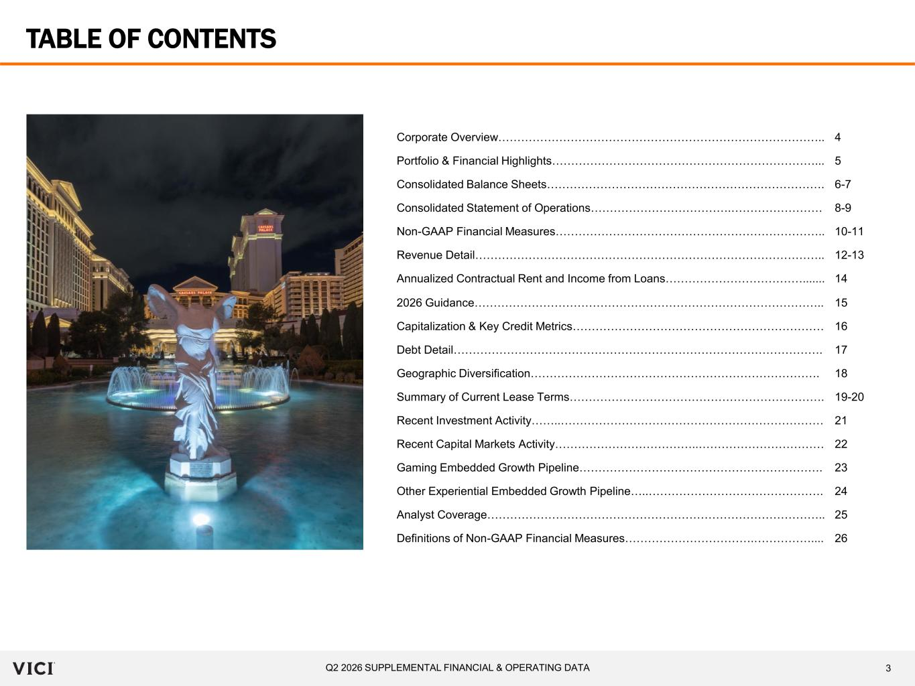
3Q2 2026 SUPPLEMENTAL FINANCIAL & OPERATING DATA TABLE OF CONTENTS Corporate Overview………………………………………………………………………….. 4 Portfolio & Financial Highlights……………………………………………………………... 5 Consolidated Balance Sheets………………………………………………………………. 6-7 Consolidated Statement of Operations……………………………….…………………… 8-9 Non-GAAP Financial Measures…………………………………………………………….. 10-11 Revenue Detail……………………………………………………………………………….. 12-13 Annualized Contractual Rent and Income from Loans………………………………....... 14 2026 Guidance……………………………………………………………………………….. 15 Capitalization & Key Credit Metrics………………………………………………………… 16 Debt Detail……………………………………………………………………………………. 17 Geographic Diversification…………………………………………………………………. 18 Summary of Current Lease Terms…………………………………………………………. 19-20 Recent Investment Activity……..…………………………………………………………… 21 Recent Capital Markets Activity………………………………..…………………………… 22 Gaming Embedded Growth Pipeline………………………………………………………. 23 Other Experiential Embedded Growth Pipeline…..………………………………………. 24 Analyst Coverage…………………………………………………………………………….. 25 Definitions of Non-GAAP Financial Measures…………………………….…………….... 26

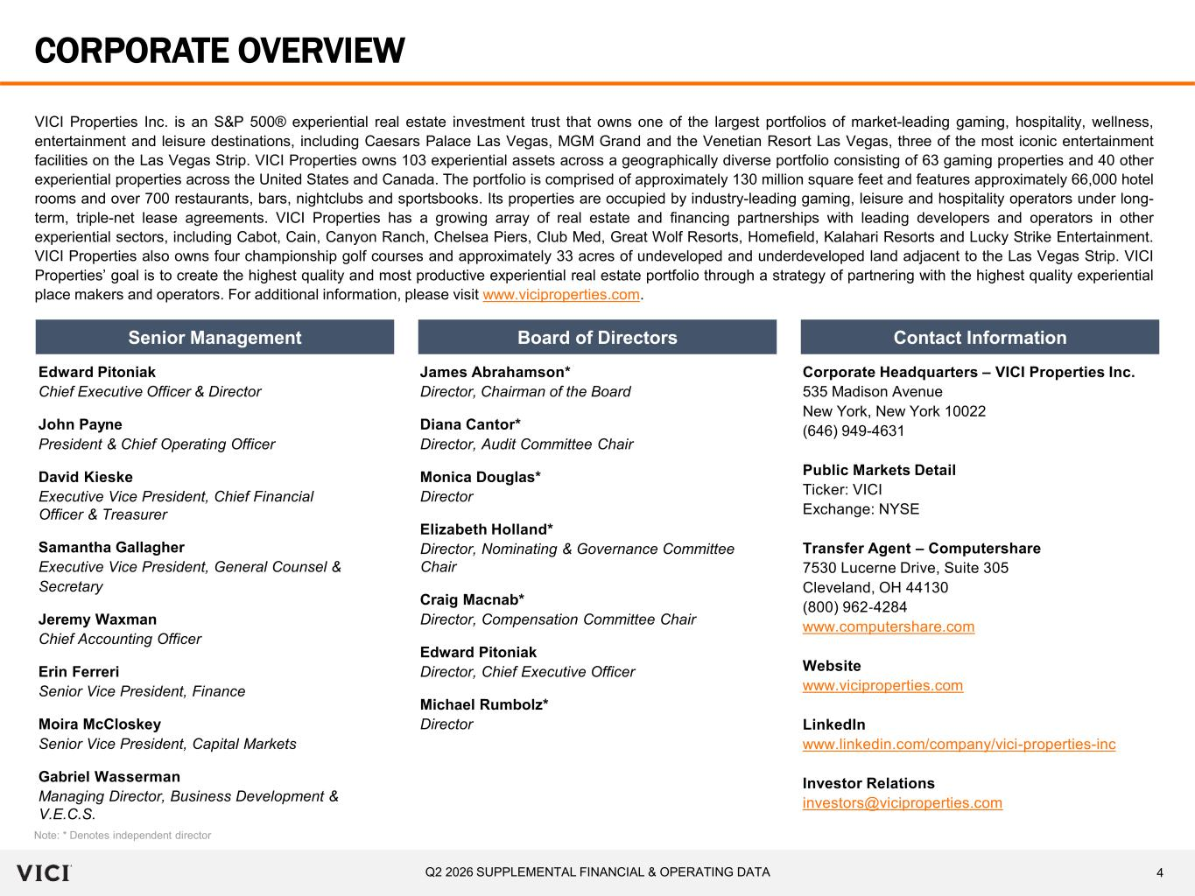
4Q2 2026 SUPPLEMENTAL FINANCIAL & OPERATING DATA CORPORATE OVERVIEW VICI Properties Inc. is an S&P 500® experiential real estate investment trust that owns one of the largest portfolios of market-leading gaming, hospitality, wellness, entertainment and leisure destinations, including Caesars Palace Las Vegas, MGM Grand and the Venetian Resort Las Vegas, three of the most iconic entertainment facilities on the Las Vegas Strip. VICI Properties owns 103 experiential assets across a geographically diverse portfolio consisting of 63 gaming properties and 40 other experiential properties across the United States and Canada. The portfolio is comprised of approximately 130 million square feet and features approximately 66,000 hotel rooms and over 700 restaurants, bars, nightclubs and sportsbooks. Its properties are occupied by industry-leading gaming, leisure and hospitality operators under long- term, triple-net lease agreements. VICI Properties has a growing array of real estate and financing partnerships with leading developers and operators in other experiential sectors, including Cabot, Cain, Canyon Ranch, Chelsea Piers, Club Med, Great Wolf Resorts, Homefield, Kalahari Resorts and Lucky Strike Entertainment. VICI Properties also owns four championship golf courses and approximately 33 acres of undeveloped and underdeveloped land adjacent to the Las Vegas Strip. VICI Properties’ goal is to create the highest quality and most productive experiential real estate portfolio through a strategy of partnering with the highest quality experiential place makers and operators. For additional information, please visit www.viciproperties.com. Senior Management Board of Directors Contact Information Edward Pitoniak Chief Executive Officer & Director John Payne President & Chief Operating Officer David Kieske Executive Vice President, Chief Financial Officer & Treasurer Samantha Gallagher Executive Vice President, General Counsel & Secretary Jeremy Waxman Chief Accounting Officer Erin Ferreri Senior Vice President, Finance Moira McCloskey Senior Vice President, Capital Markets Gabriel Wasserman Managing Director, Business Development & V.E.C.S. James Abrahamson* Director, Chairman of the Board Diana Cantor* Director, Audit Committee Chair Monica Douglas* Director Elizabeth Holland* Director, Nominating & Governance Committee Chair Craig Macnab* Director, Compensation Committee Chair Edward Pitoniak Director, Chief Executive Officer Michael Rumbolz* Director Note: * Denotes independent director Corporate Headquarters – VICI Properties Inc. 535 Madison Avenue New York, New York 10022 (646) 949-4631 Public Markets Detail Ticker: VICI Exchange: NYSE Transfer Agent – Computershare 7530 Lucerne Drive, Suite 305 Cleveland, OH 44130 (800) 962‐4284 www.computershare.com Website www.viciproperties.com LinkedIn www.linkedin.com/company/vici-properties-inc Investor Relations investors@viciproperties.com

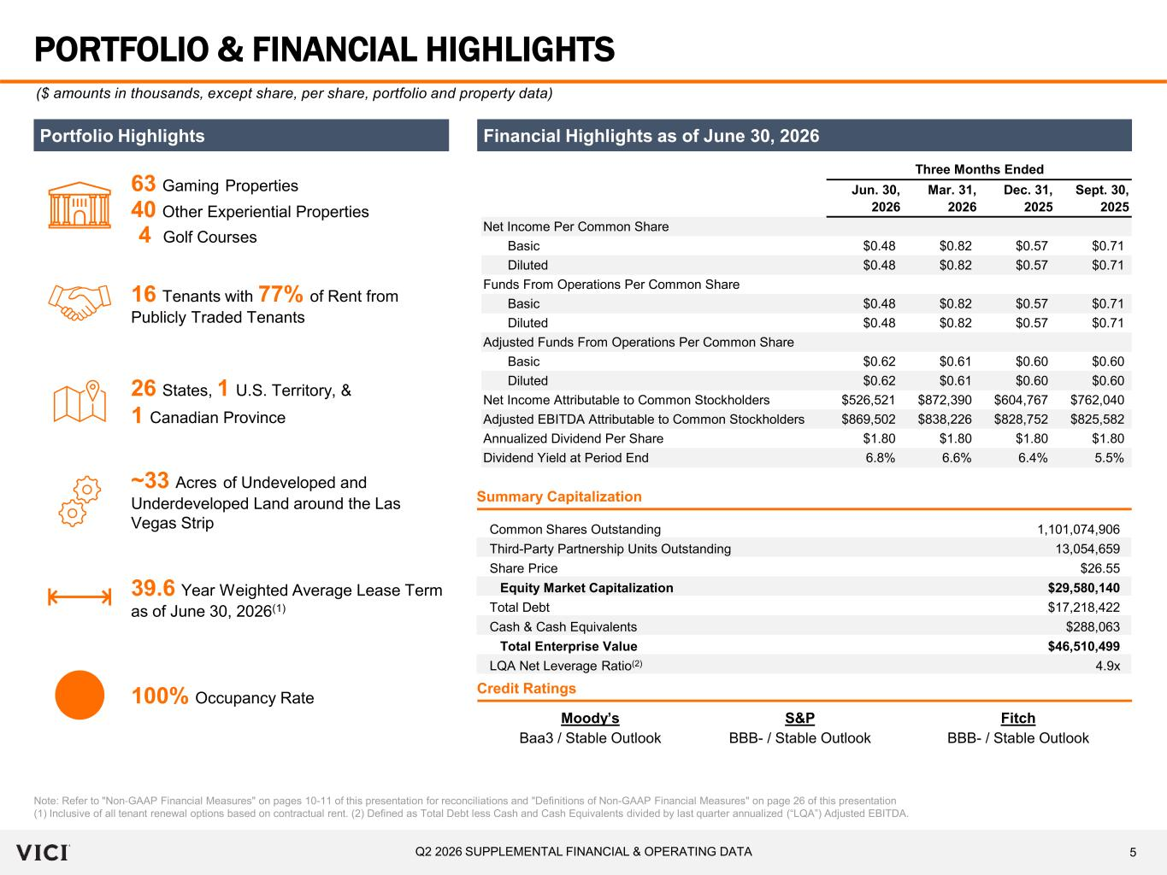
5Q2 2026 SUPPLEMENTAL FINANCIAL & OPERATING DATA Jun. 30, 2026 Mar. 31, 2026 Dec. 31, 2025 Sept. 30, 2025 Net Income Per Common Share Basic $0.48 $0.82 $0.57 $0.71 Diluted $0.48 $0.82 $0.57 $0.71 Funds From Operations Per Common Share Basic $0.48 $0.82 $0.57 $0.71 Diluted $0.48 $0.82 $0.57 $0.71 Adjusted Funds From Operations Per Common Share Basic $0.62 $0.61 $0.60 $0.60 Diluted $0.62 $0.61 $0.60 $0.60 Net Income Attributable to Common Stockholders $526,521 $872,390 $604,767 $762,040 Adjusted EBITDA Attributable to Common Stockholders $869,502 $838,226 $828,752 $825,582 Annualized Dividend Per Share $1.80 $1.80 $1.80 $1.80 Dividend Yield at Period End 6.8% 6.6% 6.4% 5.5% Three Months Ended PORTFOLIO & FINANCIAL HIGHLIGHTS Note: Refer to "Non‐GAAP Financial Measures" on pages 10-11 of this presentation for reconciliations and "Definitions of Non-GAAP Financial Measures" on page 26 of this presentation (1) Inclusive of all tenant renewal options based on contractual rent. (2) Defined as Total Debt less Cash and Cash Equivalents divided by last quarter annualized (“LQA”) Adjusted EBITDA. ($ amounts in thousands, except share, per share, portfolio and property data) Financial Highlights as of June 30, 2026 Common Shares Outstanding 1,101,074,906 Third-Party Partnership Units Outstanding 13,054,659 Share Price $26.55 Equity Market Capitalization $29,580,140 Total Debt $17,218,422 Cash & Cash Equivalents $288,063 Total Enterprise Value $46,510,499 LQA Net Leverage Ratio(2) 4.9x Summary Capitalization Portfolio Highlights 63 Gaming Properties ~33 Acres of Undeveloped and Underdeveloped Land around the Las Vegas Strip 26 States, 1 U.S. Territory, & 1 Canadian Province 39.6 Year Weighted Average Lease Term as of June 30, 2026(1) 100% Occupancy Rate 16 Tenants with 77% of Rent from Publicly Traded Tenants Moody’s S&P Fitch Baa3 / Stable Outlook BBB- / Stable Outlook BBB- / Stable Outlook Credit Ratings 40 Other Experiential Properties 4 Golf Courses

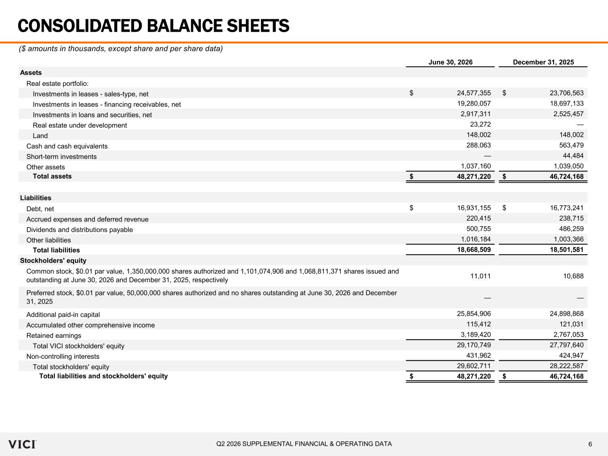
6Q2 2026 SUPPLEMENTAL FINANCIAL & OPERATING DATA June 30, 2026 December 31, 2025 Assets Real estate portfolio: Investments in leases - sales-type, net 24,577,355$ 23,706,563$ Investments in leases - financing receivables, net 19,280,057 18,697,133 Investments in loans and securities, net 2,917,311 2,525,457 Real estate under development 23,272 — Land 148,002 148,002 Cash and cash equivalents 288,063 563,479 Short-term investments — 44,484 Other assets 1,037,160 1,039,050 Total assets 48,271,220$ 46,724,168$ Liabilities Debt, net 16,931,155$ 16,773,241$ Accrued expenses and deferred revenue 220,415 238,715 Dividends and distributions payable 500,755 486,259 Other liabilities 1,016,184 1,003,366 Total liabilities 18,668,509 18,501,581 Stockholders' equity 11,011 10,688 — — Additional paid-in capital 25,854,906 24,898,868 Accumulated other comprehensive income 115,412 121,031 Retained earnings 3,189,420 2,767,053 Total VICI stockholders' equity 29,170,749 27,797,640 Non-controlling interests 431,962 424,947 Total stockholders' equity 29,602,711 28,222,587 Total liabilities and stockholders' equity 48,271,220$ 46,724,168$ Common stock, $0.01 par value, 1,350,000,000 shares authorized and 1,101,074,906 and 1,068,811,371 shares issued and outstanding at June 30, 2026 and December 31, 2025, respectively Preferred stock, $0.01 par value, 50,000,000 shares authorized and no shares outstanding at June 30, 2026 and December 31, 2025 CONSOLIDATED BALANCE SHEETS ($ amounts in thousands, except share and per share data)

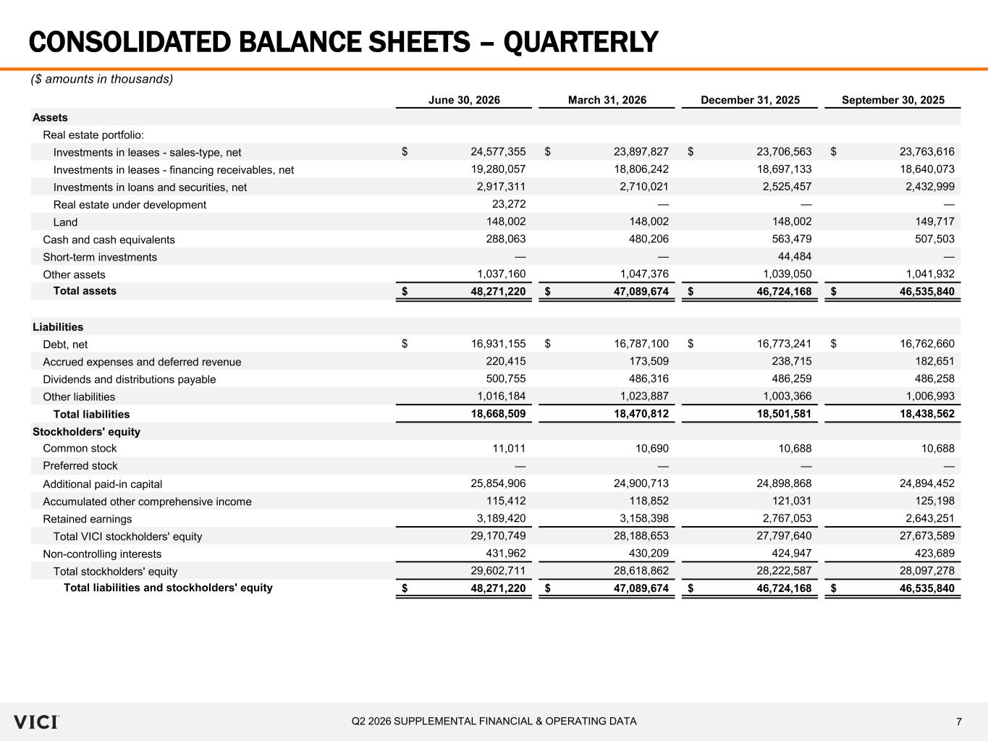
7Q2 2026 SUPPLEMENTAL FINANCIAL & OPERATING DATA June 30, 2026 March 31, 2026 December 31, 2025 September 30, 2025 Assets Real estate portfolio: Investments in leases - sales-type, net 24,577,355$ 23,897,827$ 23,706,563$ 23,763,616$ Investments in leases - financing receivables, net 19,280,057 18,806,242 18,697,133 18,640,073 Investments in loans and securities, net 2,917,311 2,710,021 2,525,457 2,432,999 Real estate under development 23,272 — — — Land 148,002 148,002 148,002 149,717 Cash and cash equivalents 288,063 480,206 563,479 507,503 Short-term investments — — 44,484 — Other assets 1,037,160 1,047,376 1,039,050 1,041,932 Total assets 48,271,220$ 47,089,674$ 46,724,168$ 46,535,840$ Liabilities Debt, net 16,931,155$ 16,787,100$ 16,773,241$ 16,762,660$ Accrued expenses and deferred revenue 220,415 173,509 238,715 182,651 Dividends and distributions payable 500,755 486,316 486,259 486,258 Other liabilities 1,016,184 1,023,887 1,003,366 1,006,993 Total liabilities 18,668,509 18,470,812 18,501,581 18,438,562 Stockholders' equity Common stock 11,011 10,690 10,688 10,688 Preferred stock — — — — Additional paid-in capital 25,854,906 24,900,713 24,898,868 24,894,452 Accumulated other comprehensive income 115,412 118,852 121,031 125,198 Retained earnings 3,189,420 3,158,398 2,767,053 2,643,251 Total VICI stockholders' equity 29,170,749 28,188,653 27,797,640 27,673,589 Non-controlling interests 431,962 430,209 424,947 423,689 Total stockholders' equity 29,602,711 28,618,862 28,222,587 28,097,278 Total liabilities and stockholders' equity 48,271,220$ 47,089,674$ 46,724,168$ 46,535,840$ CONSOLIDATED BALANCE SHEETS – QUARTERLY ($ amounts in thousands)

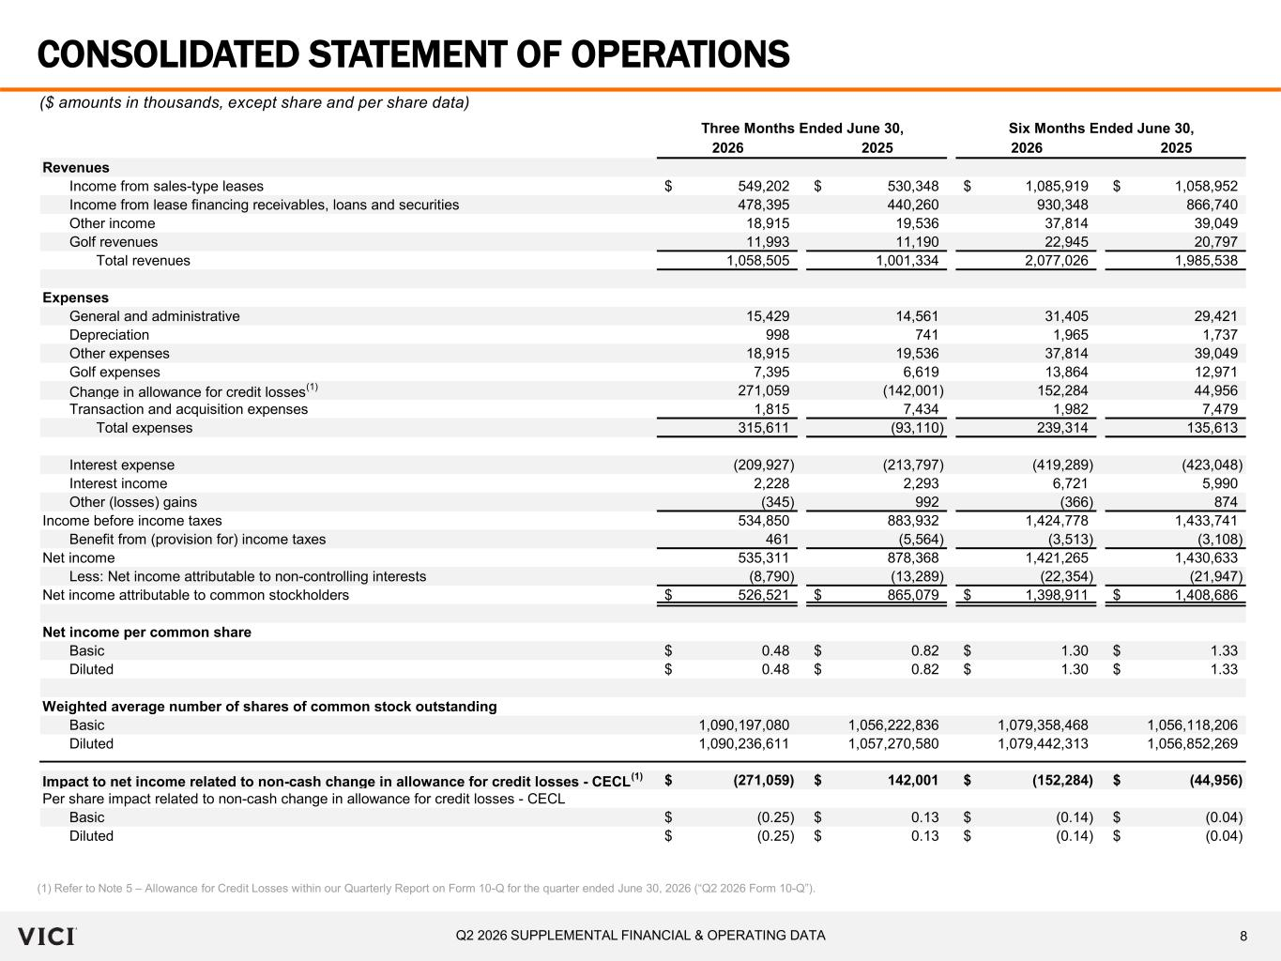
8Q2 2026 SUPPLEMENTAL FINANCIAL & OPERATING DATA Three Months Ended June 30, Six Months Ended June 30, 2026 2025 2026 2025 Revenues Income from sales-type leases 549,202$ 530,348$ 1,085,919$ 1,058,952$ Income from lease financing receivables, loans and securities 478,395 440,260 930,348 866,740 Other income 18,915 19,536 37,814 39,049 Golf revenues 11,993 11,190 22,945 20,797 Total revenues 1,058,505 1,001,334 2,077,026 1,985,538 Expenses General and administrative 15,429 14,561 31,405 29,421 Depreciation 998 741 1,965 1,737 Other expenses 18,915 19,536 37,814 39,049 Golf expenses 7,395 6,619 13,864 12,971 Change in allowance for credit losses (1) 271,059 (142,001) 152,284 44,956 Transaction and acquisition expenses 1,815 7,434 1,982 7,479 Total expenses 315,611 (93,110) 239,314 135,613 Interest expense (209,927) (213,797) (419,289) (423,048) Interest income 2,228 2,293 6,721 5,990 Other (losses) gains (345) 992 (366) 874 Income before income taxes 534,850 883,932 1,424,778 1,433,741 Benefit from (provision for) income taxes 461 (5,564) (3,513) (3,108) Net income 535,311 878,368 1,421,265 1,430,633 Less: Net income attributable to non-controlling interests (8,790) (13,289) (22,354) (21,947) Net income attributable to common stockholders 526,521$ 865,079$ 1,398,911$ 1,408,686$ Net income per common share Basic 0.48$ 0.82$ 1.30$ 1.33$ Diluted 0.48$ 0.82$ 1.30$ 1.33$ Weighted average number of shares of common stock outstanding Basic 1,090,197,080 1,056,222,836 1,079,358,468 1,056,118,206 Diluted 1,090,236,611 1,057,270,580 1,079,442,313 1,056,852,269 Impact to net income related to non-cash change in allowance for credit losses - CECL (1) (271,059)$ 142,001$ (152,284)$ (44,956)$ Per share impact related to non-cash change in allowance for credit losses - CECL Basic (0.25)$ 0.13$ (0.14)$ (0.04)$ Diluted (0.25)$ 0.13$ (0.14)$ (0.04)$ CONSOLIDATED STATEMENT OF OPERATIONS ($ amounts in thousands, except share and per share data) (1) Refer to Note 5 – Allowance for Credit Losses within our Quarterly Report on Form 10-Q for the quarter ended June 30, 2026 (“Q2 2026 Form 10-Q”).

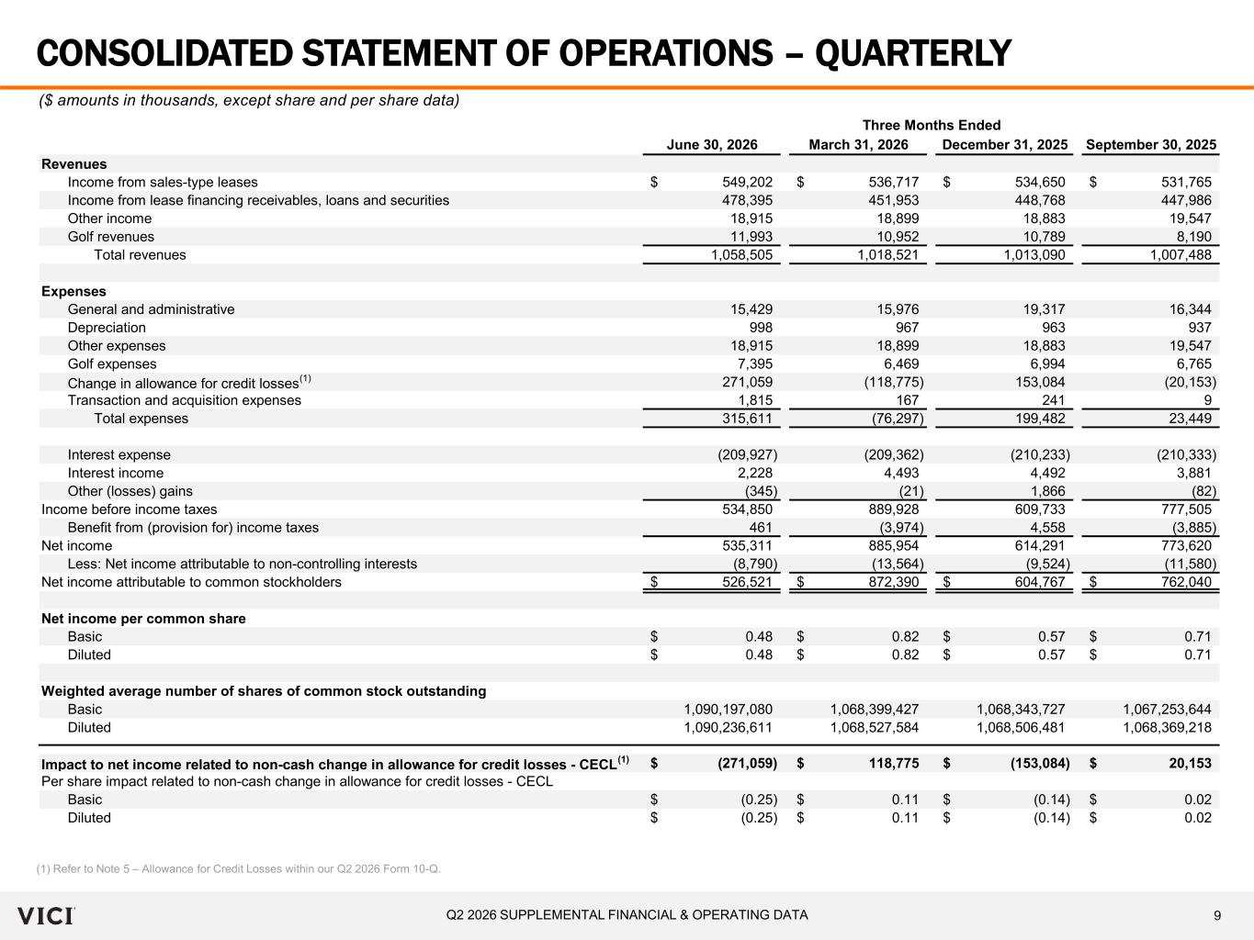
9Q2 2026 SUPPLEMENTAL FINANCIAL & OPERATING DATA June 30, 2026 March 31, 2026 December 31, 2025 September 30, 2025 Revenues Income from sales-type leases 549,202$ 536,717$ 534,650$ 531,765$ Income from lease financing receivables, loans and securities 478,395 451,953 448,768 447,986 Other income 18,915 18,899 18,883 19,547 Golf revenues 11,993 10,952 10,789 8,190 Total revenues 1,058,505 1,018,521 1,013,090 1,007,488 Expenses General and administrative 15,429 15,976 19,317 16,344 Depreciation 998 967 963 937 Other expenses 18,915 18,899 18,883 19,547 Golf expenses 7,395 6,469 6,994 6,765 Change in allowance for credit losses (1) 271,059 (118,775) 153,084 (20,153) Transaction and acquisition expenses 1,815 167 241 9 Total expenses 315,611 (76,297) 199,482 23,449 Interest expense (209,927) (209,362) (210,233) (210,333) Interest income 2,228 4,493 4,492 3,881 Other (losses) gains (345) (21) 1,866 (82) Income before income taxes 534,850 889,928 609,733 777,505 Benefit from (provision for) income taxes 461 (3,974) 4,558 (3,885) Net income 535,311 885,954 614,291 773,620 Less: Net income attributable to non-controlling interests (8,790) (13,564) (9,524) (11,580) Net income attributable to common stockholders 526,521$ 872,390$ 604,767$ 762,040$ Net income per common share Basic 0.48$ 0.82$ 0.57$ 0.71$ Diluted 0.48$ 0.82$ 0.57$ 0.71$ Weighted average number of shares of common stock outstanding Basic 1,090,197,080 1,068,399,427 1,068,343,727 1,067,253,644 Diluted 1,090,236,611 1,068,527,584 1,068,506,481 1,068,369,218 Impact to net income related to non-cash change in allowance for credit losses - CECL (1) (271,059)$ 118,775$ (153,084)$ 20,153$ Per share impact related to non-cash change in allowance for credit losses - CECL Basic (0.25)$ 0.11$ (0.14)$ 0.02$ Diluted (0.25)$ 0.11$ (0.14)$ 0.02$ Three Months Ended CONSOLIDATED STATEMENT OF OPERATIONS – QUARTERLY ($ amounts in thousands, except share and per share data) (1) Refer to Note 5 – Allowance for Credit Losses within our Q2 2026 Form 10-Q.

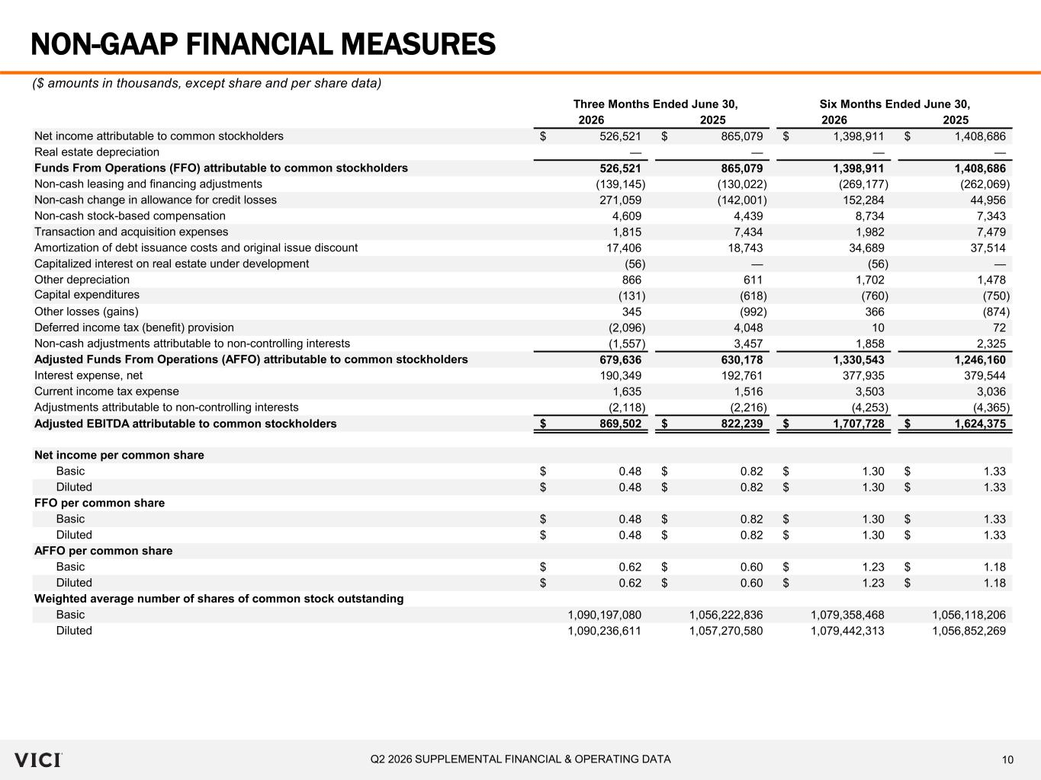
10Q2 2026 SUPPLEMENTAL FINANCIAL & OPERATING DATA Three Months Ended June 30, Six Months Ended June 30, 2026 2025 2026 2025 Net income attributable to common stockholders 526,521$ 865,079$ 1,398,911$ 1,408,686$ Real estate depreciation — — — — Funds From Operations (FFO) attributable to common stockholders 526,521 865,079 1,398,911 1,408,686 Non-cash leasing and financing adjustments (139,145) (130,022) (269,177) (262,069) Non-cash change in allowance for credit losses 271,059 (142,001) 152,284 44,956 Non-cash stock-based compensation 4,609 4,439 8,734 7,343 Transaction and acquisition expenses 1,815 7,434 1,982 7,479 Amortization of debt issuance costs and original issue discount 17,406 18,743 34,689 37,514 Capitalized interest on real estate under development (56) — (56) — Other depreciation 866 611 1,702 1,478 Capital expenditures (131) (618) (760) (750) Other losses (gains) 345 (992) 366 (874) Deferred income tax (benefit) provision (2,096) 4,048 10 72 Non-cash adjustments attributable to non-controlling interests (1,557) 3,457 1,858 2,325 Adjusted Funds From Operations (AFFO) attributable to common stockholders 679,636 630,178 1,330,543 1,246,160 Interest expense, net 190,349 192,761 377,935 379,544 Current income tax expense 1,635 1,516 3,503 3,036 Adjustments attributable to non-controlling interests (2,118) (2,216) (4,253) (4,365) Adjusted EBITDA attributable to common stockholders 869,502$ 822,239$ 1,707,728$ 1,624,375$ Net income per common share Basic 0.48$ 0.82$ 1.30$ 1.33$ Diluted 0.48$ 0.82$ 1.30$ 1.33$ FFO per common share Basic 0.48$ 0.82$ 1.30$ 1.33$ Diluted 0.48$ 0.82$ 1.30$ 1.33$ AFFO per common share Basic 0.62$ 0.60$ 1.23$ 1.18$ Diluted 0.62$ 0.60$ 1.23$ 1.18$ Weighted average number of shares of common stock outstanding Basic 1,090,197,080 1,056,222,836 1,079,358,468 1,056,118,206 Diluted 1,090,236,611 1,057,270,580 1,079,442,313 1,056,852,269 NON-GAAP FINANCIAL MEASURES ($ amounts in thousands, except share and per share data)

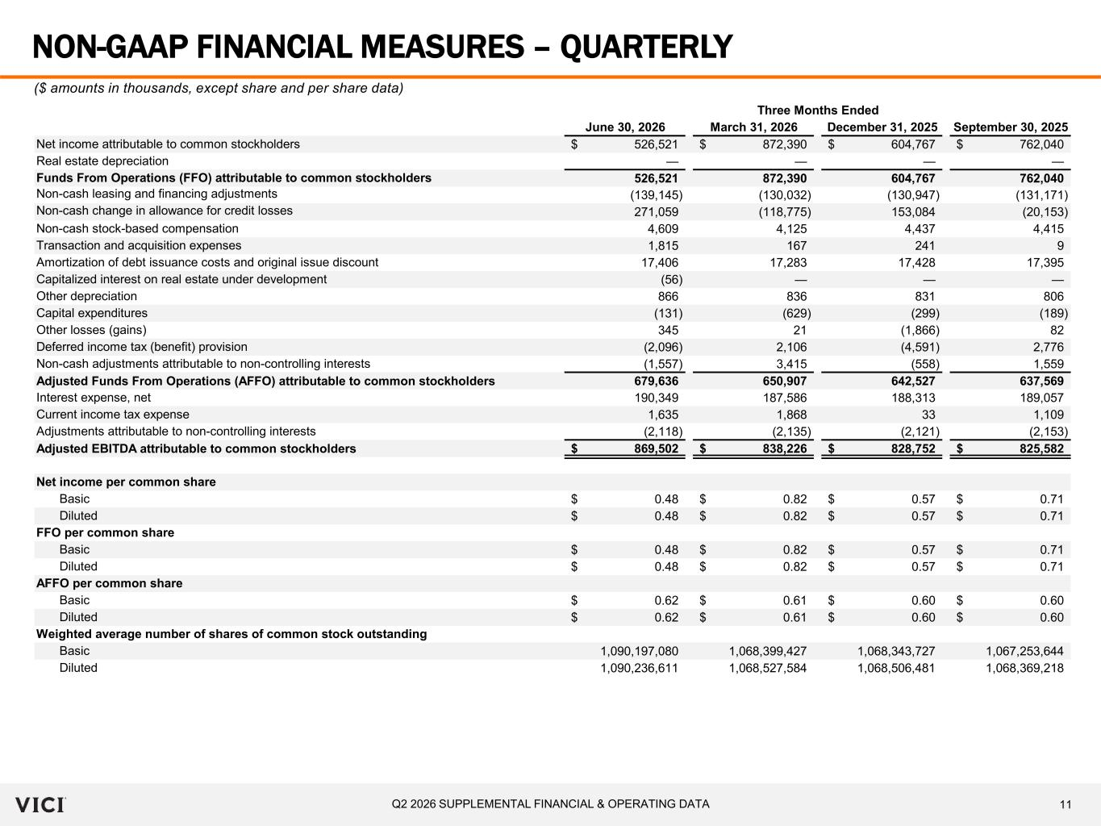
11Q2 2026 SUPPLEMENTAL FINANCIAL & OPERATING DATA June 30, 2026 March 31, 2026 December 31, 2025 September 30, 2025 Net income attributable to common stockholders 526,521$ 872,390$ 604,767$ 762,040$ Real estate depreciation — — — — Funds From Operations (FFO) attributable to common stockholders 526,521 872,390 604,767 762,040 Non-cash leasing and financing adjustments (139,145) (130,032) (130,947) (131,171) Non-cash change in allowance for credit losses 271,059 (118,775) 153,084 (20,153) Non-cash stock-based compensation 4,609 4,125 4,437 4,415 Transaction and acquisition expenses 1,815 167 241 9 Amortization of debt issuance costs and original issue discount 17,406 17,283 17,428 17,395 Capitalized interest on real estate under development (56) — — — Other depreciation 866 836 831 806 Capital expenditures (131) (629) (299) (189) Other losses (gains) 345 21 (1,866) 82 Deferred income tax (benefit) provision (2,096) 2,106 (4,591) 2,776 Non-cash adjustments attributable to non-controlling interests (1,557) 3,415 (558) 1,559 Adjusted Funds From Operations (AFFO) attributable to common stockholders 679,636 650,907 642,527 637,569 Interest expense, net 190,349 187,586 188,313 189,057 Current income tax expense 1,635 1,868 33 1,109 Adjustments attributable to non-controlling interests (2,118) (2,135) (2,121) (2,153) Adjusted EBITDA attributable to common stockholders 869,502$ 838,226$ 828,752$ 825,582$ Net income per common share Basic 0.48$ 0.82$ 0.57$ 0.71$ Diluted 0.48$ 0.82$ 0.57$ 0.71$ FFO per common share Basic 0.48$ 0.82$ 0.57$ 0.71$ Diluted 0.48$ 0.82$ 0.57$ 0.71$ AFFO per common share Basic 0.62$ 0.61$ 0.60$ 0.60$ Diluted 0.62$ 0.61$ 0.60$ 0.60$ Weighted average number of shares of common stock outstanding Basic 1,090,197,080 1,068,399,427 1,068,343,727 1,067,253,644 Diluted 1,090,236,611 1,068,527,584 1,068,506,481 1,068,369,218 Three Months Ended NON-GAAP FINANCIAL MEASURES – QUARTERLY ($ amounts in thousands, except share and per share data)

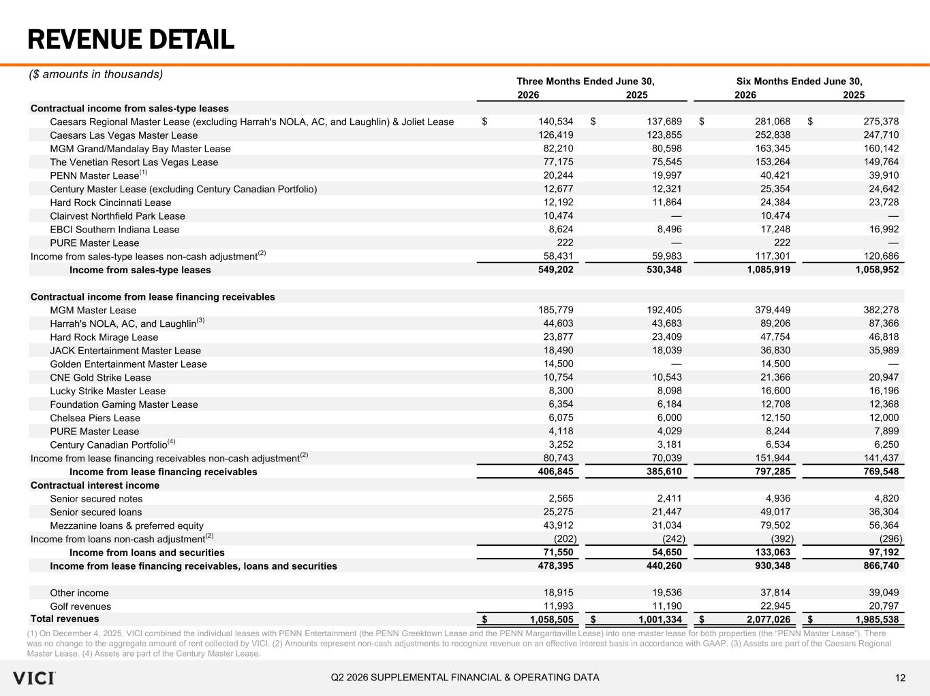
12Q2 2026 SUPPLEMENTAL FINANCIAL & OPERATING DATA Three Months Ended June 30, Six Months Ended June 30, 2026 2025 2026 2025 Contractual income from sales-type leases Caesars Regional Master Lease (excluding Harrah's NOLA, AC, and Laughlin) & Joliet Lease 140,534$ 137,689$ 281,068$ 275,378$ Caesars Las Vegas Master Lease 126,419 123,855 252,838 247,710 MGM Grand/Mandalay Bay Master Lease 82,210 80,598 163,345 160,142 The Venetian Resort Las Vegas Lease 77,175 75,545 153,264 149,764 PENN Master Lease (1) 20,244 19,997 40,421 39,910 Century Master Lease (excluding Century Canadian Portfolio) 12,677 12,321 25,354 24,642 Hard Rock Cincinnati Lease 12,192 11,864 24,384 23,728 Clairvest Northfield Park Lease 10,474 — 10,474 — EBCI Southern Indiana Lease 8,624 8,496 17,248 16,992 PURE Master Lease 222 — 222 — Income from sales-type leases non-cash adjustment (2) 58,431 59,983 117,301 120,686 Income from sales-type leases 549,202 530,348 1,085,919 1,058,952 Contractual income from lease financing receivables MGM Master Lease 185,779 192,405 379,449 382,278 Harrah's NOLA, AC, and Laughlin (3) 44,603 43,683 89,206 87,366 Hard Rock Mirage Lease 23,877 23,409 47,754 46,818 JACK Entertainment Master Lease 18,490 18,039 36,830 35,989 Golden Entertainment Master Lease 14,500 — 14,500 — CNE Gold Strike Lease 10,754 10,543 21,366 20,947 Lucky Strike Master Lease 8,300 8,098 16,600 16,196 Foundation Gaming Master Lease 6,354 6,184 12,708 12,368 Chelsea Piers Lease 6,075 6,000 12,150 12,000 PURE Master Lease 4,118 4,029 8,244 7,899 Century Canadian Portfolio (4) 3,252 3,181 6,534 6,250 Income from lease financing receivables non-cash adjustment (2) 80,743 70,039 151,944 141,437 Income from lease financing receivables 406,845 385,610 797,285 769,548 Contractual interest income Senior secured notes 2,565 2,411 4,936 4,820 Senior secured loans 25,275 21,447 49,017 36,304 Mezzanine loans & preferred equity 43,912 31,034 79,502 56,364 Income from loans non-cash adjustment (2) (202) (242) (392) (296) Income from loans and securities 71,550 54,650 133,063 97,192 Income from lease financing receivables, loans and securities 478,395 440,260 930,348 866,740 Other income 18,915 19,536 37,814 39,049 Golf revenues 11,993 11,190 22,945 20,797 Total revenues 1,058,505$ 1,001,334$ 2,077,026$ 1,985,538$ REVENUE DETAIL (1) On December 4, 2025, VICI combined the individual leases with PENN Entertainment (the PENN Greektown Lease and the PENN Margaritaville Lease) into one master lease for both properties (the “PENN Master Lease”). There was no change to the aggregate amount of rent collected by VICI. (2) Amounts represent non-cash adjustments to recognize revenue on an effective interest basis in accordance with GAAP. (3) Assets are part of the Caesars Regional Master Lease. (4) Assets are part of the Century Master Lease. ($ amounts in thousands)

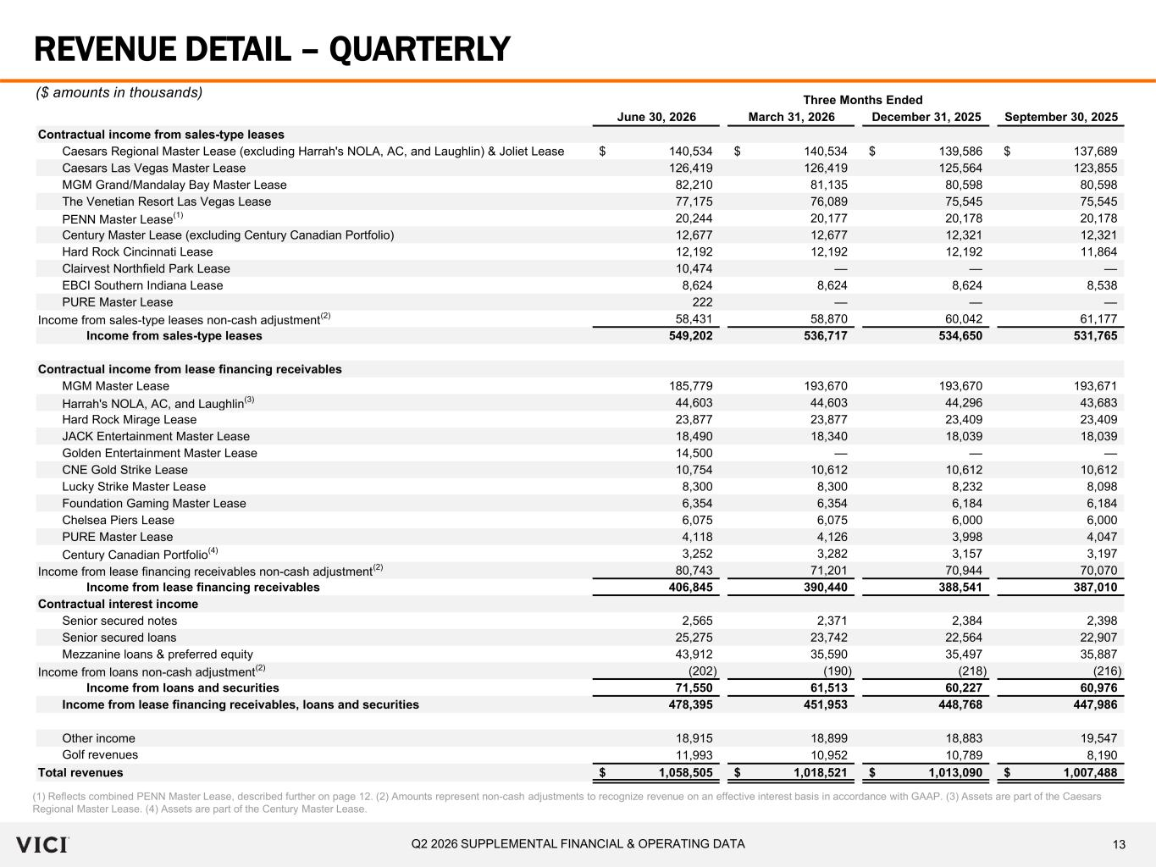
13Q2 2026 SUPPLEMENTAL FINANCIAL & OPERATING DATA Three Months Ended June 30, 2026 March 31, 2026 December 31, 2025 September 30, 2025 Contractual income from sales-type leases Caesars Regional Master Lease (excluding Harrah's NOLA, AC, and Laughlin) & Joliet Lease 140,534$ 140,534$ 139,586$ 137,689$ Caesars Las Vegas Master Lease 126,419 126,419 125,564 123,855 MGM Grand/Mandalay Bay Master Lease 82,210 81,135 80,598 80,598 The Venetian Resort Las Vegas Lease 77,175 76,089 75,545 75,545 PENN Master Lease (1) 20,244 20,177 20,178 20,178 Century Master Lease (excluding Century Canadian Portfolio) 12,677 12,677 12,321 12,321 Hard Rock Cincinnati Lease 12,192 12,192 12,192 11,864 Clairvest Northfield Park Lease 10,474 — — — EBCI Southern Indiana Lease 8,624 8,624 8,624 8,538 PURE Master Lease 222 — — — Income from sales-type leases non-cash adjustment (2) 58,431 58,870 60,042 61,177 Income from sales-type leases 549,202 536,717 534,650 531,765 Contractual income from lease financing receivables MGM Master Lease 185,779 193,670 193,670 193,671 Harrah's NOLA, AC, and Laughlin (3) 44,603 44,603 44,296 43,683 Hard Rock Mirage Lease 23,877 23,877 23,409 23,409 JACK Entertainment Master Lease 18,490 18,340 18,039 18,039 Golden Entertainment Master Lease 14,500 — — — CNE Gold Strike Lease 10,754 10,612 10,612 10,612 Lucky Strike Master Lease 8,300 8,300 8,232 8,098 Foundation Gaming Master Lease 6,354 6,354 6,184 6,184 Chelsea Piers Lease 6,075 6,075 6,000 6,000 PURE Master Lease 4,118 4,126 3,998 4,047 Century Canadian Portfolio (4) 3,252 3,282 3,157 3,197 Income from lease financing receivables non-cash adjustment (2) 80,743 71,201 70,944 70,070 Income from lease financing receivables 406,845 390,440 388,541 387,010 Contractual interest income Senior secured notes 2,565 2,371 2,384 2,398 Senior secured loans 25,275 23,742 22,564 22,907 Mezzanine loans & preferred equity 43,912 35,590 35,497 35,887 Income from loans non-cash adjustment (2) (202) (190) (218) (216) Income from loans and securities 71,550 61,513 60,227 60,976 Income from lease financing receivables, loans and securities 478,395 451,953 448,768 447,986 Other income 18,915 18,899 18,883 19,547 Golf revenues 11,993 10,952 10,789 8,190 Total revenues 1,058,505$ 1,018,521$ 1,013,090$ 1,007,488$ REVENUE DETAIL – QUARTERLY ($ amounts in thousands) (1) Reflects combined PENN Master Lease, described further on page 12. (2) Amounts represent non-cash adjustments to recognize revenue on an effective interest basis in accordance with GAAP. (3) Assets are part of the Caesars Regional Master Lease. (4) Assets are part of the Century Master Lease.

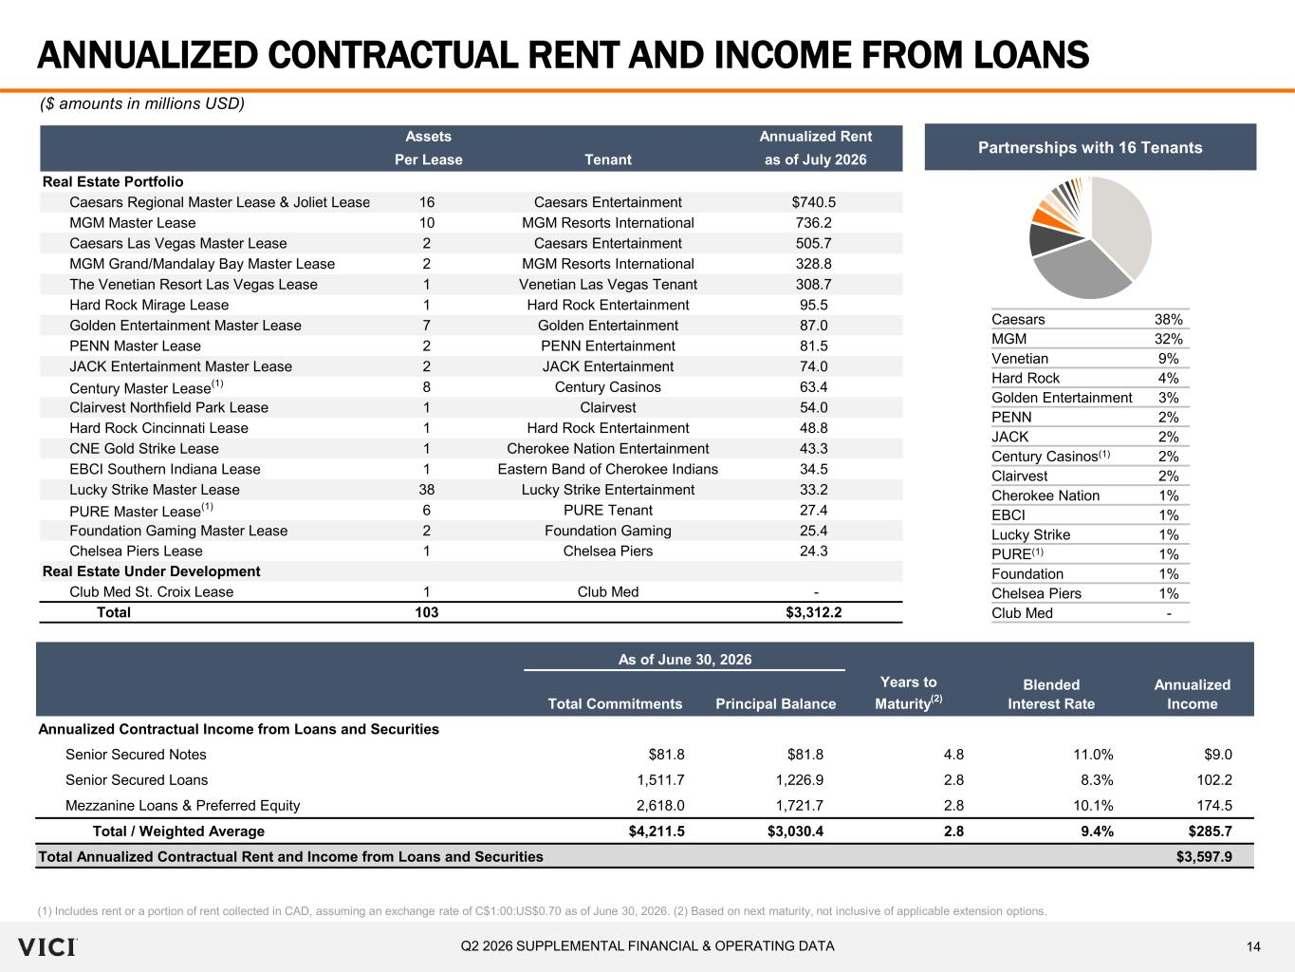
14Q2 2026 SUPPLEMENTAL FINANCIAL & OPERATING DATA Assets Annualized Rent Per Lease Tenant as of July 2026 Real Estate Portfolio Caesars Regional Master Lease & Joliet Lease 16 Caesars Entertainment $740.5 MGM Master Lease 10 MGM Resorts International 736.2 Caesars Las Vegas Master Lease 2 Caesars Entertainment 505.7 MGM Grand/Mandalay Bay Master Lease 2 MGM Resorts International 328.8 The Venetian Resort Las Vegas Lease 1 Venetian Las Vegas Tenant 308.7 Hard Rock Mirage Lease 1 Hard Rock Entertainment 95.5 Golden Entertainment Master Lease 7 Golden Entertainment 87.0 PENN Master Lease 2 PENN Entertainment 81.5 JACK Entertainment Master Lease 2 JACK Entertainment 74.0 Century Master Lease (1) 8 Century Casinos 63.4 Clairvest Northfield Park Lease 1 Clairvest 54.0 Hard Rock Cincinnati Lease 1 Hard Rock Entertainment 48.8 CNE Gold Strike Lease 1 Cherokee Nation Entertainment 43.3 EBCI Southern Indiana Lease 1 Eastern Band of Cherokee Indians 34.5 Lucky Strike Master Lease 38 Lucky Strike Entertainment 33.2 PURE Master Lease (1) 6 PURE Tenant 27.4 Foundation Gaming Master Lease 2 Foundation Gaming 25.4 Chelsea Piers Lease 1 Chelsea Piers 24.3 Real Estate Under Development Club Med St. Croix Lease 1 Club Med - Total 103 $3,312.2 As of June 30, 2026 Total Commitments Principal Balance Years to Maturity (2) Blended Interest Rate Annualized Income Annualized Contractual Income from Loans and Securities Senior Secured Notes $81.8 $81.8 4.8 11.0% $9.0 Senior Secured Loans 1,511.7 1,226.9 2.8 8.3% 102.2 Mezzanine Loans & Preferred Equity 2,618.0 1,721.7 2.8 10.1% 174.5 Total / Weighted Average $4,211.5 $3,030.4 2.8 9.4% $285.7 Total Annualized Contractual Rent and Income from Loans and Securities $3,597.9 ANNUALIZED CONTRACTUAL RENT AND INCOME FROM LOANS (1) Includes rent or a portion of rent collected in CAD, assuming an exchange rate of C$1:00:US$0.70 as of June 30, 2026. (2) Based on next maturity, not inclusive of applicable extension options. ($ amounts in millions USD) Caesars 38% MGM 32% Venetian 9% Hard Rock 4% Golden Entertainment 3% PENN 2% JACK 2% Century Casinos(1) 2% Clairvest 2% Cherokee Nation 1% EBCI 1% Lucky Strike 1% PURE(1) 1% Foundation 1% Chelsea Piers 1% Club Med - Partnerships with 16 Tenants

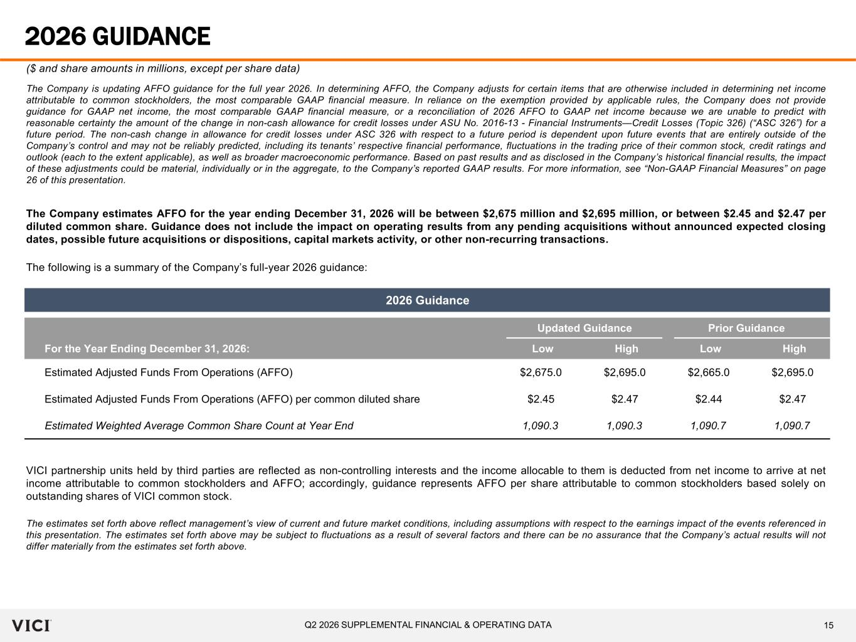
15Q2 2026 SUPPLEMENTAL FINANCIAL & OPERATING DATA 2026 Guidance Updated Guidance Prior Guidance For the Year Ending December 31, 2026: Low High Low High Estimated Adjusted Funds From Operations (AFFO) $2,675.0 $2,695.0 $2,665.0 $2,695.0 Estimated Adjusted Funds From Operations (AFFO) per common diluted share $2.45 $2.47 $2.44 $2.47 Estimated Weighted Average Common Share Count at Year End 1,090.3 1,090.3 1,090.7 1,090.7 2026 GUIDANCE ($ and share amounts in millions, except per share data) The Company is updating AFFO guidance for the full year 2026. In determining AFFO, the Company adjusts for certain items that are otherwise included in determining net income attributable to common stockholders, the most comparable GAAP financial measure. In reliance on the exemption provided by applicable rules, the Company does not provide guidance for GAAP net income, the most comparable GAAP financial measure, or a reconciliation of 2026 AFFO to GAAP net income because we are unable to predict with reasonable certainty the amount of the change in non-cash allowance for credit losses under ASU No. 2016-13 - Financial Instruments—Credit Losses (Topic 326) (“ASC 326”) for a future period. The non-cash change in allowance for credit losses under ASC 326 with respect to a future period is dependent upon future events that are entirely outside of the Company’s control and may not be reliably predicted, including its tenants’ respective financial performance, fluctuations in the trading price of their common stock, credit ratings and outlook (each to the extent applicable), as well as broader macroeconomic performance. Based on past results and as disclosed in the Company’s historical financial results, the impact of these adjustments could be material, individually or in the aggregate, to the Company’s reported GAAP results. For more information, see “Non-GAAP Financial Measures” on page 26 of this presentation. The Company estimates AFFO for the year ending December 31, 2026 will be between $2,675 million and $2,695 million, or between $2.45 and $2.47 per diluted common share. Guidance does not include the impact on operating results from any pending acquisitions without announced expected closing dates, possible future acquisitions or dispositions, capital markets activity, or other non-recurring transactions. The following is a summary of the Company’s full-year 2026 guidance: VICI partnership units held by third parties are reflected as non-controlling interests and the income allocable to them is deducted from net income to arrive at net income attributable to common stockholders and AFFO; accordingly, guidance represents AFFO per share attributable to common stockholders based solely on outstanding shares of VICI common stock. The estimates set forth above reflect management’s view of current and future market conditions, including assumptions with respect to the earnings impact of the events referenced in this presentation. The estimates set forth above may be subject to fluctuations as a result of several factors and there can be no assurance that the Company’s actual results will not differ materially from the estimates set forth above.

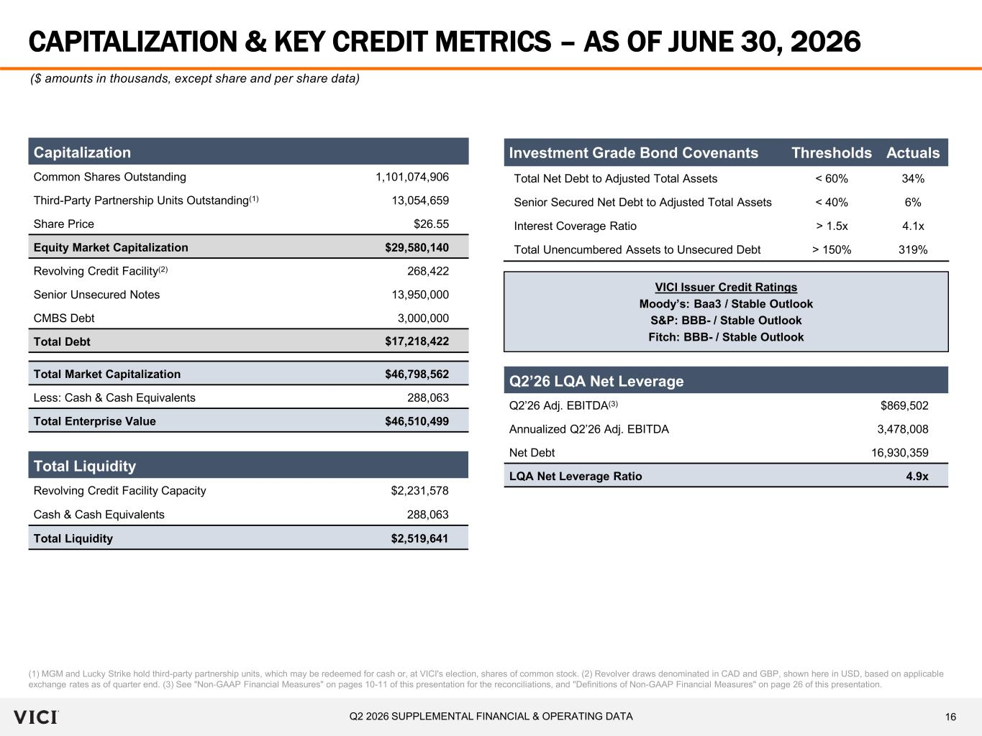
16Q2 2026 SUPPLEMENTAL FINANCIAL & OPERATING DATA CAPITALIZATION & KEY CREDIT METRICS – AS OF JUNE 30, 2026 (1) MGM and Lucky Strike hold third-party partnership units, which may be redeemed for cash or, at VICI's election, shares of common stock. (2) Revolver draws denominated in CAD and GBP, shown here in USD, based on applicable exchange rates as of quarter end. (3) See "Non‐GAAP Financial Measures" on pages 10-11 of this presentation for the reconciliations, and "Definitions of Non-GAAP Financial Measures" on page 26 of this presentation. ($ amounts in thousands, except share and per share data) Capitalization Common Shares Outstanding 1,101,074,906 Third-Party Partnership Units Outstanding(1) 13,054,659 Share Price $26.55 Equity Market Capitalization $29,580,140 Revolving Credit Facility(2) 268,422 Senior Unsecured Notes 13,950,000 CMBS Debt 3,000,000 Total Debt $17,218,422 Total Market Capitalization $46,798,562 Less: Cash & Cash Equivalents 288,063 Total Enterprise Value $46,510,499 Q2’26 LQA Net Leverage Q2’26 Adj. EBITDA(3) $869,502 Annualized Q2’26 Adj. EBITDA 3,478,008 Net Debt 16,930,359 LQA Net Leverage Ratio 4.9x VICI Issuer Credit Ratings Moody’s: Baa3 / Stable Outlook S&P: BBB- / Stable Outlook Fitch: BBB- / Stable Outlook Investment Grade Bond Covenants Thresholds Actuals Total Net Debt to Adjusted Total Assets < 60% 34% Senior Secured Net Debt to Adjusted Total Assets < 40% 6% Interest Coverage Ratio > 1.5x 4.1x Total Unencumbered Assets to Unsecured Debt > 150% 319% Total Liquidity Revolving Credit Facility Capacity $2,231,578 Cash & Cash Equivalents 288,063 Total Liquidity $2,519,641

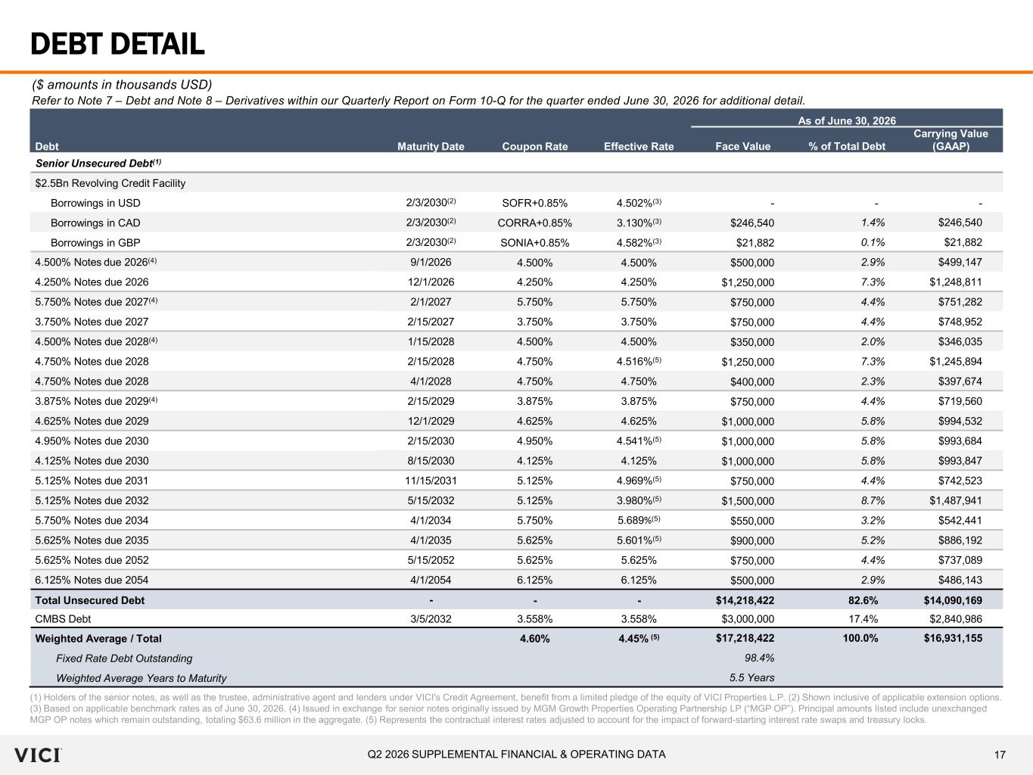
17Q2 2026 SUPPLEMENTAL FINANCIAL & OPERATING DATA DEBT DETAIL (1) Holders of the senior notes, as well as the trustee, administrative agent and lenders under VICI's Credit Agreement, benefit from a limited pledge of the equity of VICI Properties L.P. (2) Shown inclusive of applicable extension options. (3) Based on applicable benchmark rates as of June 30, 2026. (4) Issued in exchange for senior notes originally issued by MGM Growth Properties Operating Partnership LP (“MGP OP”). Principal amounts listed include unexchanged MGP OP notes which remain outstanding, totaling $63.6 million in the aggregate. (5) Represents the contractual interest rates adjusted to account for the impact of forward-starting interest rate swaps and treasury locks. ($ amounts in thousands USD) Refer to Note 7 – Debt and Note 8 – Derivatives within our Quarterly Report on Form 10-Q for the quarter ended June 30, 2026 for additional detail. As of June 30, 2026 Debt Maturity Date Coupon Rate Effective Rate Face Value % of Total Debt Carrying Value (GAAP) Senior Unsecured Debt(1) $2.5Bn Revolving Credit Facility Borrowings in USD 2/3/2030(2) SOFR+0.85% 4.502%(3) - - - Borrowings in CAD 2/3/2030(2) CORRA+0.85% 3.130%(3) $246,540 1.4% $246,540 Borrowings in GBP 2/3/2030(2) SONIA+0.85% 4.582%(3) $21,882 0.1% $21,882 4.500% Notes due 2026(4) 9/1/2026 4.500% 4.500% $500,000 2.9% $499,147 4.250% Notes due 2026 12/1/2026 4.250% 4.250% $1,250,000 7.3% $1,248,811 5.750% Notes due 2027(4) 2/1/2027 5.750% 5.750% $750,000 4.4% $751,282 3.750% Notes due 2027 2/15/2027 3.750% 3.750% $750,000 4.4% $748,952 4.500% Notes due 2028(4) 1/15/2028 4.500% 4.500% $350,000 2.0% $346,035 4.750% Notes due 2028 2/15/2028 4.750% 4.516%(5) $1,250,000 7.3% $1,245,894 4.750% Notes due 2028 4/1/2028 4.750% 4.750% $400,000 2.3% $397,674 3.875% Notes due 2029(4) 2/15/2029 3.875% 3.875% $750,000 4.4% $719,560 4.625% Notes due 2029 12/1/2029 4.625% 4.625% $1,000,000 5.8% $994,532 4.950% Notes due 2030 2/15/2030 4.950% 4.541%(5) $1,000,000 5.8% $993,684 4.125% Notes due 2030 8/15/2030 4.125% 4.125% $1,000,000 5.8% $993,847 5.125% Notes due 2031 11/15/2031 5.125% 4.969%(5) $750,000 4.4% $742,523 5.125% Notes due 2032 5/15/2032 5.125% 3.980%(5) $1,500,000 8.7% $1,487,941 5.750% Notes due 2034 4/1/2034 5.750% 5.689%(5) $550,000 3.2% $542,441 5.625% Notes due 2035 4/1/2035 5.625% 5.601%(5) $900,000 5.2% $886,192 5.625% Notes due 2052 5/15/2052 5.625% 5.625% $750,000 4.4% $737,089 6.125% Notes due 2054 4/1/2054 6.125% 6.125% $500,000 2.9% $486,143 Total Unsecured Debt - - - $14,218,422 82.6% $14,090,169 CMBS Debt 3/5/2032 3.558% 3.558% $3,000,000 17.4% $2,840,986 Weighted Average / Total 4.60% 4.45% (5) $17,218,422 100.0% $16,931,155 Fixed Rate Debt Outstanding 98.4% Weighted Average Years to Maturity 5.5 Years

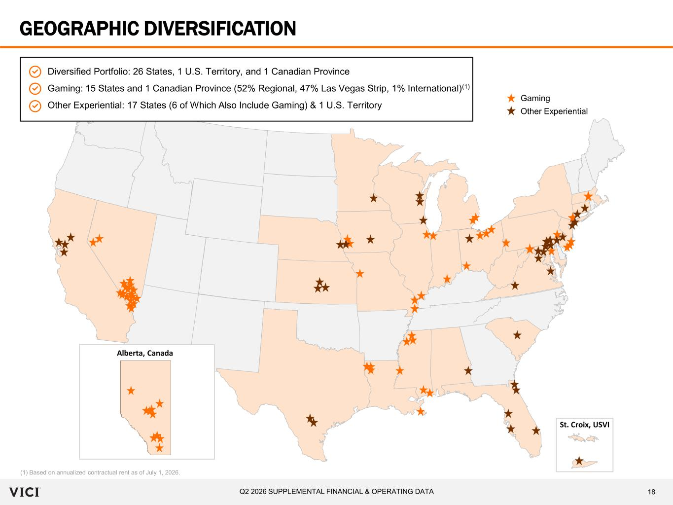
18Q2 2026 SUPPLEMENTAL FINANCIAL & OPERATING DATA GEOGRAPHIC DIVERSIFICATION (1) Based on annualized contractual rent as of July 1, 2026. Diversified Portfolio: 26 States, 1 U.S. Territory, and 1 Canadian Province Gaming: 15 States and 1 Canadian Province (52% Regional, 47% Las Vegas Strip, 1% International)(1) Other Experiential: 17 States (6 of Which Also Include Gaming) & 1 U.S. Territory Alberta, Canada Gaming Other Experiential St. Croix, USVI

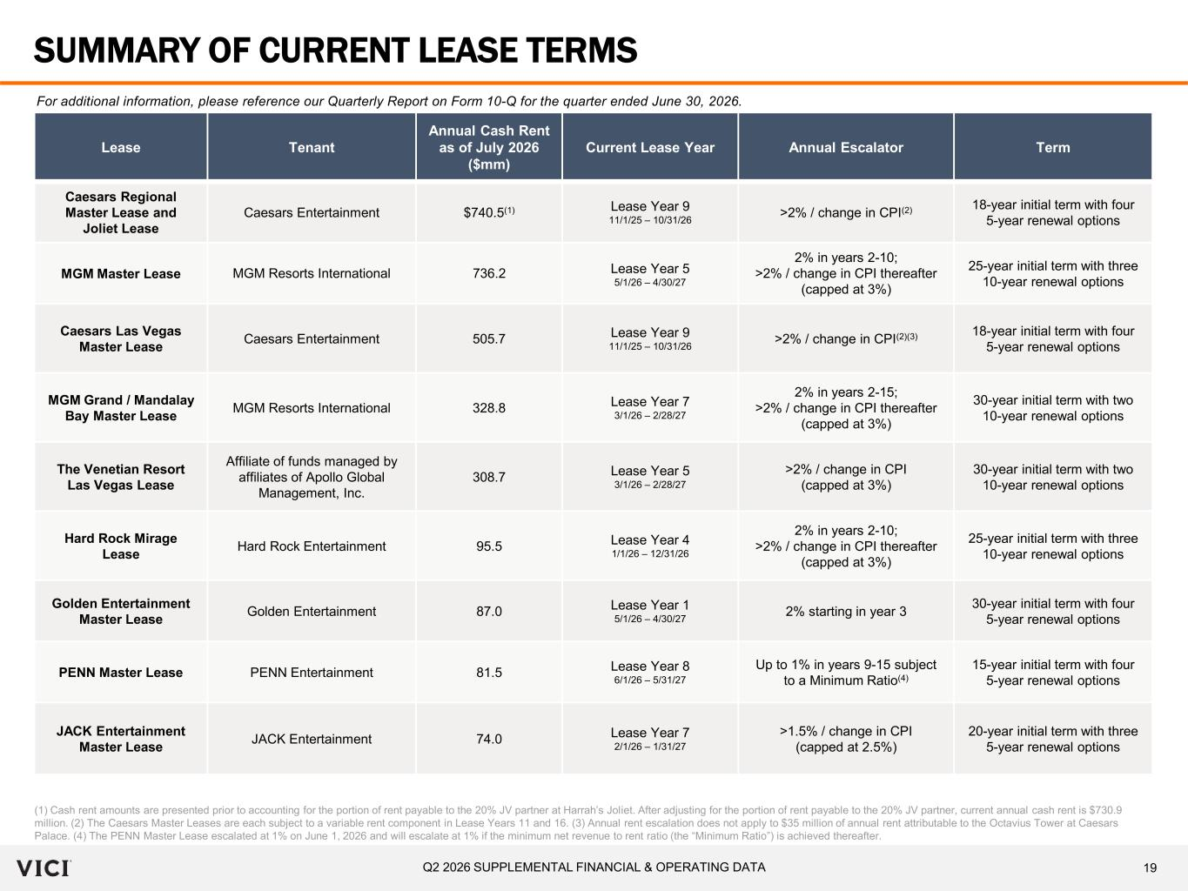
19Q2 2026 SUPPLEMENTAL FINANCIAL & OPERATING DATA SUMMARY OF CURRENT LEASE TERMS (1) Cash rent amounts are presented prior to accounting for the portion of rent payable to the 20% JV partner at Harrah’s Joliet. After adjusting for the portion of rent payable to the 20% JV partner, current annual cash rent is $730.9 million. (2) The Caesars Master Leases are each subject to a variable rent component in Lease Years 11 and 16. (3) Annual rent escalation does not apply to $35 million of annual rent attributable to the Octavius Tower at Caesars Palace. (4) The PENN Master Lease escalated at 1% on June 1, 2026 and will escalate at 1% if the minimum net revenue to rent ratio (the “Minimum Ratio”) is achieved thereafter. Lease Tenant Annual Cash Rent as of July 2026 ($mm) Current Lease Year Annual Escalator Term Caesars Regional Master Lease and Joliet Lease Caesars Entertainment $740.5(1) Lease Year 9 11/1/25 – 10/31/26 >2% / change in CPI(2) 18-year initial term with four 5-year renewal options MGM Master Lease MGM Resorts International 736.2 Lease Year 5 5/1/26 – 4/30/27 2% in years 2-10; >2% / change in CPI thereafter (capped at 3%) 25-year initial term with three 10-year renewal options Caesars Las Vegas Master Lease Caesars Entertainment 505.7 Lease Year 9 11/1/25 – 10/31/26 >2% / change in CPI(2)(3) 18-year initial term with four 5-year renewal options MGM Grand / Mandalay Bay Master Lease MGM Resorts International 328.8 Lease Year 7 3/1/26 – 2/28/27 2% in years 2-15; >2% / change in CPI thereafter (capped at 3%) 30-year initial term with two 10-year renewal options The Venetian Resort Las Vegas Lease Affiliate of funds managed by affiliates of Apollo Global Management, Inc. 308.7 Lease Year 5 3/1/26 – 2/28/27 >2% / change in CPI (capped at 3%) 30-year initial term with two 10-year renewal options Hard Rock Mirage Lease Hard Rock Entertainment 95.5 Lease Year 4 1/1/26 – 12/31/26 2% in years 2-10; >2% / change in CPI thereafter (capped at 3%) 25-year initial term with three 10-year renewal options Golden Entertainment Master Lease Golden Entertainment 87.0 Lease Year 1 5/1/26 – 4/30/27 2% starting in year 3 30-year initial term with four 5-year renewal options PENN Master Lease PENN Entertainment 81.5 Lease Year 8 6/1/26 – 5/31/27 Up to 1% in years 9-15 subject to a Minimum Ratio(4) 15-year initial term with four 5-year renewal options JACK Entertainment Master Lease JACK Entertainment 74.0 Lease Year 7 2/1/26 – 1/31/27 >1.5% / change in CPI (capped at 2.5%) 20-year initial term with three 5-year renewal options For additional information, please reference our Quarterly Report on Form 10-Q for the quarter ended June 30, 2026.

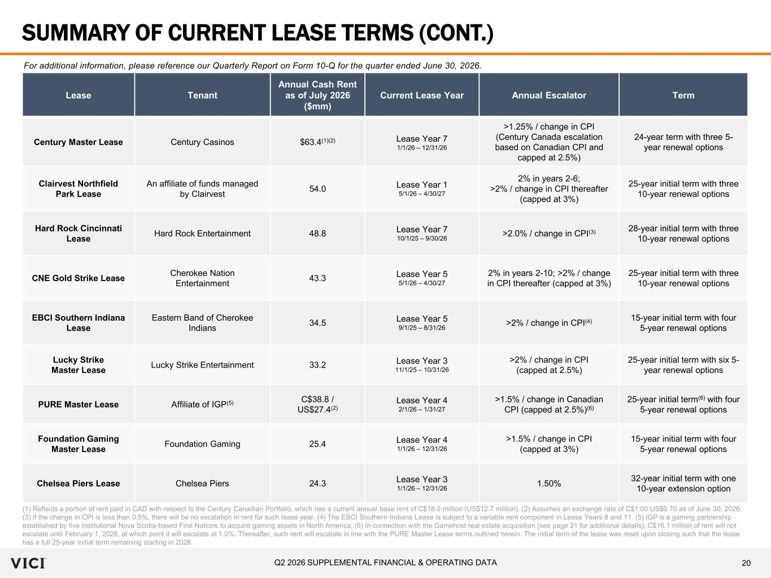
20Q2 2026 SUPPLEMENTAL FINANCIAL & OPERATING DATA SUMMARY OF CURRENT LEASE TERMS (CONT.) Lease Tenant Annual Cash Rent as of July 2026 ($mm) Current Lease Year Annual Escalator Term Century Master Lease Century Casinos $63.4(1)(2) Lease Year 7 1/1/26 – 12/31/26 >1.25% / change in CPI (Century Canada escalation based on Canadian CPI and capped at 2.5%) 24-year term with three 5- year renewal options Clairvest Northfield Park Lease An affiliate of funds managed by Clairvest 54.0 Lease Year 1 5/1/26 – 4/30/27 2% in years 2-6; >2% / change in CPI thereafter (capped at 3%) 25-year initial term with three 10-year renewal options Hard Rock Cincinnati Lease Hard Rock Entertainment 48.8 Lease Year 7 10/1/25 – 9/30/26 >2.0% / change in CPI(3) 28-year initial term with three 10-year renewal options CNE Gold Strike Lease Cherokee Nation Entertainment 43.3 Lease Year 5 5/1/26 – 4/30/27 2% in years 2-10; >2% / change in CPI thereafter (capped at 3%) 25-year initial term with three 10-year renewal options EBCI Southern Indiana Lease Eastern Band of Cherokee Indians 34.5 Lease Year 5 9/1/25 – 8/31/26 >2% / change in CPI(4) 15-year initial term with four 5-year renewal options Lucky Strike Master Lease Lucky Strike Entertainment 33.2 Lease Year 3 11/1/25 – 10/31/26 >2% / change in CPI (capped at 2.5%) 25-year initial term with six 5- year renewal options PURE Master Lease Affiliate of IGP(5) C$38.8 / US$27.4(2) Lease Year 4 2/1/26 – 1/31/27 >1.5% / change in Canadian CPI (capped at 2.5%)(6) 25-year initial term(6) with four 5-year renewal options Foundation Gaming Master Lease Foundation Gaming 25.4 Lease Year 4 1/1/26 – 12/31/26 >1.5% / change in CPI (capped at 3%) 15-year initial term with four 5-year renewal options Chelsea Piers Lease Chelsea Piers 24.3 Lease Year 3 1/1/26 – 12/31/26 1.50% 32-year initial term with one 10-year extension option (1) Reflects a portion of rent paid in CAD with respect to the Century Canadian Portfolio, which has a current annual base rent of C$18.0 million (US$12.7 million). (2) Assumes an exchange rate of C$1:00:US$0.70 as of June 30, 2026. (3) If the change in CPI is less than 0.5%, there will be no escalation in rent for such lease year. (4) The EBCI Southern Indiana Lease is subject to a variable rent component in Lease Years 8 and 11. (5) IGP is a gaming partnership established by five institutional Nova Scotia-based First Nations to acquire gaming assets in North America. (6) In connection with the Gamehost real estate acquisition (see page 21 for additional details), C$16.1 million of rent will not escalate until February 1, 2028, at which point it will escalate at 1.0%. Thereafter, such rent will escalate in line with the PURE Master Lease terms outlined herein. The initial term of the lease was reset upon closing such that the lease has a full 25-year initial term remaining starting in 2026. For additional information, please reference our Quarterly Report on Form 10-Q for the quarter ended June 30, 2026.

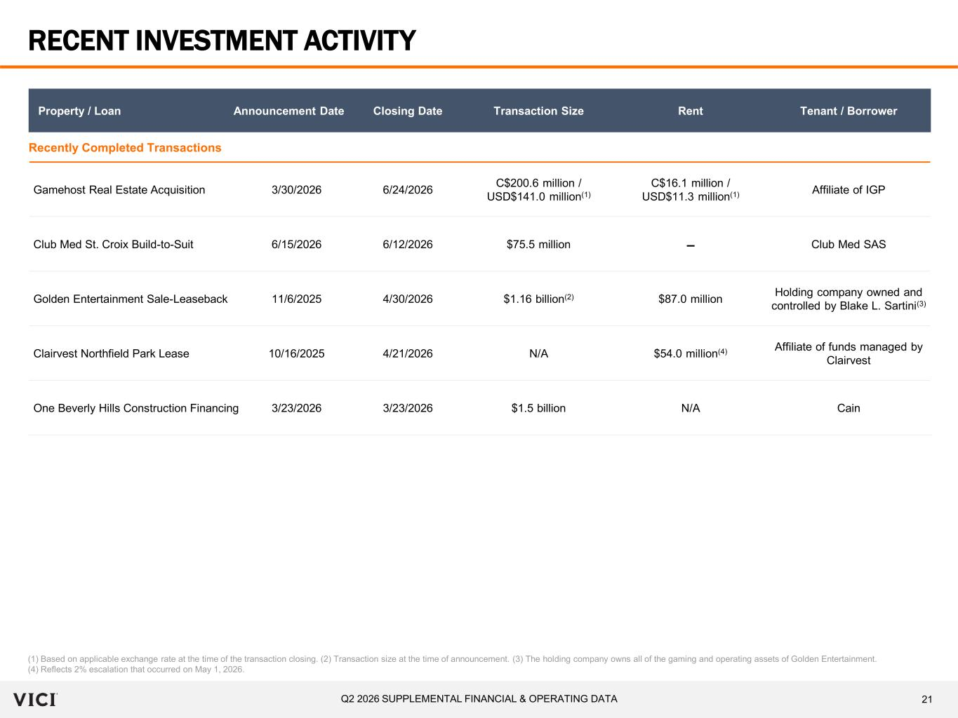
21Q2 2026 SUPPLEMENTAL FINANCIAL & OPERATING DATA RECENT INVESTMENT ACTIVITY (1) Based on applicable exchange rate at the time of the transaction closing. (2) Transaction size at the time of announcement. (3) The holding company owns all of the gaming and operating assets of Golden Entertainment. (4) Reflects 2% escalation that occurred on May 1, 2026. Property / Loan Announcement Date Closing Date Transaction Size Rent Tenant / Borrower Recently Completed Transactions Gamehost Real Estate Acquisition 3/30/2026 6/24/2026 C$200.6 million / USD$141.0 million(1) C$16.1 million / USD$11.3 million(1) Affiliate of IGP Club Med St. Croix Build-to-Suit 6/15/2026 6/12/2026 $75.5 million -- Club Med SAS Golden Entertainment Sale-Leaseback 11/6/2025 4/30/2026 $1.16 billion(2) $87.0 million Holding company owned and controlled by Blake L. Sartini(3) Clairvest Northfield Park Lease 10/16/2025 4/21/2026 N/A $54.0 million(4) Affiliate of funds managed by Clairvest One Beverly Hills Construction Financing 3/23/2026 3/23/2026 $1.5 billion N/A Cain

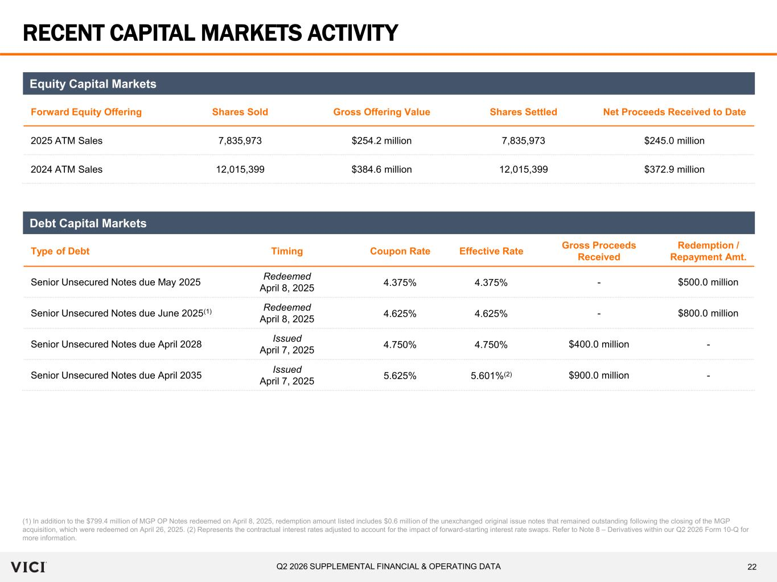
22Q2 2026 SUPPLEMENTAL FINANCIAL & OPERATING DATA RECENT CAPITAL MARKETS ACTIVITY (1) In addition to the $799.4 million of MGP OP Notes redeemed on April 8, 2025, redemption amount listed includes $0.6 million of the unexchanged original issue notes that remained outstanding following the closing of the MGP acquisition, which were redeemed on April 26, 2025. (2) Represents the contractual interest rates adjusted to account for the impact of forward-starting interest rate swaps. Refer to Note 8 – Derivatives within our Q2 2026 Form 10-Q for more information. Forward Equity Offering Shares Sold Gross Offering Value Shares Settled Net Proceeds Received to Date 2025 ATM Sales 7,835,973 $254.2 million 7,835,973 $245.0 million 2024 ATM Sales 12,015,399 $384.6 million 12,015,399 $372.9 million Equity Capital Markets Type of Debt Timing Coupon Rate Effective Rate Gross Proceeds Received Redemption / Repayment Amt. Senior Unsecured Notes due May 2025 Redeemed April 8, 2025 4.375% 4.375% - $500.0 million Senior Unsecured Notes due June 2025(1) Redeemed April 8, 2025 4.625% 4.625% - $800.0 million Senior Unsecured Notes due April 2028 Issued April 7, 2025 4.750% 4.750% $400.0 million - Senior Unsecured Notes due April 2035 Issued April 7, 2025 5.625% 5.601%(2) $900.0 million - Debt Capital Markets

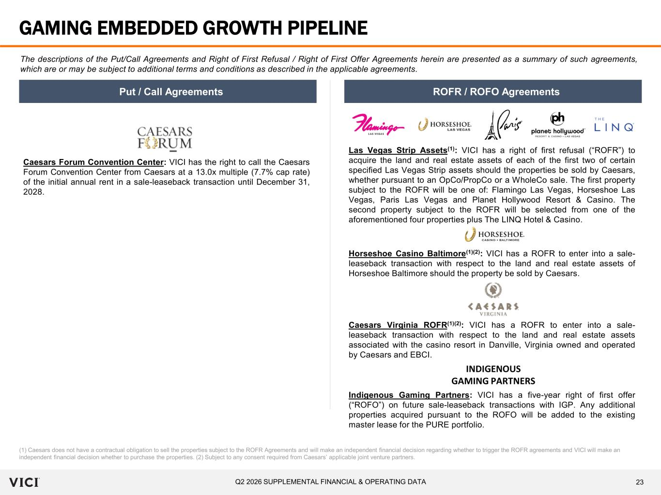
23Q2 2026 SUPPLEMENTAL FINANCIAL & OPERATING DATA GAMING EMBEDDED GROWTH PIPELINE The descriptions of the Put/Call Agreements and Right of First Refusal / Right of First Offer Agreements herein are presented as a summary of such agreements, which are or may be subject to additional terms and conditions as described in the applicable agreements. Put / Call Agreements ROFR / ROFO Agreements (1) Caesars does not have a contractual obligation to sell the properties subject to the ROFR Agreements and will make an independent financial decision regarding whether to trigger the ROFR agreements and VICI will make an independent financial decision whether to purchase the properties. (2) Subject to any consent required from Caesars’ applicable joint venture partners. Caesars Forum Convention Center: VICI has the right to call the Caesars Forum Convention Center from Caesars at a 13.0x multiple (7.7% cap rate) of the initial annual rent in a sale-leaseback transaction until December 31, 2028. Las Vegas Strip Assets(1): VICI has a right of first refusal (“ROFR”) to acquire the land and real estate assets of each of the first two of certain specified Las Vegas Strip assets should the properties be sold by Caesars, whether pursuant to an OpCo/PropCo or a WholeCo sale. The first property subject to the ROFR will be one of: Flamingo Las Vegas, Horseshoe Las Vegas, Paris Las Vegas and Planet Hollywood Resort & Casino. The second property subject to the ROFR will be selected from one of the aforementioned four properties plus The LINQ Hotel & Casino. Horseshoe Casino Baltimore(1)(2): VICI has a ROFR to enter into a sale- leaseback transaction with respect to the land and real estate assets of Horseshoe Baltimore should the property be sold by Caesars. Caesars Virginia ROFR(1)(2): VICI has a ROFR to enter into a sale- leaseback transaction with respect to the land and real estate assets associated with the casino resort in Danville, Virginia owned and operated by Caesars and EBCI. Indigenous Gaming Partners: VICI has a five-year right of first offer (“ROFO”) on future sale-leaseback transactions with IGP. Any additional properties acquired pursuant to the ROFO will be added to the existing master lease for the PURE portfolio. INDIGENOUS GAMING PARTNERS

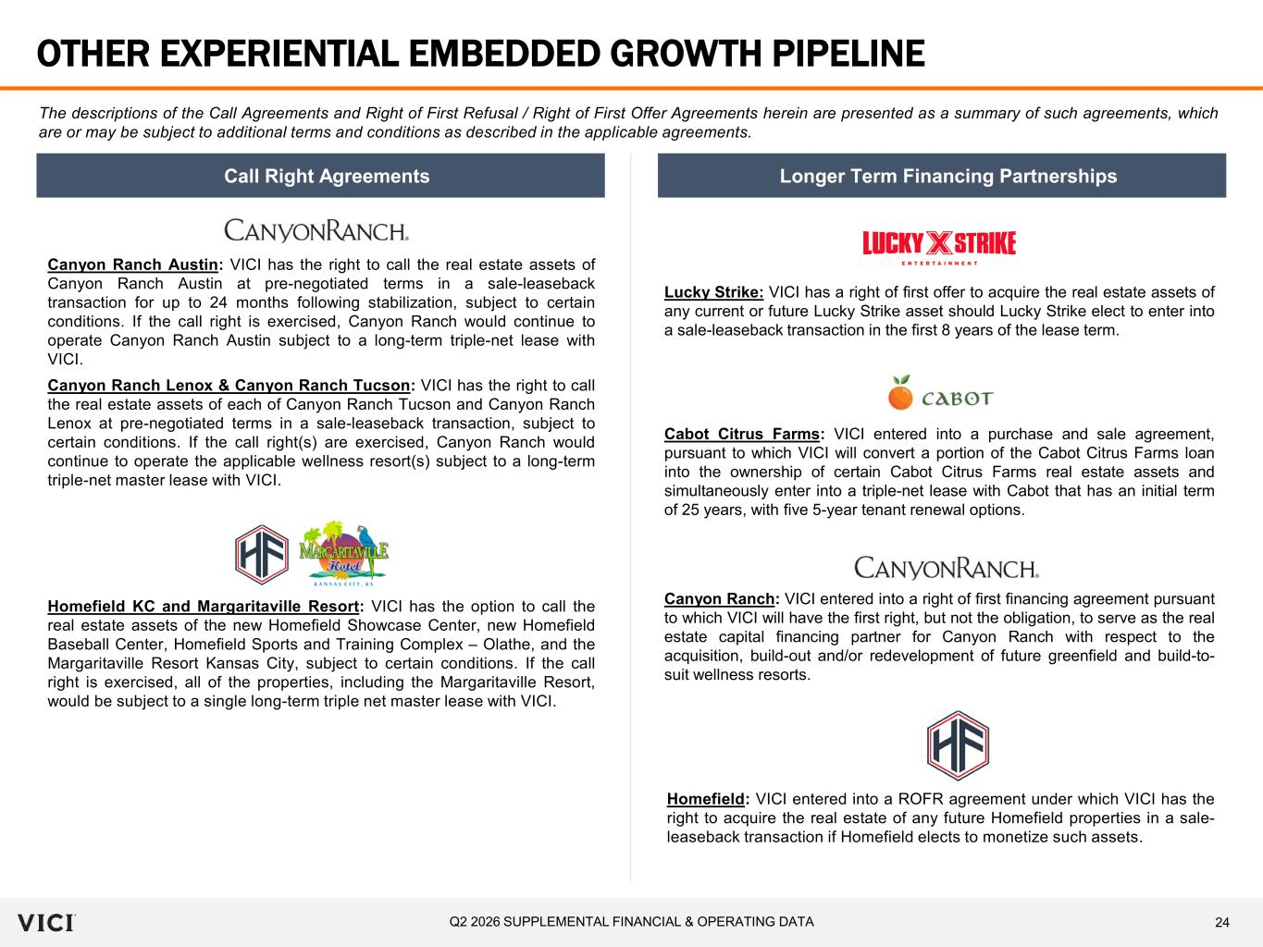
24Q2 2026 SUPPLEMENTAL FINANCIAL & OPERATING DATA OTHER EXPERIENTIAL EMBEDDED GROWTH PIPELINE The descriptions of the Call Agreements and Right of First Refusal / Right of First Offer Agreements herein are presented as a summary of such agreements, which are or may be subject to additional terms and conditions as described in the applicable agreements. Canyon Ranch Lenox & Canyon Ranch Tucson: VICI has the right to call the real estate assets of each of Canyon Ranch Tucson and Canyon Ranch Lenox at pre-negotiated terms in a sale-leaseback transaction, subject to certain conditions. If the call right(s) are exercised, Canyon Ranch would continue to operate the applicable wellness resort(s) subject to a long-term triple-net master lease with VICI. Call Right Agreements Longer Term Financing Partnerships Canyon Ranch Austin: VICI has the right to call the real estate assets of Canyon Ranch Austin at pre-negotiated terms in a sale-leaseback transaction for up to 24 months following stabilization, subject to certain conditions. If the call right is exercised, Canyon Ranch would continue to operate Canyon Ranch Austin subject to a long-term triple-net lease with VICI. Cabot Citrus Farms: VICI entered into a purchase and sale agreement, pursuant to which VICI will convert a portion of the Cabot Citrus Farms loan into the ownership of certain Cabot Citrus Farms real estate assets and simultaneously enter into a triple-net lease with Cabot that has an initial term of 25 years, with five 5-year tenant renewal options. Canyon Ranch: VICI entered into a right of first financing agreement pursuant to which VICI will have the first right, but not the obligation, to serve as the real estate capital financing partner for Canyon Ranch with respect to the acquisition, build-out and/or redevelopment of future greenfield and build-to- suit wellness resorts. Lucky Strike: VICI has a right of first offer to acquire the real estate assets of any current or future Lucky Strike asset should Lucky Strike elect to enter into a sale-leaseback transaction in the first 8 years of the lease term. Homefield KC and Margaritaville Resort: VICI has the option to call the real estate assets of the new Homefield Showcase Center, new Homefield Baseball Center, Homefield Sports and Training Complex – Olathe, and the Margaritaville Resort Kansas City, subject to certain conditions. If the call right is exercised, all of the properties, including the Margaritaville Resort, would be subject to a single long-term triple net master lease with VICI. Homefield: VICI entered into a ROFR agreement under which VICI has the right to acquire the real estate of any future Homefield properties in a sale- leaseback transaction if Homefield elects to monetize such assets.

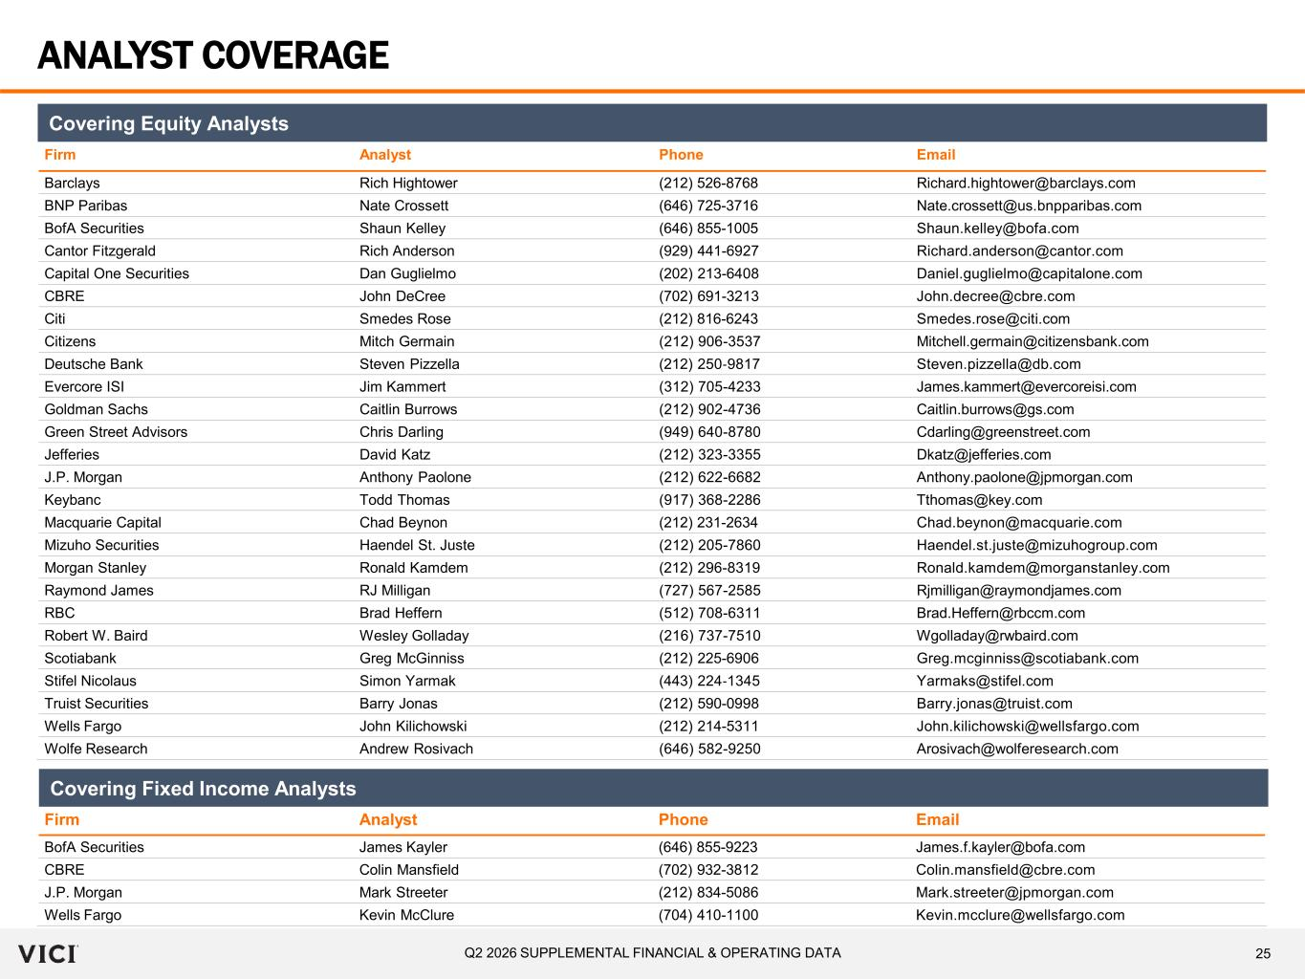
25Q2 2026 SUPPLEMENTAL FINANCIAL & OPERATING DATA ANALYST COVERAGE Firm Analyst Phone Email Barclays Rich Hightower (212) 526-8768 Richard.hightower@barclays.com BNP Paribas Nate Crossett (646) 725-3716 Nate.crossett@us.bnpparibas.com BofA Securities Shaun Kelley (646) 855-1005 Shaun.kelley@bofa.com Cantor Fitzgerald Rich Anderson (929) 441-6927 Richard.anderson@cantor.com Capital One Securities Dan Guglielmo (202) 213-6408 Daniel.guglielmo@capitalone.com CBRE John DeCree (702) 691-3213 John.decree@cbre.com Citi Smedes Rose (212) 816-6243 Smedes.rose@citi.com Citizens Mitch Germain (212) 906-3537 Mitchell.germain@citizensbank.com Deutsche Bank Steven Pizzella (212) 250‐9817 Steven.pizzella@db.com Evercore ISI Jim Kammert (312) 705-4233 James.kammert@evercoreisi.com Goldman Sachs Caitlin Burrows (212) 902-4736 Caitlin.burrows@gs.com Green Street Advisors Chris Darling (949) 640-8780 Cdarling@greenstreet.com Jefferies David Katz (212) 323-3355 Dkatz@jefferies.com J.P. Morgan Anthony Paolone (212) 622-6682 Anthony.paolone@jpmorgan.com Keybanc Todd Thomas (917) 368-2286 Tthomas@key.com Macquarie Capital Chad Beynon (212) 231-2634 Chad.beynon@macquarie.com Mizuho Securities Haendel St. Juste (212) 205-7860 Haendel.st.juste@mizuhogroup.com Morgan Stanley Ronald Kamdem (212) 296-8319 Ronald.kamdem@morganstanley.com Raymond James RJ Milligan (727) 567-2585 Rjmilligan@raymondjames.com RBC Brad Heffern (512) 708-6311 Brad.Heffern@rbccm.com Robert W. Baird Wesley Golladay (216) 737-7510 Wgolladay@rwbaird.com Scotiabank Greg McGinniss (212) 225-6906 Greg.mcginniss@scotiabank.com Stifel Nicolaus Simon Yarmak (443) 224‐1345 Yarmaks@stifel.com Truist Securities Barry Jonas (212) 590-0998 Barry.jonas@truist.com Wells Fargo John Kilichowski (212) 214-5311 John.kilichowski@wellsfargo.com Wolfe Research Andrew Rosivach (646) 582-9250 Arosivach@wolferesearch.com Firm Analyst Phone Email BofA Securities James Kayler (646) 855-9223 James.f.kayler@bofa.com CBRE Colin Mansfield (702) 932-3812 Colin.mansfield@cbre.com J.P. Morgan Mark Streeter (212) 834-5086 Mark.streeter@jpmorgan.com Wells Fargo Kevin McClure (704) 410-1100 Kevin.mcclure@wellsfargo.com Covering Fixed Income Analysts Covering Equity Analysts

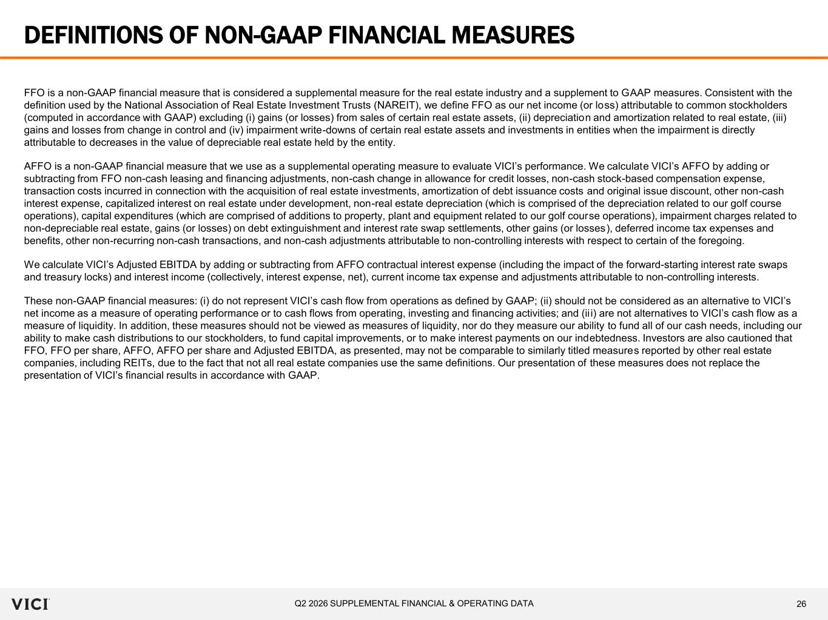
26Q2 2026 SUPPLEMENTAL FINANCIAL & OPERATING DATA DEFINITIONS OF NON-GAAP FINANCIAL MEASURES FFO is a non-GAAP financial measure that is considered a supplemental measure for the real estate industry and a supplement to GAAP measures. Consistent with the definition used by the National Association of Real Estate Investment Trusts (NAREIT), we define FFO as our net income (or loss) attributable to common stockholders (computed in accordance with GAAP) excluding (i) gains (or losses) from sales of certain real estate assets, (ii) depreciation and amortization related to real estate, (iii) gains and losses from change in control and (iv) impairment write-downs of certain real estate assets and investments in entities when the impairment is directly attributable to decreases in the value of depreciable real estate held by the entity. AFFO is a non-GAAP financial measure that we use as a supplemental operating measure to evaluate VICI’s performance. We calculate VICI’s AFFO by adding or subtracting from FFO non-cash leasing and financing adjustments, non-cash change in allowance for credit losses, non-cash stock-based compensation expense, transaction costs incurred in connection with the acquisition of real estate investments, amortization of debt issuance costs and original issue discount, other non-cash interest expense, capitalized interest on real estate under development, non-real estate depreciation (which is comprised of the depreciation related to our golf course operations), capital expenditures (which are comprised of additions to property, plant and equipment related to our golf course operations), impairment charges related to non-depreciable real estate, gains (or losses) on debt extinguishment and interest rate swap settlements, other gains (or losses), deferred income tax expenses and benefits, other non-recurring non-cash transactions, and non-cash adjustments attributable to non-controlling interests with respect to certain of the foregoing. We calculate VICI’s Adjusted EBITDA by adding or subtracting from AFFO contractual interest expense (including the impact of the forward-starting interest rate swaps and treasury locks) and interest income (collectively, interest expense, net), current income tax expense and adjustments attributable to non-controlling interests. These non-GAAP financial measures: (i) do not represent VICI’s cash flow from operations as defined by GAAP; (ii) should not be considered as an alternative to VICI’s net income as a measure of operating performance or to cash flows from operating, investing and financing activities; and (ii i) are not alternatives to VICI’s cash flow as a measure of liquidity. In addition, these measures should not be viewed as measures of liquidity, nor do they measure our ability to fund all of our cash needs, including our ability to make cash distributions to our stockholders, to fund capital improvements, or to make interest payments on our indebtedness. Investors are also cautioned that FFO, FFO per share, AFFO, AFFO per share and Adjusted EBITDA, as presented, may not be comparable to similarly titled measures reported by other real estate companies, including REITs, due to the fact that not all real estate companies use the same definitions. Our presentation of these measures does not replace the presentation of VICI’s financial results in accordance with GAAP.

